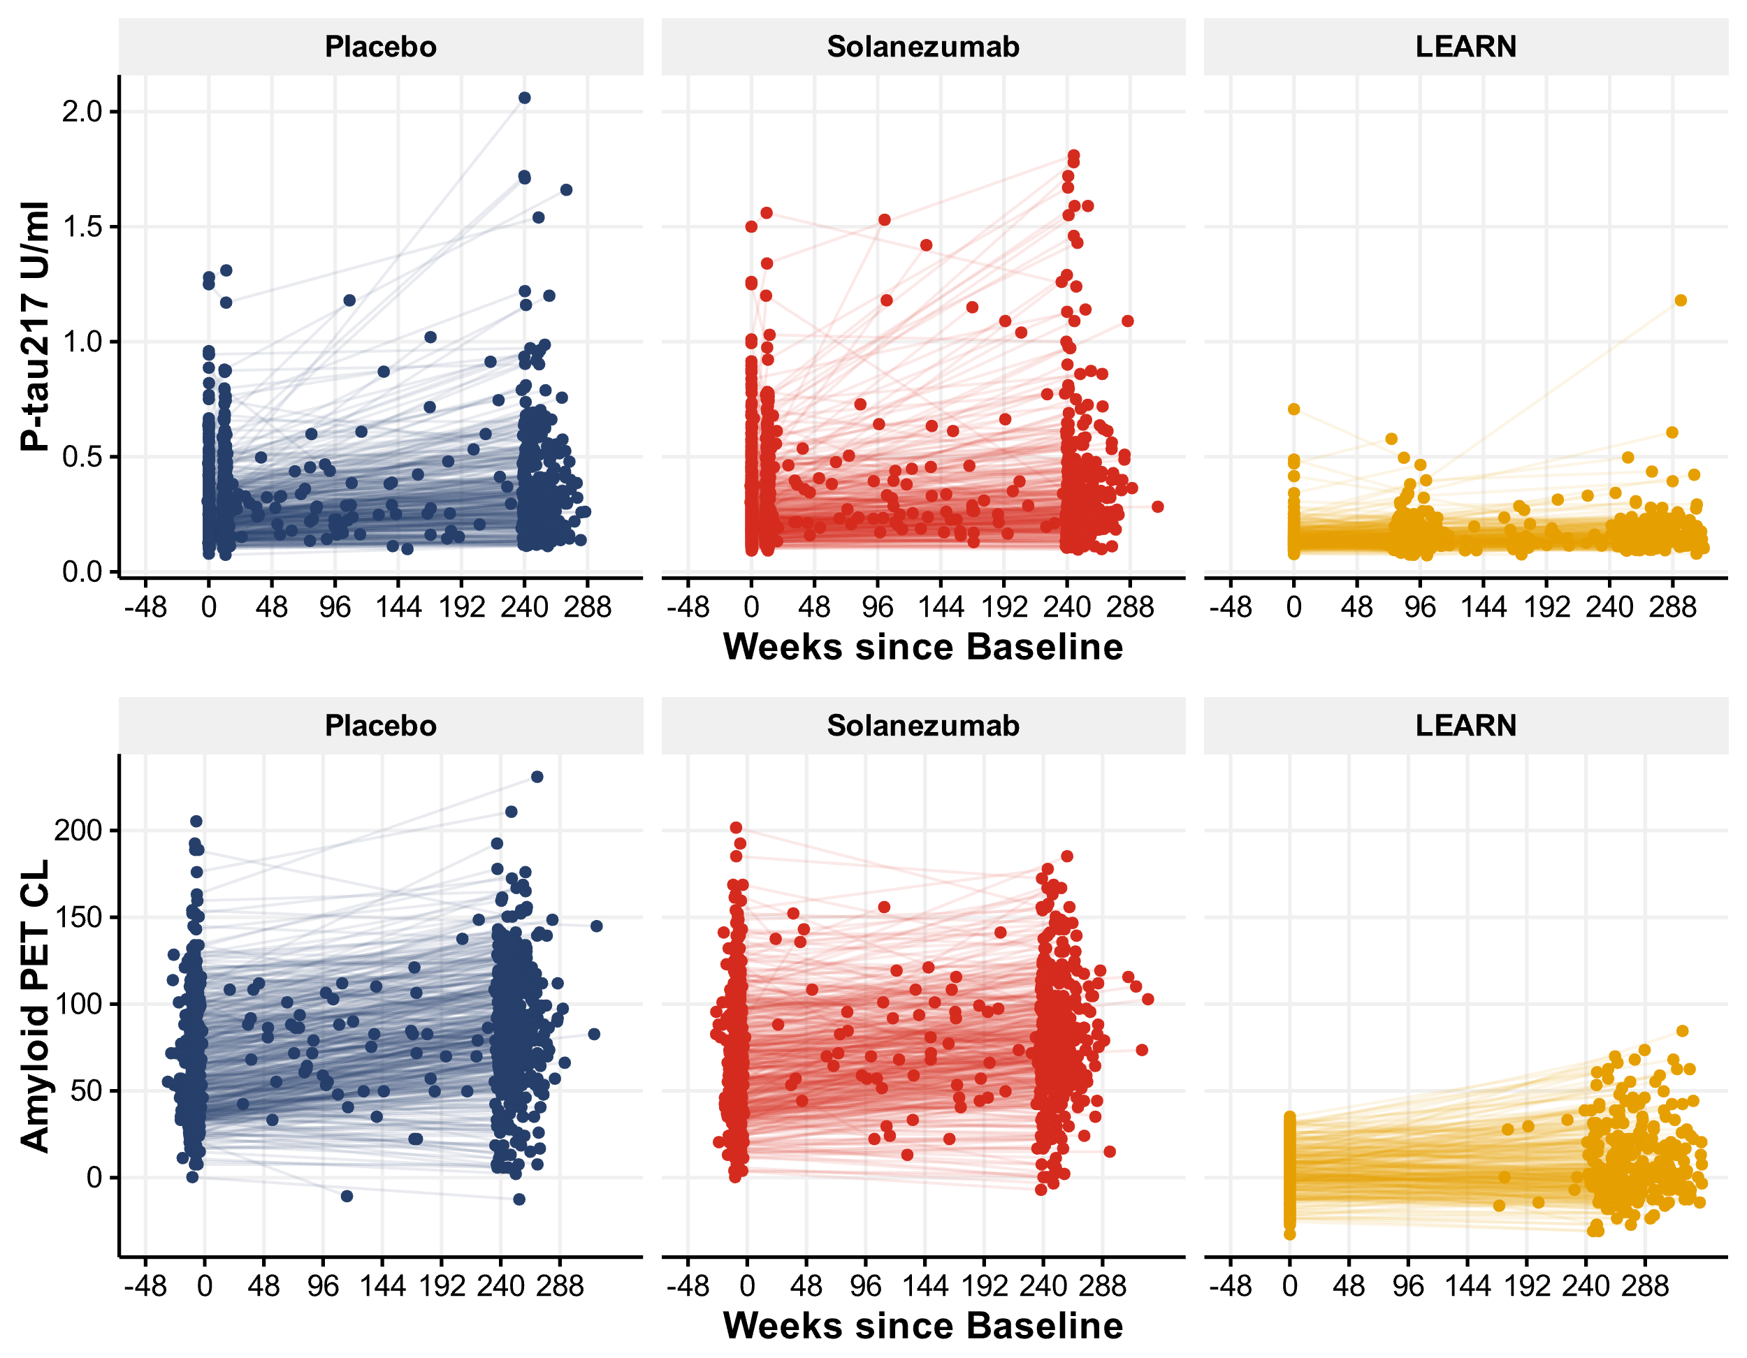

Figure S1: Spaghetti plots of P-tau217 and amyloid PET for A4 and LEARN