Exploring the association between amyloid-β and memory markers for Alzheimer’s disease in cognitively unimpaired older adults

Table 1. Neuropsychological Tests included in the battery of tests used in the Cognitive Reserve Study¹ and tests selected for the present study (see manuscript for motivation of such a selection).
Full Neuropsychological Battery |  | Tests Selected for the Study
Dementia Screen and General Intellectual functioning
Mattis Dementia Rating Scale (DRS)
Premorbid IQ Wechsler Test of Adult Reading (WTAR)
Wechsler Adult Intelligence Scale – Third Edition (WAIS-III) – Vocabulary subtest
Learning and Memory
Selective Reminding Test
Wechsler Memory Scale-III
Verbal Paired Associates
Basic Attention
WAIS-III Digit Span forward
Processing Speed
Trail Making Test Part A
WAIS-III Digit Symbol subtest
Stroop Color Reading
Executive functions
a. Inhibition
Stroop Color and Word Test
b. Shifting Wisconsin Card Sorting Test
WCST
Trail Making Test Part B;
c. Revision & Monitoring
WAIS-III Letter-Number Sequencing
WAIS-III Digit Span backwards
Fluid Reasoning
WAIS-III Similarities subtest
WAIS-III Matrix Reasoning subtest
Reaction Time
Variable-foreperiod simple reaction time
Choice reaction time (go-no go task, 2-choice RT and 4-choice RT)
Language
Boston Naming Test
Controlled Oral Word Association Test
Category Fluency Test
Visuoconstruction
WAIS-III Block Design subtest
1. Habeck C, Gazes Y, Stern Y. Age-Specific Activation Patterns and Inter-Subject Similarity During Verbal Working Memory Maintenance and Cognitive Reserve. Original Research. Frontiers in Psychology. 2022-June-09 2022;13doi:10.3389/fpsyg.2022.852995

Table 2. Demographic information for the participants that agreed to participate in the study and those that received amyloid PET but declined participate in the current study. There was no statistical difference between the two groups in these demographic information.

 | In study (N=39) | Not in study (N=62) | p-value
Age - Mean(SD) | 65.3 (3.07) | 65.3 (3.33) | 0.793
Sex - F/M | 16/23 | 35/27 | 0.131
Education - Mean(SD) | 16.2 (1.90) | 16.3 (2.35) | 0.861
WTAR - Mean(SD) | 111 (13.1) | 111 (13.1) | 0.972
WTAR: Wechsler Test of Adult Reading.

Table 3. Brain regions revealing significant differences in Aβ deposits between LBC and HBC during whole-brain voxelwise analysis.
Voxels | Max lodP | X (mm) | Y (mm) | Z (mm) | Brain regions
10347 | 4.38 | -24 | -63 | -4 | Bilateral lingual and fusiform gyri
5871 | 3.56 | -8 | -93 | 10 | Bilateral cuneus and supracalcarine
5028 | 2.99 | 65 | -51 | 20 | Right angular and middle temporal gyri, right lateral occipital cortex
3776 | 2.94 | -51 | -79 | 11 | Left middle temporal gyrus and lateral occipital cortex
1787 | 3.23 | 17 | 1 | -24 | Right entorhinal cortex, parahippocampal gyrus, and temporal pole
1123 | 2.41 | -64 | -45 | 15 | Left superior and middle temporal gyri, and angular and supramarginal gyri
1015 | 1.89 | 44 | -31 | 54 | Right postcentral gyrus and superior parietal lobule
961 | 3.04 | -37 | -95 | 2 | Left lateral occipital cortex and occipital pole
718 | 2.37 | -45 | 6 | 30 | Left middle and inferior frontal gyri, and precentral gyrus
587 | 2.25 | 34 | -78 | 24 | Right lateral occipital cortex

Figure 1. Scatterplots depicting the correlations between the Binding Cost and the accumulation of Amyloid-β in four ROI known to be nodes of the VSTMB network: (A) right cuneus, (B) right fusiform gyrus, (C) right lateral occipital cortex, and (D) right entorhinal cortex. We show correlations that survived FDR corrections.
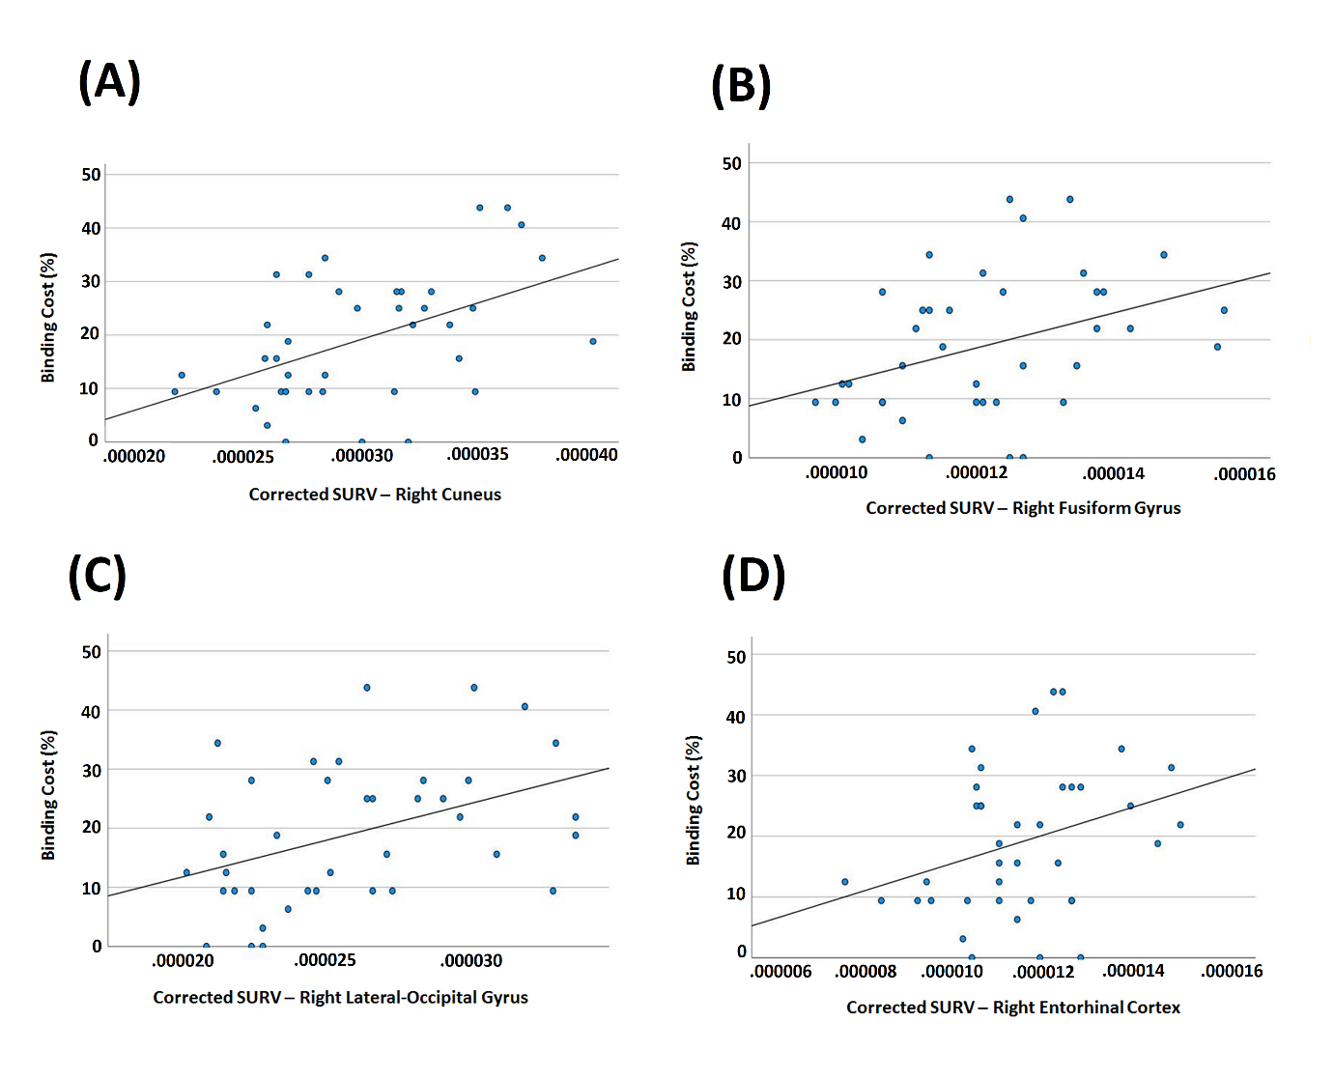

Figure 2. Additional ROI where whole-brain voxel-wise analyses (between-groups) revealed that Aβ deposits significantly correlated with the cost of binding (all corrected for multiple comparisons) (see also Figure 5 in main manuscript).
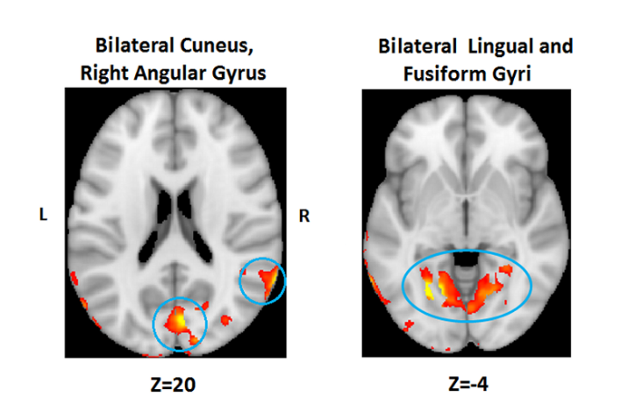
Table 4. Results from the correlation analysis. We show correlations that survived FDR corrections (see Figure 4.A in manuscript for the full set of correlations).
Correlations with Binding Cost | Statistic
 | r | p-value | CI
Left superior temporal gyrus | 0.366 | 0.022 | (0.057-0.611)
Right superior temporal gyrus | 0.369 | 0.021 | (0.061-0.613)
Left middle temporal gyrus | 0.352 | 0.028 | (0.041-0.601)
Right middle temporal gyrus | 0.383 | 0.016 | (0.077-0.623)
Left superior parietal lobule | 0.375 | 0.019 | (0.068-0.618)
Right superior parietal lobule | 0.355 | 0.027 | (0.044-0.603)
Left pericalcarine cortex | 0.522 | 0.001 | (0.247-0.719)
Right pericalcarine cortex | 0.565 | 0.000 | (0.304-0.747)
Left lingual gyrus | 0.473 | 0.002 | (0.185-0.686)
Right lingual gyrus | 0.534 | 0.000 | (0.262-0.727)
Left inferior parietal lobule | 0.407 | 0.010 | (0.105-0.641)
Right lateral occipital cortex | 0.419 | 0.008 | (0.119-0.649)
Right entorhinal cortex | 0.321 | 0.046 | (0.006-0.578)
Right fusiform gyrus | 0.379 | 0.017 | (0.072-0.620)
Left cuneus | 0.453 | 0.004 | (0.161-0.672)

