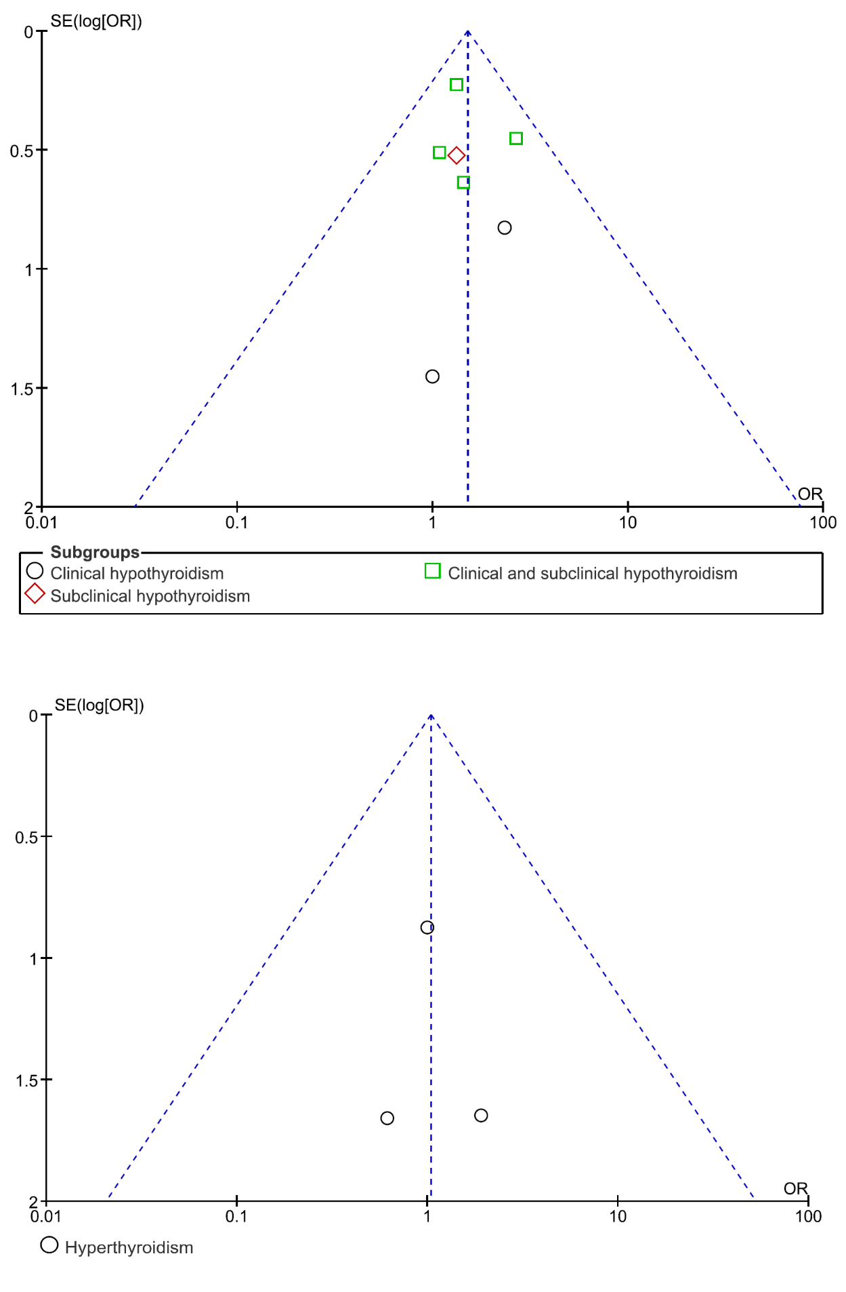
Supplementary Figure 1, Funnel plots depicting publication biases among included studies

