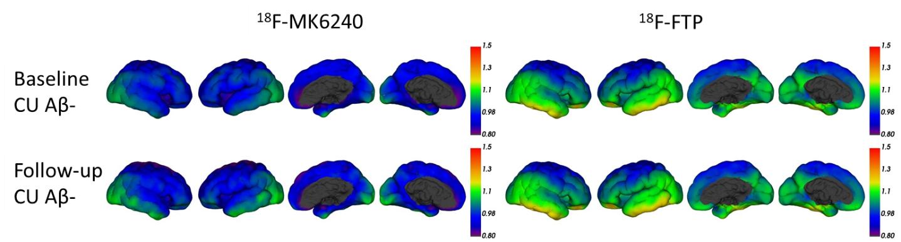
Supplementary Figure 1. Baseline and follow-up Mean SUVR in the Aβ- CU group for ¹⁸F-MK6240 (Left) and ¹⁸F-FTP (Right)

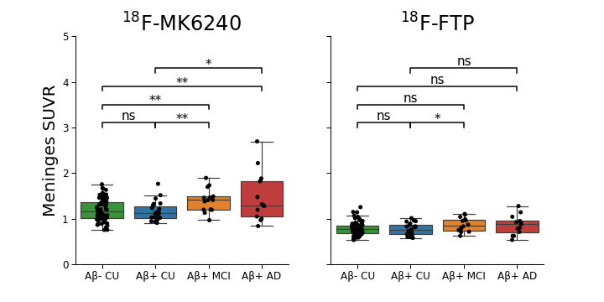
Supplementary Figure 2. Baseline SUVR for ¹⁸F-MK6240 (Left) and ¹⁸F-FTP (Right) in the meninges. (ns: not significant; *: p<0.5; **:p<0.1).
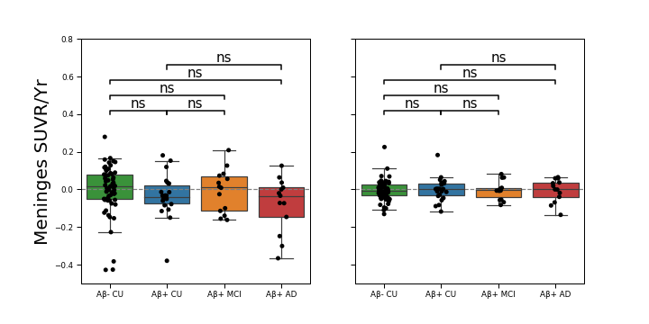
Supplementary Figure 3. SUVR change (SUVR/Year) for ¹⁸F-MK6240 (Left) and ¹⁸F-FTP (Right) in the meninges. (ns: not significant)

