Extended Data
Figure S1. Treatment difference of change from baseline in CDR‐SB, MMSE, ADAS‐Cog13, and ADCS‐ADL‐MCI at week 78 grouped by study, dose, and ApoE ε4 carrier status and including or excluding post‐ARIA observations
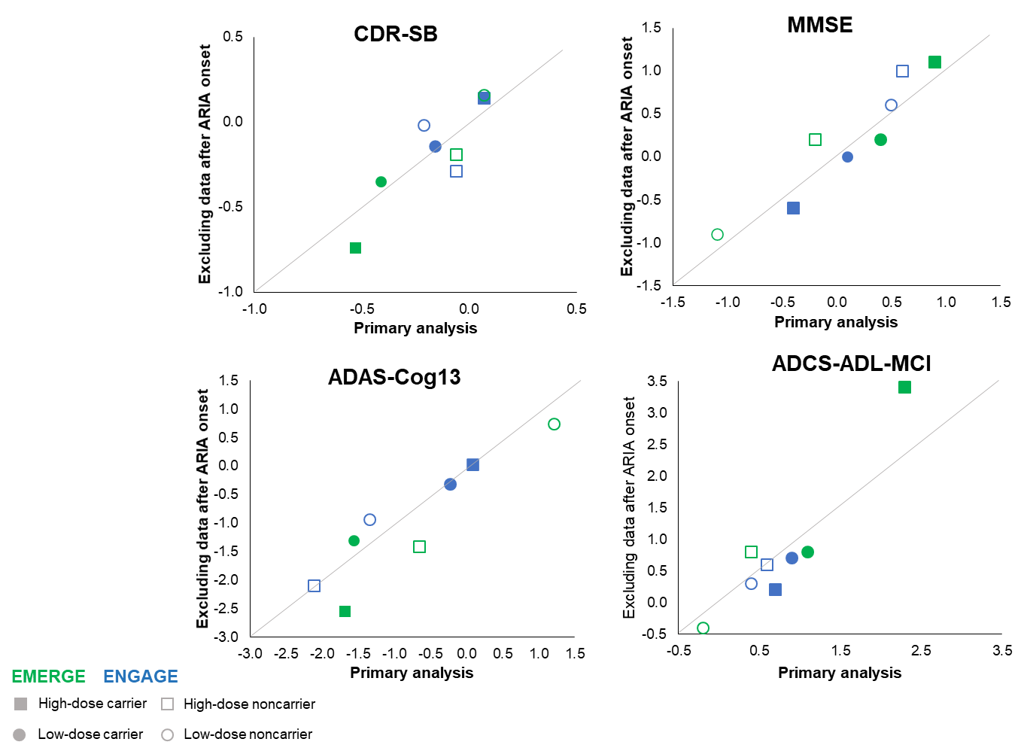
Blue represents ENGAGE; green represents EMERGE; square, high dose; circle, low dose; filled, ApoE ε4 carrier; nonfilled, ApoE ε4; noncarrier; solid line is line of unity.
Primary analysis includes post-ARIA observations. Results were based on an MMRM, with change from baseline in CDR-SB, MMSE, ADAS-Cog13, or ADCS-ADL-MCI score as the dependent variable and with fixed effects of treatment group, categorical visit, treatment-by-visit interaction, baseline measure, baseline measure–by-visit interaction, baseline MMSE score (same as baseline score in the MMSE model), Alzheimer disease symptomatic medication use at baseline, region, laboratory ApoE ε4 status, ApoE ε4–by-visit, ApoE ε4–by-treatment, and ApoE ε4–by-visit-by-treatment interactions. ADAS-Cog13, Alzheimer’s Disease Assessment Scale–Cognitive Subscale, 13 item; ADCS-ADL-MCI, Alzheimer’s Disease Cooperative Study–Activities of Daily Living Inventory, mild cognitive impairment version; ApoE, apolipoprotein E; ARIA, amyloid-related imaging abnormalities; CDR-SB, Clinical Dementia Rating Scale–Sum of Boxes; MMRM, mixed model for repeated measures; MMSE, Mini-Mental State Examination.

Figure S2. Distribution of CDR-SB change from baseline at week 78
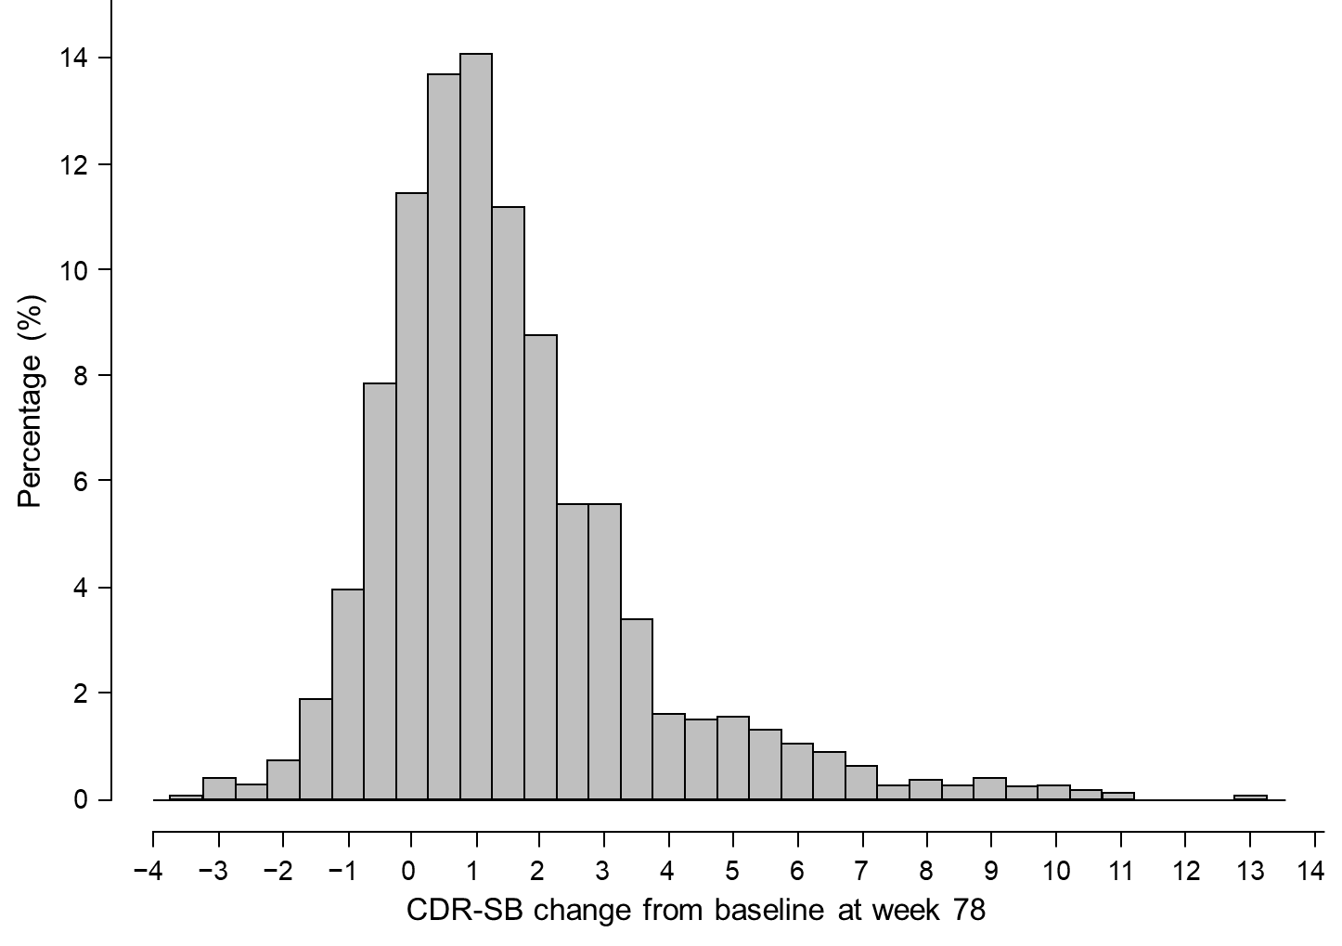
A histogram display of the data from all treatment groups across both studies revealed that CDR‐SB change from baseline at week 78 was right‐skewed with a small percentage of patients having relatively large increases (31 rapid progressors [ >8 points on CDR-SB change from baseline over 78 weeks] out of 3265 patients in EMERGE and ENGAGE). Some degree of right‐skewness is expected as the mean baseline CDR‐SB was approximately 2.5 on a scale that ranges from 0 to 18. CDR-SB, Clinical Dementia Rating Scale–Sum of Boxes.
Figure S3. Adjusted mean change on CDR-SB by ApoE carrier status in the pre-PV4 and PV4 subsets
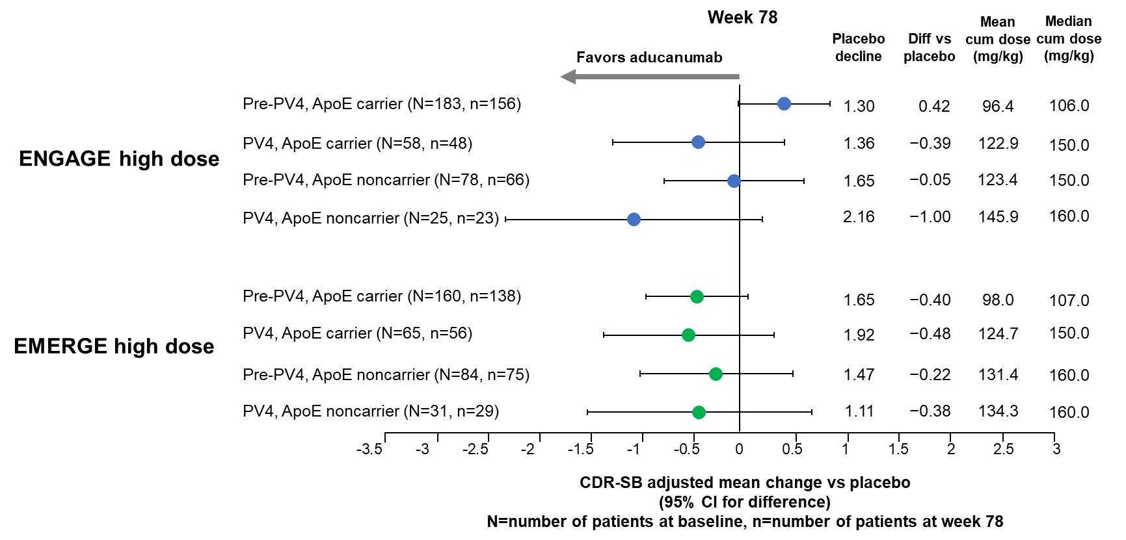

ITT population that have had the opportunity to complete Week 78 by March 20, 2019.
ApoE, apolipoprotein E; CDR-SB, Clinical Dementia Rating Scale–Sum of Boxes; cum, cumulative; diff, difference; PV4, protocol version 4.
Table S1. Summary of treatment effects on clinical endpoints at week 78 in EMERGE and ENGAGE
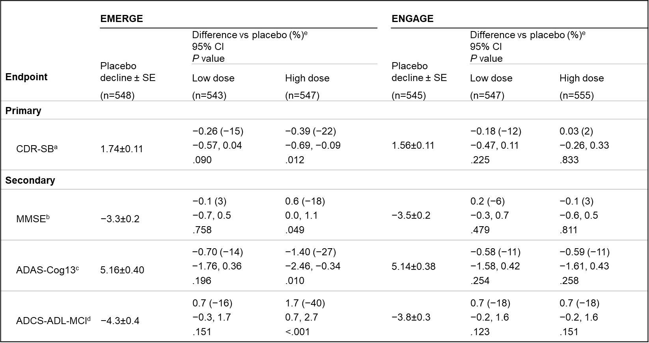
EMERGE and ENGAGE results from Budd Haeberlein S, et al. 2022. The analyses were performed in the ITT population. MMRM was used to assess CDR-SB, MMSE, ADAS-Cog13, and ADCS-ADL-MCI scores, with fixed effects of treatment, categorical visit, treatment-by-visit interaction, baseline score, baseline score–by-visit interaction, baseline MMSE score (same as baseline score in the MMSE model), Alzheimer disease symptomatic medication use at baseline, region, and ApoE ε4 status (carrier and noncarrier).
ADAS-Cog13, Alzheimer’s Disease Assessment Scale–Cognitive Subscale, 13 item; ADCS-ADL-MCI, Alzheimer’s Disease Cooperative Study–Activities of Daily Living Inventory, mild cognitive impairment version; ApoE, apolipoprotein E; CDR-SB, Clinical Dementia Rating Scale–Sum of Boxes; ITT, intention to treat; MMRM, mixed model for repeated measures; MMSE, Mini-Mental State Examination.
ª CDR-SB scores range from 0 to 18, with higher scores indicating greater impairment.
^{b} MMSE scores range from 0 to 30, with lower scores indicating greater impairment.
^{c} ADAS-Cog13 scores range from 0 to 85, with higher scores indicating greater impairment.
^{d} ADCS-ADL-MCI scores range from 0 to 53, with lower scores indicating greater impairment.
^{e} Difference vs placebo at week 78. Negative percentage means less progression in the treated arm.

Table S2. Radiographic severity and symptomatic status of ARIA
Number of participants (%) | EMERGE |  |  | ENGAGE
 | Placebo (n=544) | Low dose (n=537) | High dose (n=541) | Placebo (n=532) | Low dose (n=545) | High dose (n=554)
Any ARIA | 56 (10.3) | 178 (33.1) | 228 (42.1) | - 55 (10.3) | - 171 (31.4) | - 226 (40.8)
ARIA-E | 13 | 140 | 188 | 16 | 141 | 199
Mild | 9 (69.2) | 48 (34.3) | 56 (29.8) | 12 (75.0) | 45 (31.9) | 59 (29.6)
Moderate | 4 (30.8) | 80 (57.1) | 114 (60.6) | 4 (25.0) | 82 (58.2) | 109 (54.8)
Severe | 0 | 12 (8.6) | 18 (9.6) | 0 | 14 (9.9) | 31 (15.6)
Asymptomatic | 12 (92.3) | 105 (75.0) | 146 (77.7) | 14 (87.5) | 115 (81.6) | 140 (70.4)
Symptomatic | 1 (7.7) | 35 (25.0) | 42 (22.3) | 2 (12.5) | 26 (18.4) | 59 (29.6)
ARIA-H microhemorrhage | 37 | 87 | 108 | 34 | 89 | 104
Mild | 34 (91.9) | 65 (74.7) | 80 (74.1) | 31 (91.2) | 69 (77.5) | 74 (71.2)
Moderate | 3 (8.1) | 9 (10.3) | 12 (11.1) | 2 (5.9) | 4 (4.5) | 17 (16.3)
Severe | 0 | 13 (14.9) | 16 (14.8) | 1 (2.9) | 16 (18.0) | 13 (12.5)
Asymptomatic | 36 (97.3) | 76 (87.4) | 97 (89.8) | 32 (94.1) | 87 (97.8) | 86 (82.7)
Symptomatic | 1 (2.7) | 11 (12.6) | 11 (10.2) | 2 (5.9) | 2 (2.2) | 18 (17.3)
ARIA-H superficial siderosis | 14 | 52 | 73 | 10 | 51 | 89
Mild | 14 (100) | 30 (57.7) | 38 (52.1) | 8 (80.0) | 28 (54.9) | 41 (46.1)
Moderate | 0 | 12 (23.1) | 21 (28.8) | 0 | 16 (31.4) | 26 (29.2)
Severe | 0 | 10 (19.2) | 14 (19.2) | 2 (20.0) | 7 (13.7) | 22 (24.7)
Asymptomatic | 14 (100) | 46 (88.5) | 64 (87.7) | 10 (100) | 44 (86.3) | 72 (80.9)
Symptomatic | 0 | 6 (11.5) | 9 (12.3) | 0 | 7 (13.7) | 17 (19.1)
Symptoms during an ARIA event | 2 | 38 | 45 | 3 | 28 | 65
Mild | 1 (50.0) | 20 (52.6) | 26 (57.8) | 2 (3.6) | 20 (11.7) | 46 (20.4)
Moderate | 0 | 13 (34.2) | 12 (26.7) | 1 (1.8) | 5 (2.9) | 17 (7.5)
Severe | 1 (50.0) | 3 (7.9) | 3 (6.7) | 0 | 2 (1.2) | 2 (0.9)
Serious ARIA | 1 (0.2) | 5 (0.9) | 8 (1.5) | 1 (0.2) | 2 (0.4) | 8 (1.4)
ARIA, amyloid-related imaging abnormalities.

Table S3. Change from baseline in CDR-SB at week 78: with and without post-ARIA observations
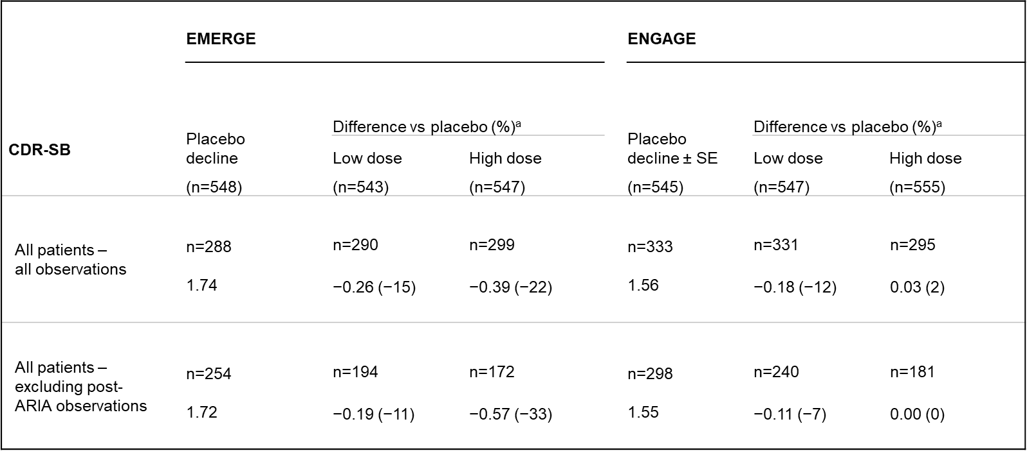

The analyses were performed in the ITT population. A mixed model for repeated measures was used to assess CDR-SB scores, with fixed effects of treatment, categorical visit, treatment-by-visit interaction, baseline score, baseline score–by-visit interaction, baseline MMSE score (same as baseline score in the MMSE model), Alzheimer disease symptomatic medication use at baseline, region, and ApoE ε4 status (carrier and noncarrier).
ApoE, apolipoprotein E; ARIA, amyloid-related imaging abnormalities; CDR-SB, Clinical Dementia Rating Scale–Sum of Boxes; ITT, intent to treat; MMSE, Mini-Mental State Examination.
ª Difference vs placebo at week 78. Negative percentage means less progression in the treated arm.

Table S4. Summary of patients with CDR-SB change from baseline at week 78 > 8
CDR-SB change at Week 78 > 8,  no of patients (%) | EMERGE (ITT) |  |  |  |  | ENGAGE (ITT)
 | Placebo  (n=548) | Low dose  (n=543) | High dose  (n=547) | Total  (n=1638) |  | Placebo  (n=545) | Low dose  (n=547) | High dose  (n=555) | Total  (n=1647)
Total population | 4 (1.4) | 4 (1.4) | 5 (1.7) | 13 (1.5) |  | 4 (1.2) | 5 (1.5) | 9 (1.3) | 18 (1.9)
PV4 | 2 (2.5) | 1 (1.2) | 1 (1.2) | 4 (1.6) |  | 2 (2.9) | 1 (1.2) | 0 (0) | 3 (1.3)
Pre-PV4 | 2 (1.0) | 3 (1.4) | 4 (1.9) | 9 (1.4) |  | 2 (0.8) | 4 (1.6) | 9 (4.1) | 15 (2.0)

PV4 = patients with opportunity to receive all 14 doses of 10 mg/kg; pre-PV4 = patients without opportunity to receive all 14 doses of 10 mg/kg.
CDR-SB, Clinical Dementia Rating Scale–Sum of Boxes; ITT, intent to treat.

