Additional file 3: Effects of lifestyle interventions on executive function and verbal fluency
Supplementary Figure 1: Effects of lifestyle interventions on executive function, stratified by gender

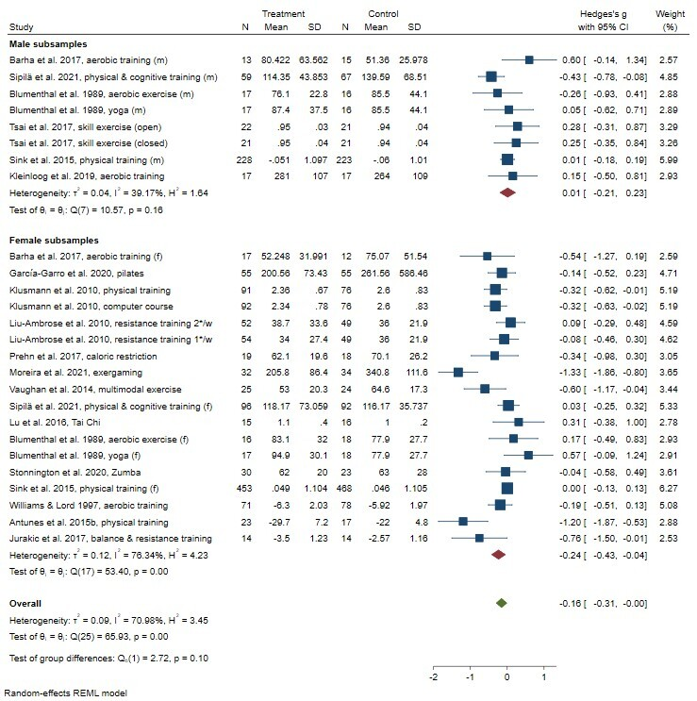

Supplementary Table 1: Random effects meta-regression for executive function
 | Coeff. | SE | 95% CI
Female sex | .01 | .15 | -.28; .30
MCI at baseline (ref.: cognitively unimpaired) | .27 | .34 | -.41; .94
Type of intervention (ref.: physical activity intervention)
Nutritional intervention | -.82 | .50 | -1.80; .16
Physical + cognitive intervention | -.97 | .31 | -1.59; -.36
Cognitive intervention | -.10 | .28 | -.65; .46
Assessment instrument (ref.: TMT-B)
Stroop test (auditory) | .49 | .40 | -.29; 1.28
Task switching paradigm | .14 | .30 | -.45; .73
Composite score | -1.12 | .48 | -2.06; -.19
Multitasking test | .33 | .41 | -.48; 1.13
Cattel’s matrices tests | -.14 | .26 | -.65; .36
WCST | -1.43 | .42 | -2.26; -.61
MoCA subscore executive | -.69 | .51 | -1.70; .32
Number of sessions | .01 | .01 | -.01; .01
Intervention duration (weeks) | .00 | .01 | -.01; .01
Mean age of participants (years) | -.05 | .03 | -.12; .02
CI: confidence interval; Coeff.: coefficient; MCI: mild cognitive impairment; MoCA: Montreal Cognitive Assessment; SE: standard error; TMT-B: Trail Making Test B; WCST: Wisconsin Card Sorting Test

Supplementary Figure 2: Effects of lifestyle interventions on verbal fluency, stratified by gender
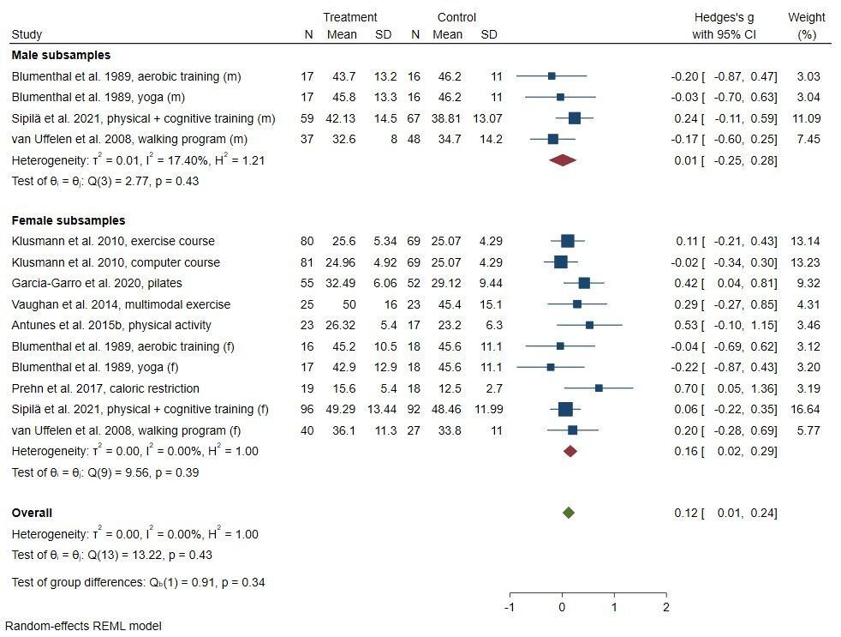
Supplementary Table 2: Random effects meta-regression for verbal fluency
 | Coeff. | SE | 95% CI
Female sex | .03 | .21 | -.39; .45
MCI at baseline (ref.: cognitively unimpaired) | -1.82 | 2.30 | -6.33; 2.70
Type of intervention (ref.: physical activity intervention)
Nutritional intervention | .76 | 1.52 | -2.22; 3.73
Physical + cognitive intervention | -1.80 | 2.22 | -6.15; 2.55
Cognitive intervention | -.13 | .33 | -.79; .52
Assessment instrument (ref.: CERAD verbal fluency test)
Isaacs test | -.01 | 1.67 | -3.37; 3.19
COWAT | -.25 | 1.50 | -3.18; 2.68
Phonemic verbal fluency test¹ | -.97 | 1.68 | -4.26; 2.33
Phonemic verbal fluency test² | -.89 | 3.38 | -7.51; 5.74
Number of sessions | .00 | .02 | -.05; .05
Intervention duration (weeks) | .06 | .10 | -.14; .27
Mean age of participants (years) | -.05 | .05 | -.14; .05
CI: confidence interval; Coeff.: coefficient; COWAT: Controlled Oral Word Association Test; MCI: mild cognitive impairment; SE: standard error; ¹: verbal fluency test using one trial with a single letter (as applied in Antunes 2015b, Blumenthal et al. 1988); ²: verbal fluency test, using three trials with one letter each (as applied in Sipilä et al. 2021, van Uffelen et al. 2008)

