Supplemental Figure 1: Screening sequence for CREAD, CREAD2, and Tauriel studies. Different episodic memory tests were used for screening in CREAD/CREAD2 (FCSRT) versus Tauriel (RBANS).
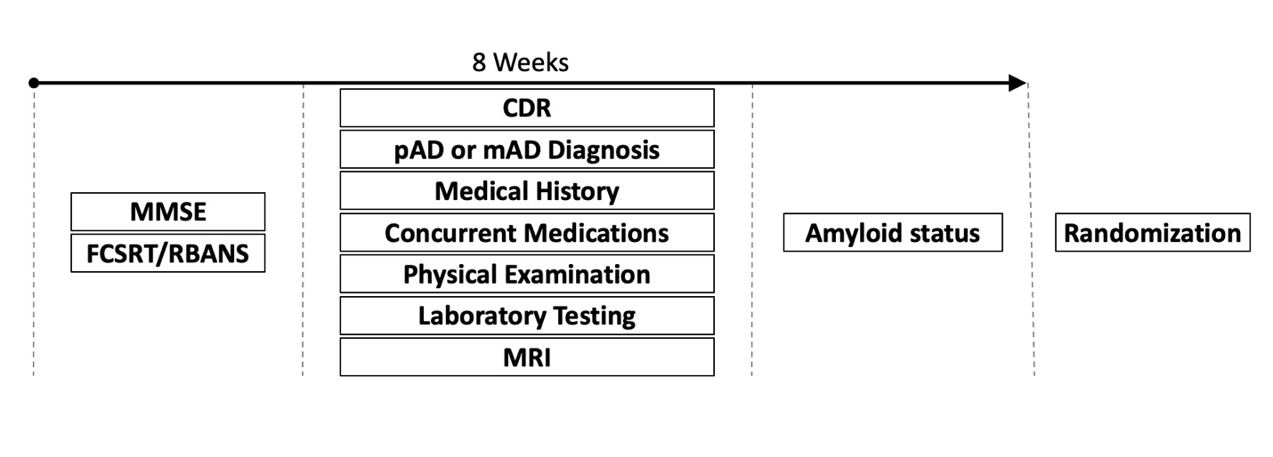

Supplemental Figure 2: Schedule for longitudinal clinical outcome assessments in CREAD, CREAD2, and Tauriel.
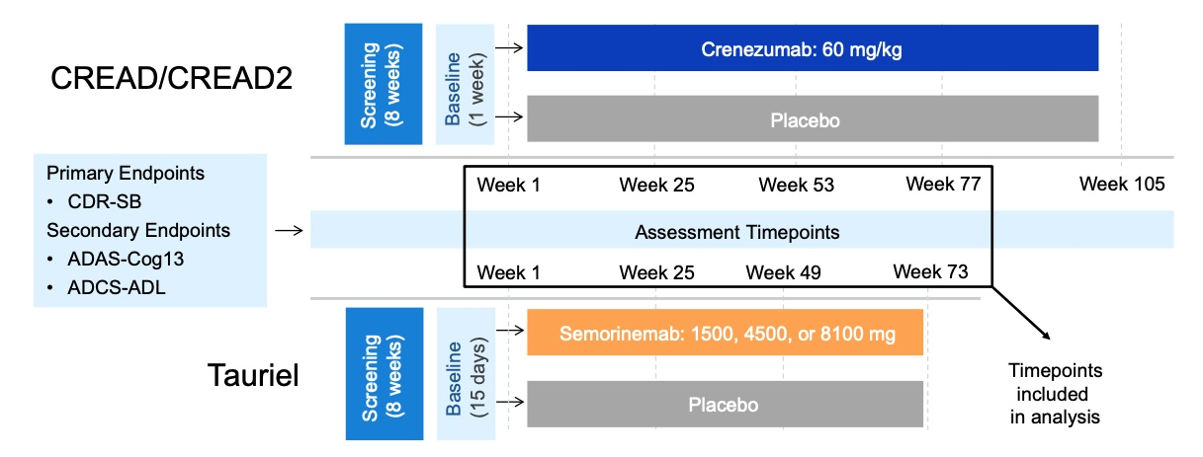

Supplemental Figure 3: Mixed models for repeated measures (MMRM) least squares estimates of mean change from baseline on the CDR-SB, ADAS-Cog13, and ADCS-ADL from pooled arms of the CREAD and CREAD2 (which used cutoffs from the FCSRT for their episodic memory inclusion criteria) and Tauriel (which used a cutoff on the RBANS DMI for its episodic memory inclusion criteria) studies. Tauriel data are illustrated for the overall cohort (i.e., RBANS DMI ≤ 85) as well as a more stringent cutoff (i.e., RBANS DMI ≤ 64, 2.4 SD below normative mean) which may be more analogous to FCSRT cutoffs used in CREAD and CREAD2. The tables below each graph indicate the number of participants assessed and standard deviation (in parentheses) at each time point.

