Supplemental Material
Supplemental Appendix A: target and anchor measures
The target outcome measures for this analysis included the Clinical Dementia Rating Scale – Sum of Boxes (CDR-SB), the Alzheimer’s Disease Assessment Scale – Cognitive Subscale (ADAS-Cog), and the Mini-Mental State Examination (MMSE). The anchor measures for this analysis included the Global Deterioration Scale (GDS) and the Mild Cognitive Impairment–Clinical Global Impression of Change (MCI-CGIC). Table S-1 describes these measures in detail.
In brief, the CDR is a widely used instrument that assesses cognitive and functional abilities based on a semistructured interview with the patient and an informant or care partner to stage dementia severity (1,2). A clinician rates the patient in six cognitive and functional domains based on a semistructured interview of the patient and a reliable informant (e.g., a family member) (3). The CDR yields both a global score (0–3) and a CDR-SB score (0–18) representing the sum score of the six domain ratings. The global CDR score is a 5-point numeric rating scale, while the CDR-SB score can be used to stage patients with Alzheimer’s disease (AD) and to monitor progression within and between stages of dementia based on global CDR score. Higher scores indicate greater severity/impairment. CDR-SB scores have demonstrated, with reasonable accuracy, an ability to discriminate between patients with very early AD and those with MCI (4).
The ADAS-Cog is a performance-based assessment of cognitive function, widely used in AD clinical trials (5,6). The 11-item ADAS-Cog (ADAS-Cog 11), the original version of the ADAS-Cog, includes 11 patient-completed tasks, administered by a trained psychometrist. The ADAS-Cog total score ranges from 0–70; higher scores indicate more performance errors and greater dysfunction, and scores of at least 18 indicate cognitive impairment (5,7,8). The 13-item ADAS-Cog (ADAS-Cog 13) includes, with the original 11 tasks, a number cancellation task and a delayed free-recall task; the ADAS-Cog 13 total score for this modification ranges from 0–85 (9). The current analyses included both the ADAS-Cog 11 and ADAS-Cog 13.
The MMSE is an extensively used 30-point clinician-rated screening instrument for distinguishing cognitively impaired people from cognitively unimpaired aging people and for monitoring cognitive changes in an individual over time (10). The MMSE total score ranges from 0–30. Although a score of ≤ 23 has been recommended as an indicator of cognitive impairment (11), other suggested cut-offs adjusted for age, education, race, and literacy have been identified (12).
The GDS is a clinician-reported global impression of current cognitive functioning in patients with primary degenerative dementia, including AD (13). Results are reported as a single score ranging from 1 (no cognitive decline) to 7 (very severe cognitive decline [severe dementia]).
The clinician-reported MCI-CGIC is a version of the commonly used Alzheimer’s Disease Cooperative Study-CGIC (14), modified for an MCI population. The MCI-CGIC yields a 7-point single score, determined by a clinician who considers the patient’s overall change in domains related to cognitive, behavioral, and functional activity since the beginning of a study without reference to other information, such as cognitive test results (15).

Table S-1. Target and anchor clinical outcomes assessment measures
Outcome measure, domains, and rating system | Response scale/scoring
Target measures
CDR  - Memory  - Orientation  - Judgment & Problem Solving  - Community Affairs  - Home & Hobbies  - Personal Care  Clinician rated, based on a semistructured interview with the patient and a reliable informant (e.g., family member) | 5-point numeric rating scale:  - 0 = Normal  - 0.5 = Very mild dementia*  - 1 = Mild  - 2 = Moderate  - 3 = Severe dementia  CDR global score is based on the highest ranking and reported on a 0–3 scale (Morris, 1993)  CDR-SB is the sum score of the six domain ratings and ranges from 0–18; higher scores indicate greater severity/impairment
ADAS-Cog  11-item and 13-item versions:  - Memory  - Language  - Praxis  - Orientation  The original ADAS-Cog included 11 tasks in these domains [1,14]; an expanded 13-item version included a number cancellation task and a delayed free-recall task [1]  Psychometrist administered and clinician rated | 11-item version:  - Total score ranging from 0–70  - Scores of ≥ 18 indicate cognitive impairment  13-item version:  - Total score ranging from 0–85  Higher scores indicate more performance errors and greater dysfunction†
MMSE  - Orientation  - Memory  - Attention  - Language  - Praxis  Psychometrist administered and clinician rated | - Total score ranges from 0–30  - Score of ≤ 23 is a general indicator of cognitive impairment  Higher scores indicate better cognitive functioning
Anchor measures
GDS  Clinician’s global impression of the current status of cognitive function of patients with primary degenerative dementia, including AD  Clinician rated | Single 7-point score:  1 = No cognitive decline  2 = Very mild cognitive decline (age-associated memory impairment)  3 = Mild cognitive decline (mild cognitive impairment)  4 = Moderate cognitive decline (mild dementia)  5 = Moderately severe cognitive decline (moderate dementia)  6 = Severe cognitive decline (moderately severe dementia)  7 = Very severe cognitive decline (severe dementia)
MCI-CGIC  ADCS-CGIC, modified for an MCI population  Clinician’s global impression of a patient’s overall change in domains related to cognitive, behavioral, and functional activity since the beginning of a study, without reference to other information, such as cognitive test results to determine the single score  Clinician rated based on a semistructured interview with care partners (s) and an examination of the patient | Single 7-point score:  1 = Marked improvement  2 = Moderate improvement  3 = Minimal improvement  4 = No change  5 = Minimal worsening  6 = Moderate worsening  7 = Marked worsening
AD, Alzheimer’s disease; ADAS-Cog = Alzheimer’s Disease Assessment Scale – Cognitive Subscale; ADCS-CGIC = Alzheimer’s Disease Cooperative Study–Clinical Global Impression of Change; CDR = Clinical Dementia Rating Scale; CDR-SB = Clinical Dementia Rating Scale – Sum of Boxes; GDS = Global Deterioration Scale; MCI-CGIC = Mild Cognitive Impairment–CGIC; MMSE = Mini-Mental State Examination.
* A rating of 0.5 was originally considered to indicate questionable dementia but has been reconceptualized as prodromal or very mild dementia.
† The current analyses included both the 11-item and 13-item versions of the ADAS-Cog and treated missing data due to cognitive and/or physical issues as the worst response score. Furthermore, if after application of this rule, any domain score was missing, the subsequent total score was set to missing.
Supplemental Appendix B: Distribution-based analyses
Methods
Supportive distribution-based meaningful-change thresholds were estimated using one-half standard deviation (half SD) at baseline, standard error of measurement (SEM), standard error of difference (S_{diff}), and reliable change (RC) approaches (16,17,18,19). Test-retest analysis was conducted to provide reliability estimates for the computation of the reliability-based thresholds (SEM and RC).
The one-half SD is a commonly used, distribution-based method to define minimally important differences in clinical outcome assessment research (20,21). The one-half SD at baseline, which corresponds to a moderate effect size, and the 0.2-SD at baseline, which corresponds to a small effect size, were used to provide supportive threshold estimates characterizing improvement on an endpoint.
The SEM, as recommended by Wyrwich et al., (1999), was also computed using the following formula:
,
where the SD was the SD of an endpoint score at baseline and r was a test-retest reliability estimate. Because it includes reliability (r), this distribution-based estimate explicitly considers measurement precision and presents average random error unexplained by the measured construct. In classical test theory, the SEM has the theoretical distinction of being relatively consistent across the range of a measure and hence is relatively stable across samples (22,23).
In addition, standard error of difference ($S_{diff}$) between two assessments (24) was computed as follows:
$S_{diff}=\sqrt{{{SEM}^{2}+SEM}^{2}}$ $=$ SEM$\sqrt{2}$.
The two assessment time points were selected based on review of the descriptive statistics (baseline with Month 6, 12, or 36).
The RC was also calculated to obtain a more conservative estimate, as recommended by Hays et al., (2005):
RCI = 1.96 SEM$\sqrt{2}$
A change above one SEM has an approximately 48% chance of being within the measurement error of difference between two assessments distributing as Normal (0, $S_{diff}$); a change above one $S_{diff}$ reduces this chance to 32%, and a change above one RC index (RCI) further reduces it to 5%.
Results
The distribution-based threshold estimates are provided in Table S-3 for the CDR-SB, in Table S-4 for the ADAS-Cog 11 and ADAS-Cog 13, and in Table S-5 for the MMSE. For the CDR-SB within-patient changes, the thresholds based on half SD at baseline provided the smallest values and the RCI values were the largest (Table S-2). For the ADAS-Cog measures, estimates ranged from 2.19–7.12 for the ADAS-Cog 11 and from 2.98–8.25 for the ADAS-Cog 13. For the ADAS-Cog evaluations, the values based on the half-SD and SEM methods, the most commonly applied distribution-based methods were similar, while the RCI estimates were considerably higher (Table S-4). For the MMSE, distribution-based estimates ranged from 0.92–3.70 (Table S-5).
Table S-2. Interpretation of change: Distribution-based results
Baseline measure | Overall
CDR-SB
Half-SD | 0.39
SEM | 0.45
S_{diff} | 0.63
RCI | 1.24
ADAS-Cog 11
Half-SD | 2.19
SEM | 2.57
S_{diff} | 3.63
RCI | 7.12
ADAS-Cog 13
Half-SD | 3.04
SEM | 2.98
S_{diff} | 4.21
RCI | 8.25
MMSE
Half-SD | 0.92
SEM | 1.33
S_{diff} | 1.89
RCI | 3.70
ADAS-Cog = Alzheimer’s Disease Assessment Scale – Cognitive Subscale; CDR-SB = Clinical Dementia Rating Scale – Sum of Boxes; MMSE = Mini-Mental State Examination; RCI = reliable change index; SD = standard deviation; S_{diff} = standard error of difference; SEM = standard error of measurement.

Supplemental Appendix C: Cumulative distribution function and probability density function plots
Empirical cumulative distribution functions (CDFs) and probability density functions (PDFs) represent different visualizations of the distribution of patients (i.e., empirical percentages and smoothed densities), achieving a given change from baseline in an endpoint at every change level of an anchor measure. Empirical CDF plots optimally aid in evaluating the risk of misclassification of a chosen threshold, while PDF plots provide intuitive evidence for a viable anchor measure. PDF plots portray smoothed distributions of the target outcome’s score change by levels of changes in an anchor measure; graphically, the outcome’s change score is represented on the horizontal axis and the estimated kernel density of each change score is represented on the vertical axis. For both plots, less overlap in the curves is preferred and indicates greater difference between the score distributions of different anchor levels, hence greater ability of a chosen threshold to differentiate responders and nonresponders.
Figures S-1A and 1B present CDF curves for the changes in target measures from baseline to Month 12 by MCI-CGIC levels. The progression of score changes in ADAS-Cog 11 and ADAS-Cog 13 by MCI-CGIC levels are as expected (Figures S-1A and 1B), showing that approximately 40% of the participants in the moderate-worsening group had a more than 4-point increment on the ADAS-Cog 11 and a more than 5-point increment on the ADAS-Cog 13, in contrast to less than 20% in each of the less or no worsening groups for both end points. Figures S-1C–S-1G provide the CDF curves for changes on the target measures from baseline to Month 12 or Month 36 by levels of change on the GDS. The proposed thresholds for the GDS and the ADAS-Cog still showed clear between-group differences. For the MMSE change from baseline to Month 36 by levels of change on the GDS, approximately 50% of the participants with 2-point worsening on the GDS had a reduction of at least 6-points compared with approximately 20% or less in each of the less or no worsening groups.
The PDF plots shown in Figures S-2 and S-3 provide complementary information to the CDF. Overall, both plots provide visual confirmation of the appropriateness of the anchor measures and a visual representation of the threshold estimates presented in Table 5 of the main article.

References
- Hughes CP, Berg L, Danziger WL, Coben, LA, Martin, RL. A new clinical scale for the staging of dementia. Br J Psychiatry. 1982;140:566-572.
- Williams MM, Storandt M, Roe CM, Morris JC. Progression of Alzheimer’s disease as measured by Clinical Dementia Rating Sum of Boxes scores. Alzheimers Dement. 2013 Feb;9(1 Suppl):S39-44.
- Morris JC. Clinical dementia rating. Neurology. 1993;43:2412-2414.
- O’Bryant SE, Waring SC, Cullum CM, et al. Staging dementia using Clinical Dementia Rating Scale Sum of Boxes scores: a Texas Alzheimer’s research consortium study. Arch Neurol. 2008;65:1091-1095.
- Rosen WG, Mohs RC, Davis KL. A new rating scale for Alzheimer’s disease. Am J Psychiatry. 1984 Nov;141(11):1356-1364.
- Wesnes KA. Assessing change in cognitive function in dementia: the relative utilities of the Alzheimer’s Disease Assessment Scale-Cognitive Subscale and the Cognitive Drug Research system. Neurodegener Dis. 2008;5(3-4):261-263.
- Verma N, Beretvas SN, Pascual B, Masdeu JC, Markey MK. New scoring methodology improves the sensitivity of the Alzheimer’s Disease Assessment Scale-Cognitive subscale (ADAS-Cog) in clinical trials. Alzheimers Res Ther. 2015;7:1-17.
- Rockwood K, Fay S, Gorman M, Carver D, Graham JE. The clinical meaningfulness of ADAS-Cog changes in Alzheimer’s disease patients treated with donepezil in an open-label trial. BMC Neurol. 2007;7:26. doi:10.1186/1471-2377-7-26
- Mohs RC, Knopman D, Petersen RC, et al. Development of cognitive instruments for use in clinical trials of antidementia drugs: additions to the Alzheimer’s Disease Assessment Scale that broaden its scope. The Alzheimer’s Disease Cooperative Study. Alzheimer Dis Assoc Disord. 1997;11(Suppl 2):S13-21.
- Folstein M, Folstein SE, McHugh PR. “Mini-Mental State” a practical method for grading the cognitive state of patients for the clinician. J Psychiatr Res. 1975;12(3):189-198.
- Tombaugh TN, McIntyre NJ. The mini-mental state examination: a comprehensive review. J Am Geriatr Soc. 1992;40(9):922-935.
- Mitchell AJ. A meta-analysis of the accuracy of the Mini-Mental State Examination in the detection of dementia and mild cognitive impairment. J Psychiatr Res. 2009 Jan;43(4):411-431.
- Reisberg B, Ferris SH, Franssen EH, et al. Mortality and temporal course of probable Alzheimer’s disease: a 5-year prospective study. Int Psychogeriatr. 1996 Summer;8(2):291-311.
- Alzheimer Disease Research Center at the University of Southern California. CGIC or ADCS-CGIC: one of the most common global change form used in Alzheimer’s disease trials. 2018. http://adrc.usc.edu/cgic/ (accessed June 21, 2022).
- Schneider LS, Raman R, Schmitt FA, et al. Characteristics and performance of a modified version of the ADCS-CGIC CIBIC+ for mild cognitive impairment clinical trials. Alzheimer Dis Assoc Disord. 2009 Jul-Sep;23(3):260-267.
- Copay AG, Subach BR, Glassman SD, Polly DW Jr, Schuler TC. Understanding the minimum clinically important difference: a review of concepts and methods. Spine J. 2007 Sep-Oct;7(5):541-6.
- Food and Drug Administration (FDA). Guidance for industry. Patient-reported outcome measures: use in medical product development to support labeling claims. December 2009. Available at: https://www.fda.gov/media/77832/download Accessed June 21, 2022
- Hays RD, Brodsky M, Johnston MF, Spritzer KL, Hui K. Evaluating the statistical significance of health-related quality of life change in individual patients. Eval Health Prof. 2005;28:160-71.
- Wyrwich KW, Norquist JM, Lenderking WR. Methods for interpreting change over time in patient-reported outcome measures. Qual Life Res. 2013 Apr;22(3):475-83.
- Norman GR, Sloan JA, Wyrwich KW. Interpretation of changes in health-related quality-of-life: the remarkable universality of half a standard deviation. Med Care. 2003;4:582-92.
- McLeod LD, Fehnel SE, Cappelleri JC. Patient-reported outcome measures: development and psychometric validation. In: Peace KE, Chen D-G, Menon S (editors). Biopharmaceutical Applied Statistics Symposium: Design of Clinical Trials, Volume 1, Chapter 13. Singapore: Springer Nature Singapore Pte Ltd. 2018:317-346.
- Wyrwich KW, Tierney WM, Wolinsky FD. Further evidence supporting an SEM-based criterion for identifying meaningful intra-individual changes in health-related quality of life. J Clin Epidemiol. 1999;52:861-73
- Crosby RD, Kolotkin RL, Williams GR. Defining clinically meaningful change in health-related quality of life. J Clin Epidemiol. 2003;56:395-407.
- Charter RA. Effect of measurement error on tests of statistical significance. J Clin Exp Neuropsychol. 1997;19:458-62.

Figure S-1. Cumulative distribution function plots of target measures by anchor measures
A. Change in ADAS-Cog 11* from baseline to Month 12, by MCI-CGIC
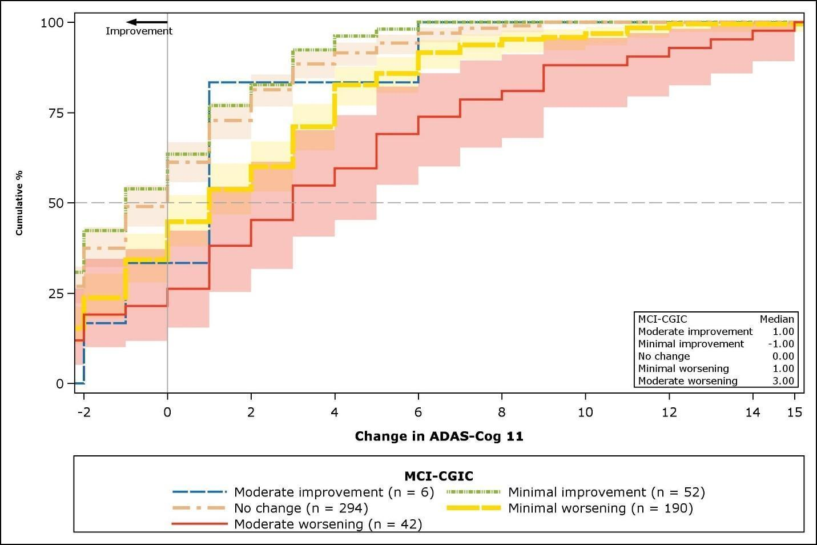

B. Change in ADAS-Cog 13* from baseline to Month 12, by MCI-CGIC
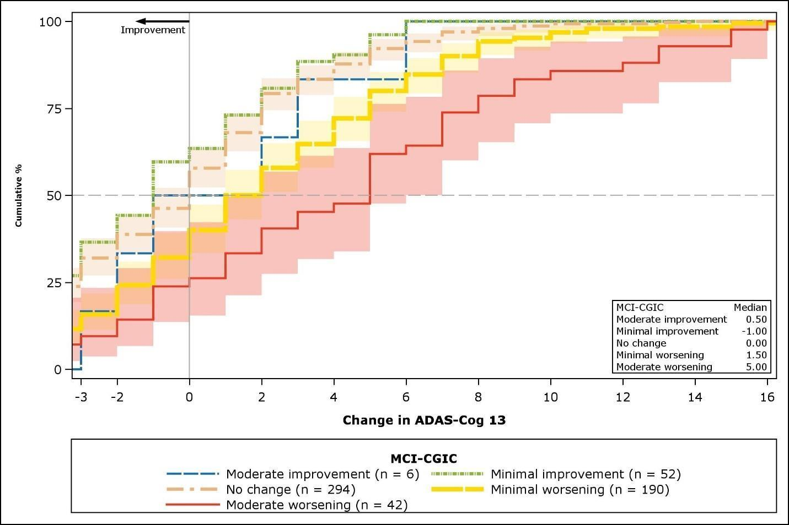

C. Change in CDR-SB† from baseline to Month 12, by change in GDS
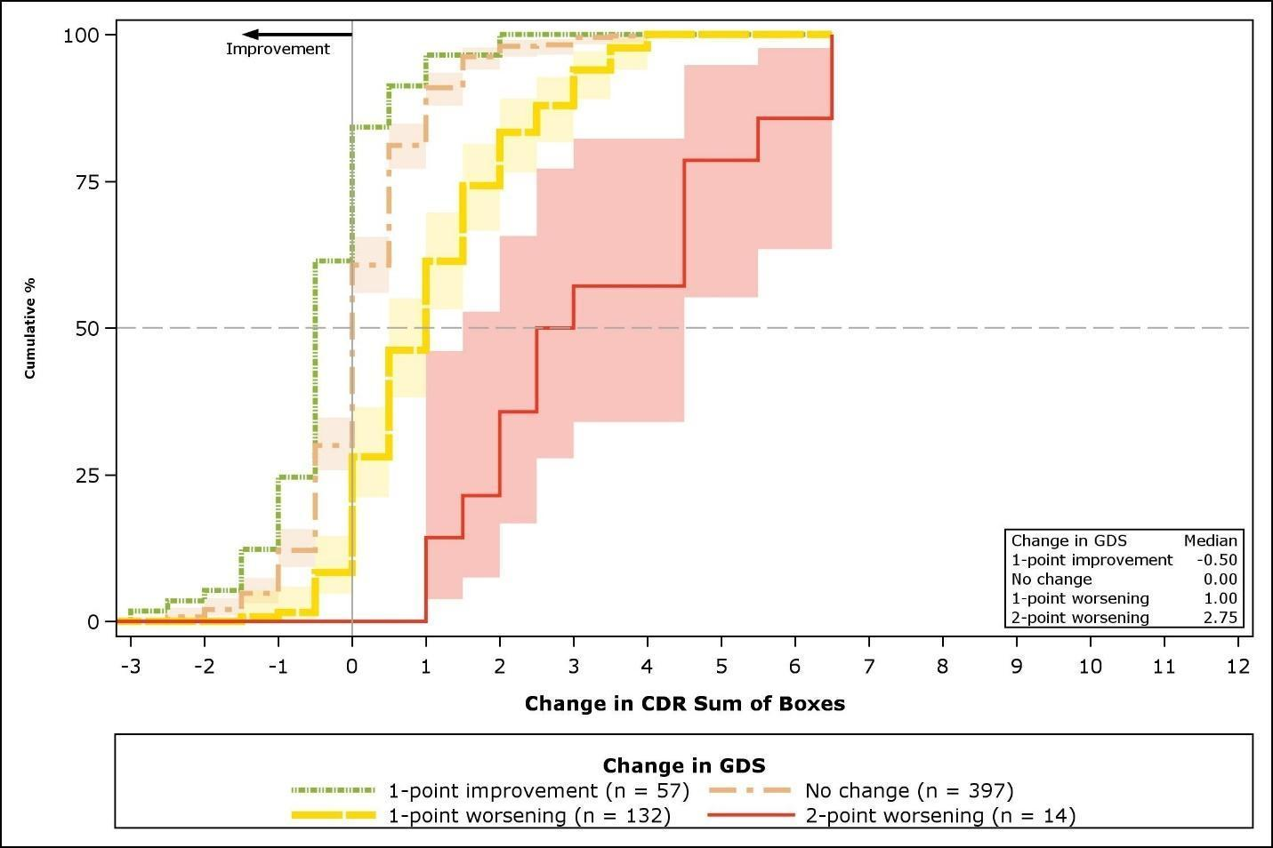

D. Change in CDR-SB from baseline to Month 36, by change in GDS
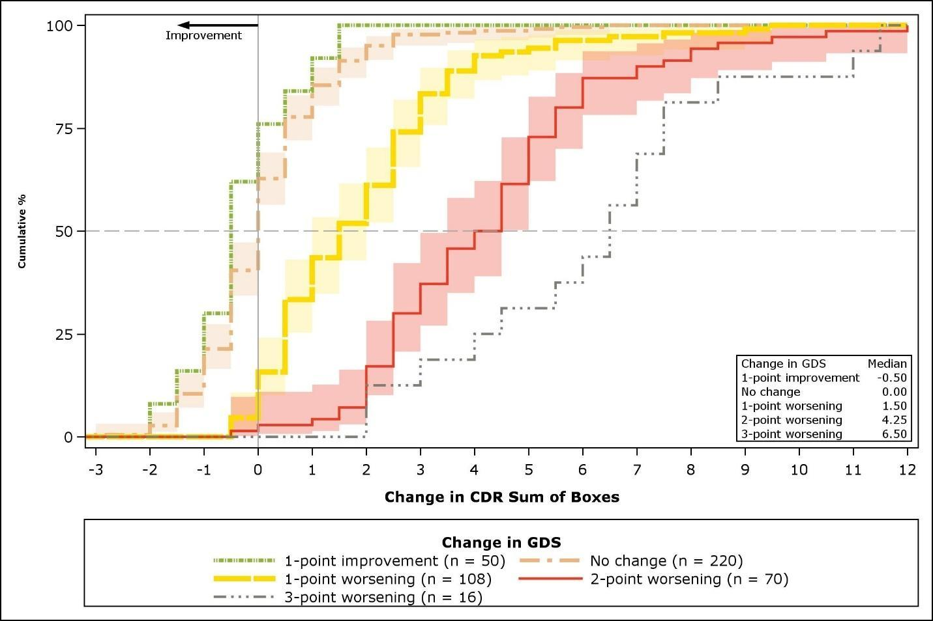
E. Change in ADAS-Cog 11† From baseline to Month 36, by change in GDS
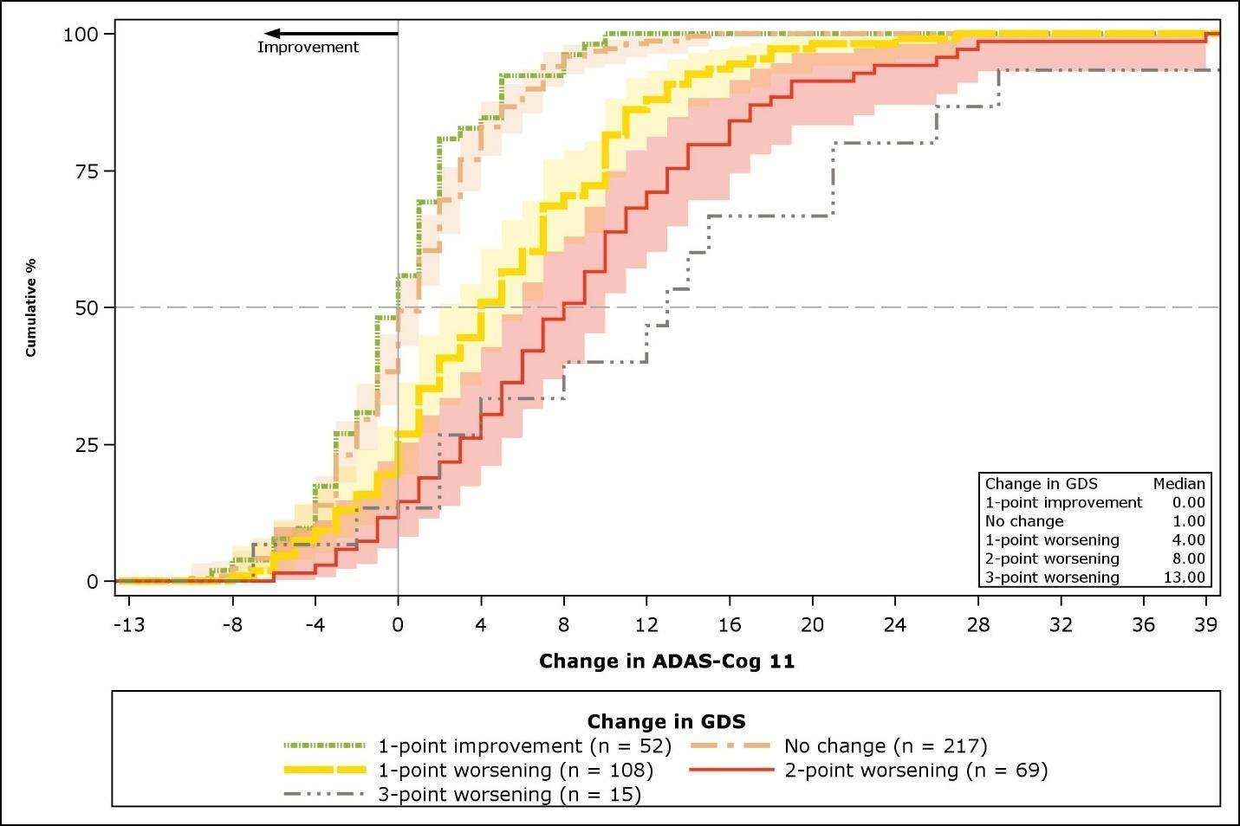

F. Change in ADAS-Cog 13† from baseline to Month 36, by change in GDS
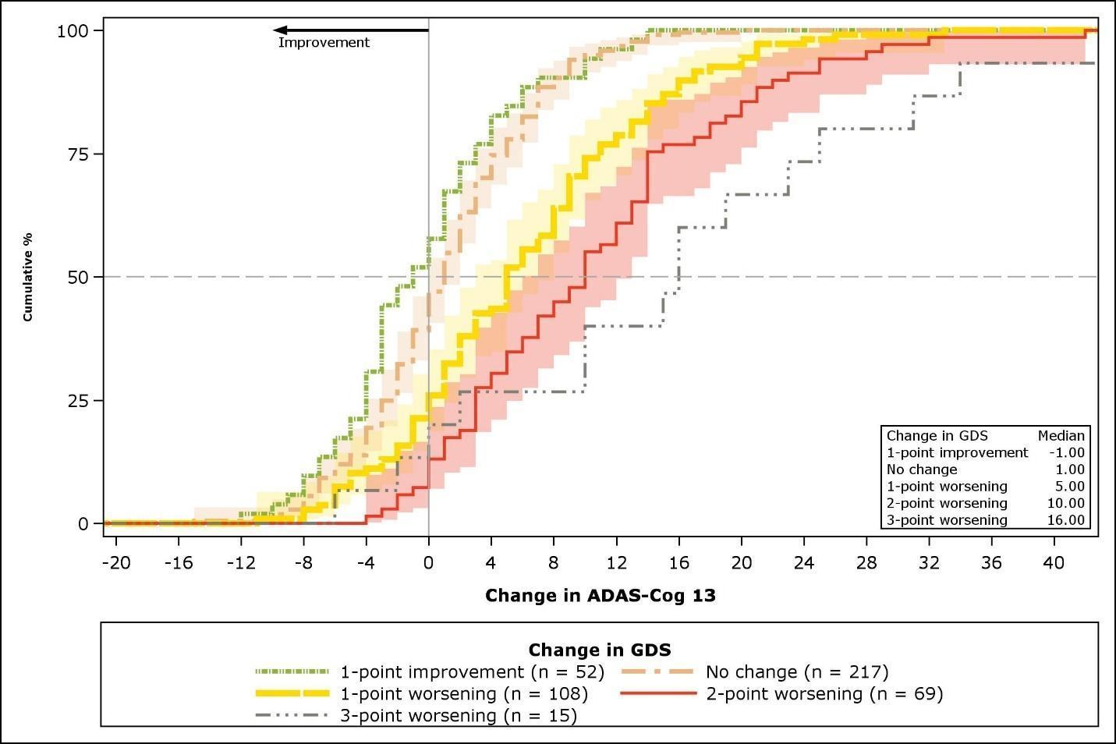

G. Change in MMSE† from baseline to Month 36, by change in GDS
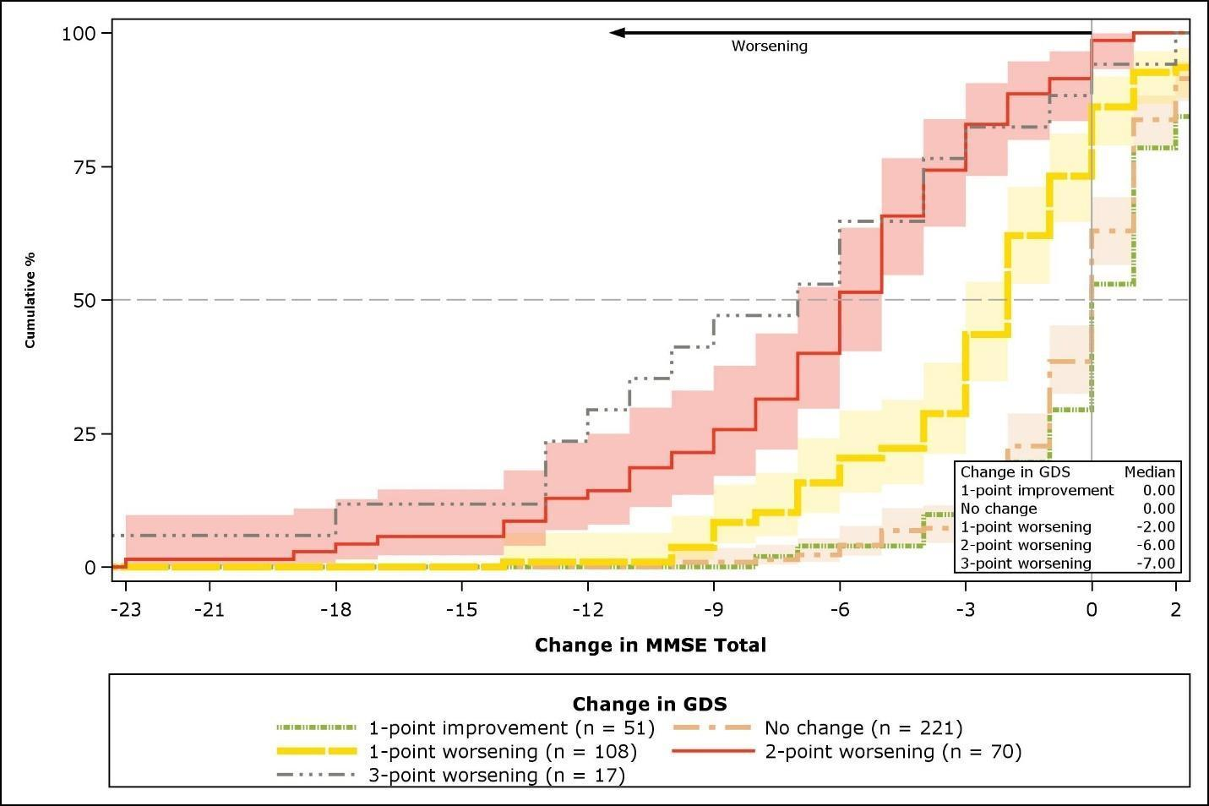
ADAS-Cog 11 = 11-item Alzheimer’s Disease Assessment Scale – Cognitive Subscale; ADAS-Cog 13 = 13-item ADAS-Cog; CDF = cumulative distribution function; CDR = Clinical Dementia Rating Scale; GDS = Global Deterioration Scale; MCI-CGIC = Mild Cognitive Impairment–Clinical Global Impression of Change; MMSE = Mini-Mental State Examination.
Note: Median values are plotted as the crossed points of the 50% horizontal dotted line and the CDF curves (stepped lines). The shading bands around CDF curves denote 95% confidence limits of the target measure change score in the “no change”, “minimal worsening”/”1-point worsening”, and “moderate worsening”/”2-point worsening” groups (if each n > 5).
* The plotting range of the x-axis is from the Month 12 minimum change of the “moderate improvement” group to the Month 12 maximum change of “moderate worsening” group for the corresponding target measure.
† The plotting range of the x-axis is from the Month 36 minimum change of the "2-point improvement" group to the Month 36 maximum change of "2-point worsening" group for the corresponding target measure.

Figure S-2. Probability density function plots of target outcome measures by MCI-CGIC
A. Change in CDR-SB from baseline to Month 12, by MCI-CGIC
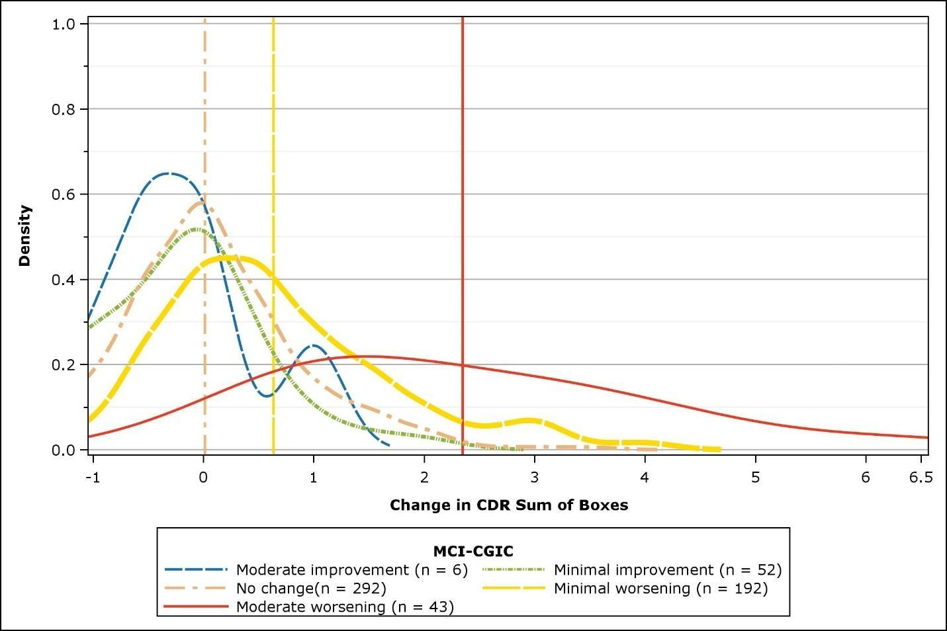
B. Change in ADAS-Cog 11 from baseline to Month 12, by MCI-CGIC
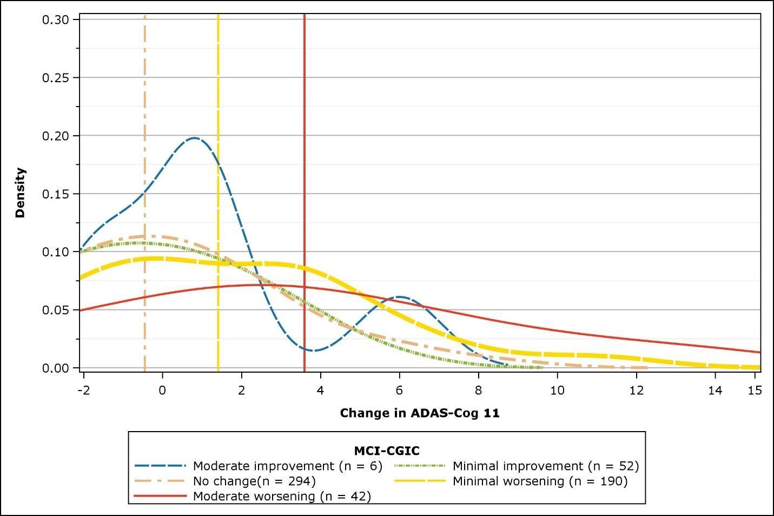
C. Change in ADAS-Cog 13 from baseline to Month 12, by MCI-CGIC
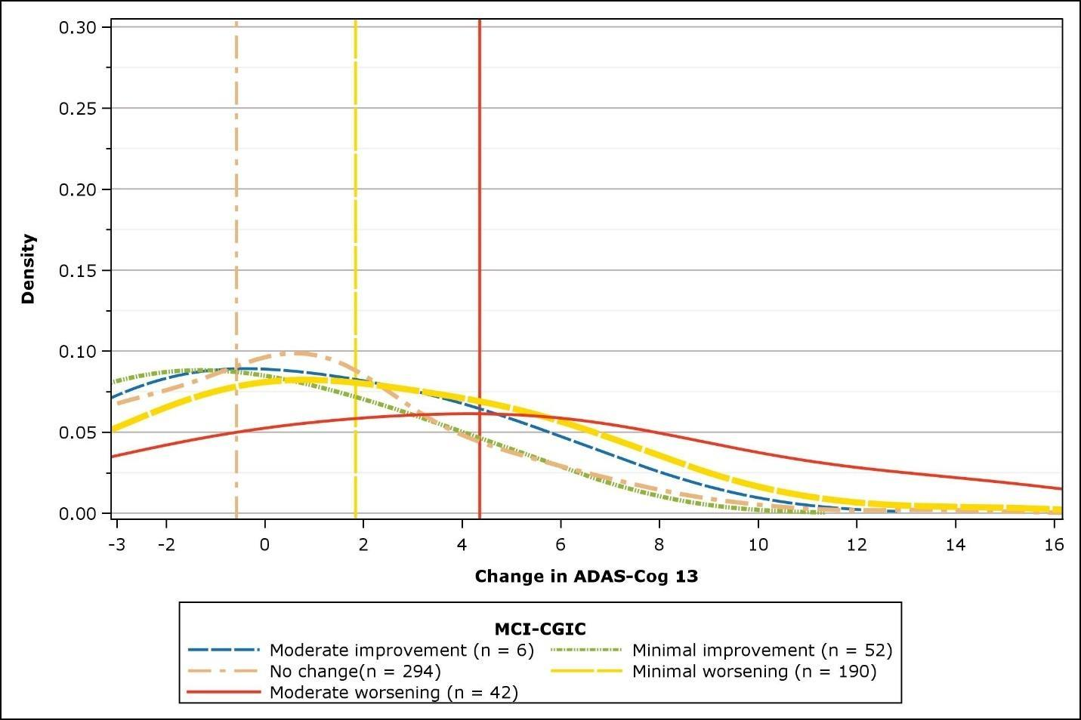 ADAS-Cog 11 = 11-item Alzheimer’s Disease Assessment Scale – Cognitive Subscale; ADAS-Cog 13 = 13-item ADAS-Cog; CDR = Clinical Dementia Rating Scale; MCI-CGIC = Mild Cognitive Impairment–Clinical Global Impression of Change.
Note: Vertical lines denote means of the target measure change score in the “no change”, “minimal worsening”, and “moderate worsening” groups (if each n > 5).
The plotting range of the x-axis is from the Month 12 minimum change of the "moderate improvement" group to the Month 12 maximum change of "moderate worsening" group for the corresponding target measure.

Figure S-3 Probability density function plots of target outcome measures by GDS
A. Change in CDR-SB from baseline to Month 12, by change in GDS
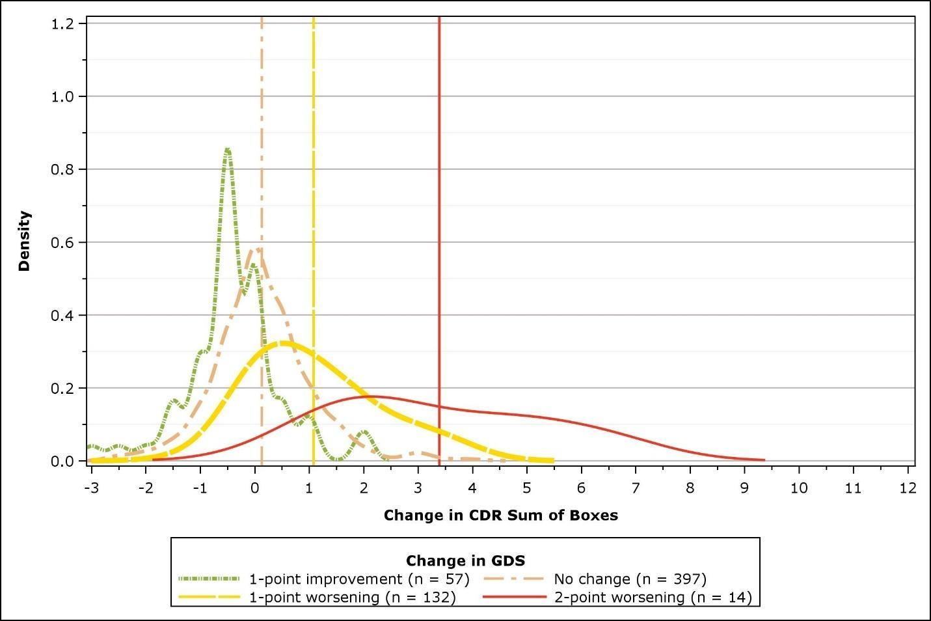

B. Change in CDR-SB from baseline to Month 36, by change in GDS
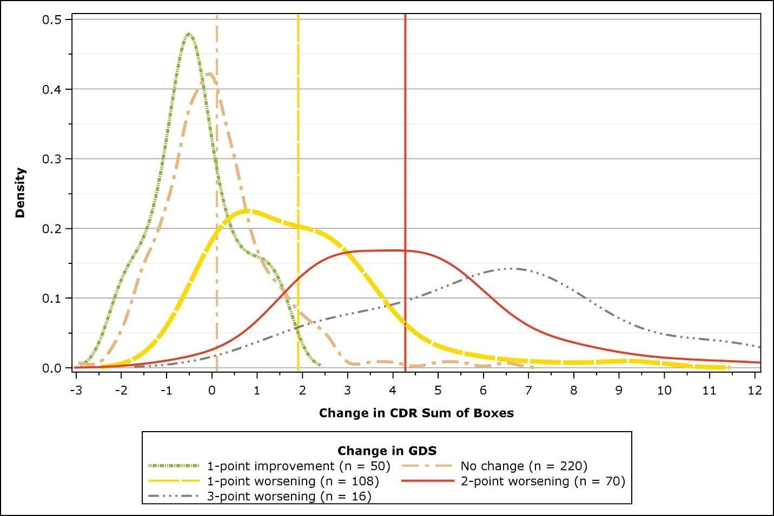
C. Change in ADAS-Cog 11 from baseline to Month 36, by change in GDS
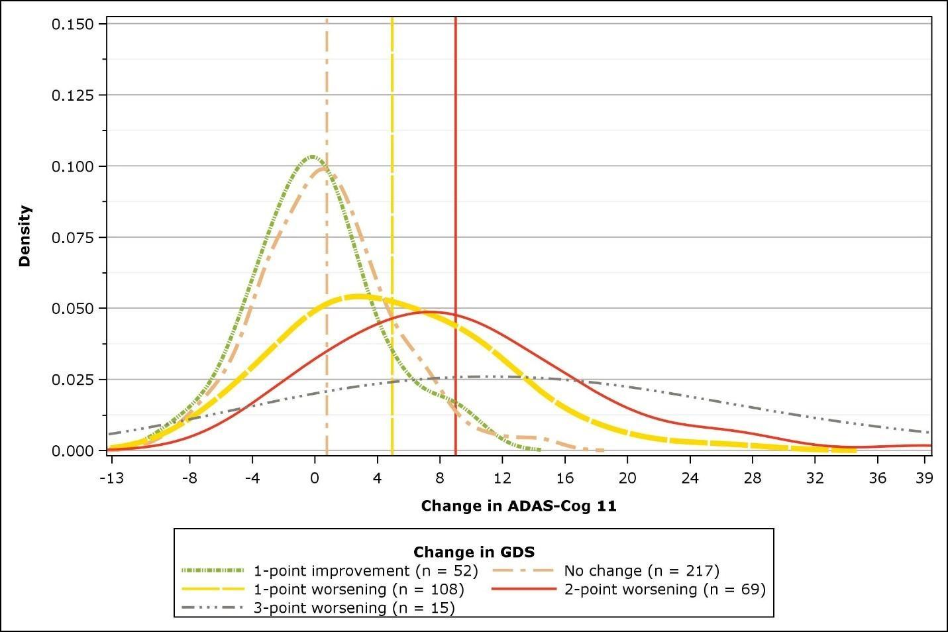

D. Change in ADAS-Cog 13 from baseline to Month 36, by change in GDS
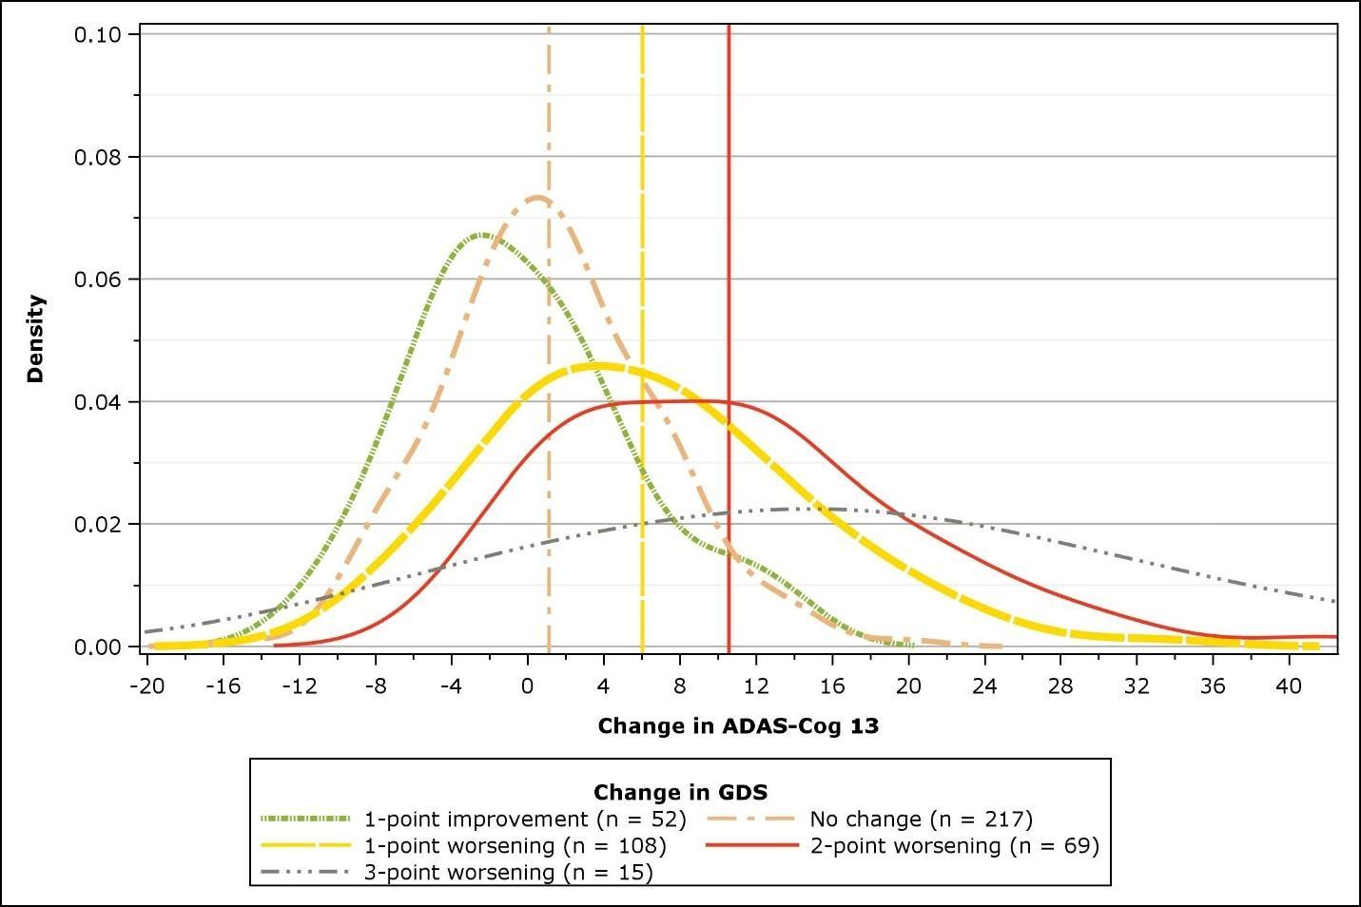
E. Change in MMSE Total from baseline to Month 36, by change in GDS
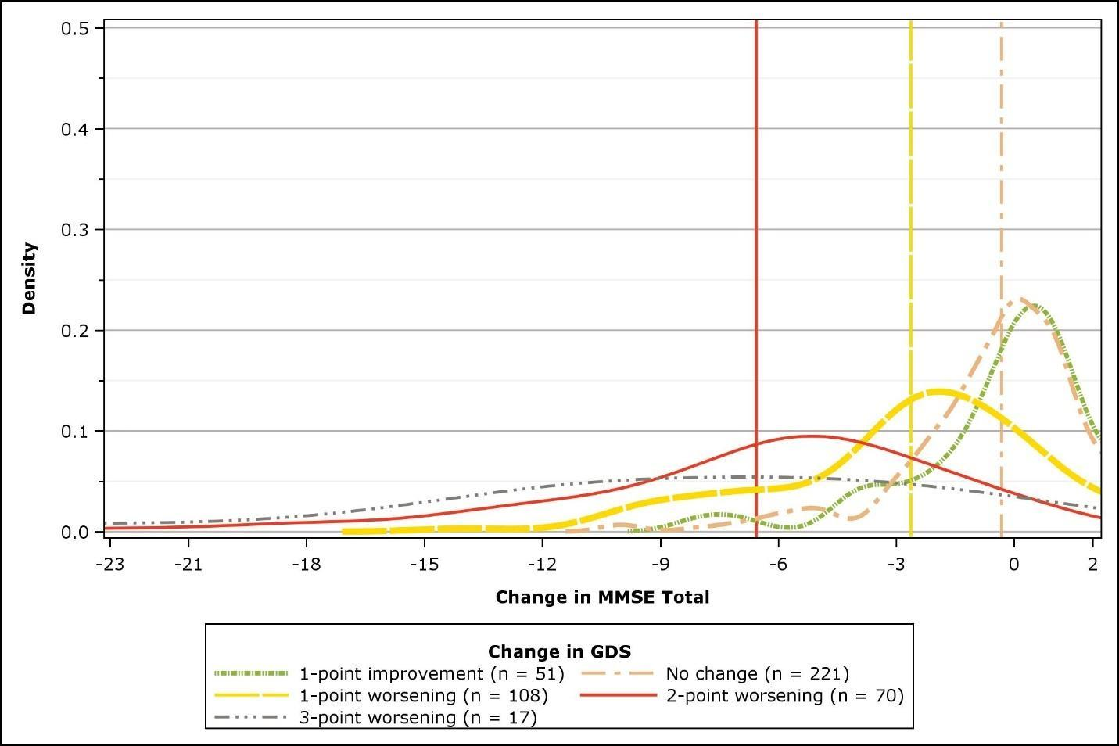 ADAS-Cog 11 = 11-item Alzheimer’s Disease Assessment Scale – Cognitive Subscale; ADAS-Cog 13 = 13-item ADAS-Cog; CDR = Clinical Dementia Rating Scale; GDS = Global Deterioration Scale; MMSE = Mini-Mental State Examination.
Note: Vertical lines denote means of the target measure change score in the “no change”, ”1-point worsening”, and ”2-point worsening” groups (if each n > 5).
The plotting range of the x-axis is from the Month 36 minimum change of the "2-point worsening" group to the Month 36 maximum change of "2-point improvement" group for the corresponding target measure.
Supplemental Appendix D: Additional descriptive statistics for the anchor measures
Figure S-4. Summary of anchor measures
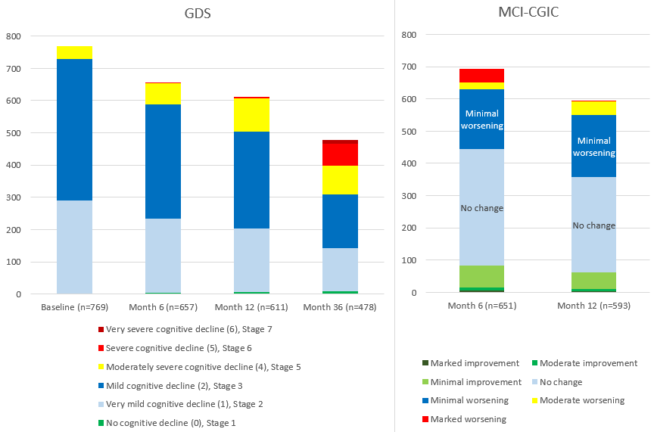
Table S-3. Descriptive statistics for the GDS
 |  |  | Response frequency, n (%)
Measure/time point | n | Mean (SD) | No cognitive decline  (0)  Stage 1 | Very mild cognitive decline  (1)  Stage 2 | Mild cognitive decline  (2)  Stage 3 | Moderate cognitive decline  (3)  Stage 4 | Moderately severe cognitive decline  (4)  Stage 5 | Severe cognitive decline  (5)  Stage 6 | Very severe cognitive decline  (6)  Stage 7
GDS
Baseline | 769 | 2.67 (0.57) | 2 (0.3) | 288 (37.5) | 439 (57.1) | 40 (5.2) | 0 (0) | 0 (0) | 0 (0)
Baseline (participants with BL and Month 6 scores) | 657 | 2.69 (0.58) | 2 (0.3) | 238 (36.2) | 380 (57.8) | 37 (5.6) | 0 (0) | 0 (0) | 0 (0)
Baseline (participants with BL and Month 12 scores) | 611 | 2.69 (0.58) | 2 (0.3) | 220 (36.0) | 353 (57.8) | 36 (5.9) | 0 (0) | 0 (0) | 0 (0)
Baseline (participants with BL and Month 36 scores) | 478 | 2.70 (0.58) | 2 (0.4) | 168 (35.1) | 281 (58.8) | 27 (5.6) | 0 (0) | 0 (0) | 0 (0)
Month 6 | 657 | 2.75 (0.66) | 5 (0.8) | 229 (34.9) | 354 (53.9) | 66 (10.0) | 3 (0.5) | 0 (0) | 0 (0)
Month 12 | 611 | 2.84 (0.73) | 6 (1.0) | 198 (32.4) | 300 (49.1) | 102 (16.7) | 5 (0.8) | 0 (0) | 0 (0)
Month 36 | 478 | 3.23 (1.13) | 9 (1.9) | 134 (28.0) | 165 (34.5) | 91 (19.0) | 68 (14.2) | 11 (2.3) | 0 (0)
BL = baseline; GDS = Global Deterioration Scale; SD = standard deviation.
Note: The percentage with nonmissing responses is based on the number of participants with a nonmissing value at the time point of interest.
Supplemental Appendix E: Correlations between changes in target and outcome measures
Table S-4. Correlations between changes in target and anchor measures
Change/time point | Correlation coefficient with anchor measures
 | GDS change | MCI-CGIC
Month 6 | (n = 651–656) | (n = 645–650)
CDR global | 0.19 | 0.22
CDR-SB | 0.36 | 0.37
ADAS-Cog 11 | 0.15 | 0.09
ADAS-Cog 13 | 0.16 | 0.15
MMSE Total | –0.15 | –0.19
Month 12 | (n = 602–609) | (n = 587–591)
CDR global | 0.42 | 0.41
CDR-SB | 0.50 | 0.53
ADAS-Cog 11 | 0.19 | 0.32
ADAS-Cog 13 | 0.20 | 0.34
MMSE Total | –0.22 | –0.27
Month 36 | (n = 468–476)
CDR global | 0.68
CDR-SB | 0.74
ADAS-Cog 11 | 0.51
ADAS-Cog 13 | 0.51
MMSE Total | –0.60
ADAS-Cog 11 = 11-item Alzheimer’s Disease Assessment Scale – Cognitive Subscale; ADAS-Cog 13 = 13-item ADAS-Cog; CDR = Clinical Dementia Rating Scale; CDR-SB = Clinical Dementia Rating Scale – Sum of Boxes; GDS = Global Deterioration Scale; MCI-CGIC = Mild Cognitive Impairment–Clinical Global Impression of Change; MMSE = Mini-Mental State Examination.
Note: Pearson correlation coefficients were computed for the GDS change and polyserial correlation coefficients for the MCI-CGIC.
Supplemental Appendix F: Progressor analysis
Table S-5. Progressors at Month 12 based on the proposed thresholds, overall population
Outcome | N | Based on selected “minimal deterioration” threshold | Based on selected “moderate deterioration” threshold
CDR-SB |  | Threshold: 1-point increase | Threshold: 2.5-point increase
Overall | 605 | 165 (27.3%) | 39 (6.4%)
Placebo | 212 | 64 (30.2%) | 18 (8.5%)
Donepezil | 184 | 46 (25.0%) | 6 (3.3%)
Vitamin E | 209 | 55 (26.3%) | 15 (7.2%)
ADAS-Cog 11 |  | Threshold: 2-point increase | Threshold: 4-point increase
Overall | 607 | 213 (35.1%) | 118 (19.4%)
Placebo | 211 | 77 (36.5%) | 42 (19.9%)
Donepezil | 187 | 60 (32.1%) | 31 (16.6%)
Vitamin E | 209 | 76 (36.4%) | 45 (21.5%)
ADAS-Cog 13 |  | Threshold: 2-point increase | Threshold: 5-point increase
Overall | 607 | 241 (39.7%) | 122 (20.1%)
Placebo | 211 | 85 (40.3%) | 43 (20.4%)
Donepezil | 187 | 70 (37.4%) | 34 (18.2%)
Vitamin E | 209 | 86 (41.1%) | 45 (21.5%)
MMSE |  | Threshold: 2-point reduction | Threshold: 7-point reduction
Overall | 609 | 172 (28.2%) | 12 (2.0%)
Placebo | 214 | 70 (32.7%) | 5 (2.3%)
Donepezil | 186 | 46 (24.7%) | 3 (1.6%)
Vitamin E | 209 | 56 (26.8%) | 4 (1.9%)
ADAS-Cog 11 = 11-item Alzheimer’s Disease Assessment Scale – Cognitive Subscale; ADAS-Cog 13 = 13-item ADAS-Cog; CDR-SB = Clinical Dementia Rating Scale – Sum of Boxes; MMSE = Mini-Mental State Examination.

