Cognitive Digital Biomarkers from Automated Transcription of Spoken Language - Supplementary Materials

Supplementary Table 1. Codes used to represent each neuropsychological subtest of interest.
Test | Code | Description
Logical Memory | S | Anna Thompson Immediate Recall
 | SA | Anna Thompson Questions
 | SR | Anna Thompson Delayed Recall
Verbal Pair Associates | 1R | Paired Recall 1
 | 2R | Paired Recall 2
 | 3R | Paired Recall 3
Digit Span | BN | Backward Numbers
 | N | Forward Numbers
 | Total | Total transcription (participant and proctor)

Supplementary Table 2. Paralinguistic variables derived from automated transcription.
count_common_words | Number of common words
frac_common_words | Fraction of common words
frac_stop_words | Fraction of stop words
n_words | Number of words
pause_time | Time spent in pauses
pause_fraction | Fraction of pauses
section_time | Time spent in task section
speaking_time | Speaking time
speaking_fraction | Speaking fraction
word_mean_certainty | Mean word transcription confidence
word_std_certainty | Standard deviation of word transcription confidence
word_mean_time | Mean word utterance time
word_std_time | Standard deviation of word utterance time

Supplementary Table 3. Top 10 production rules for linguistic data.
Rule | Frequency (%)
NP → PRP | 9.1
S → NP VP | 7.6
S1 → NP | 5.5
S1 → S | 5.1
NP → NN | 3.8
NP → DT NN | 3.1
INTJ → UH | 2.9
PP → IN NP | 2.8
NP → NNP | 2.3
ADVP → RB | 2.3

Supplementary Table 4. Demographic data for recordings from participants that were automatically transcribed.
 | CN (n = 35) | MCI (n = 55) | P vs CN* | Dementia (n = 110) | P vs CN* | P vs MCI*
Age, mean (SD) | 82.6 (7.2) | 81.7 (7.9) | 0.65 | 83.3 (6.4) | 0.58 | 0.22
Sex, n (%) |  |  | 0.83 |  | 0.69 | 0.40
Female | 21 (60) | 31 (56) |  | 70 (64)
Male | 14 (40) | 24 (44) |  | 40 (36)
*Fisher’s Exact test for categorical data and the t-test for continuous data. CN = cognitively normal, MCI = mild cognitive impairment.
Supplementary Table 5. Demographic data for recordings from participants with manually transcribed recordings.
 | CN (n = 86) | MCI or dementia (n = 41) | P*
Age, mean (SD) | 67.1 (16.6) | 82.2 (7.7) | < 0.001
Sex, n (%) |  |  | 0.012
Female | 42 (49) | 30 (73)
Male | 44 (51) | 11 (27)
*Fisher’s Exact test for categorical data and the t-test for continuous data. CN = cognitively normal, MCI = mild cognitive impairment.

Supplementary Table 6. Demographic data at the time of recordings for those with manual transcriptions, excluding those age 67 or younger.
 | CN (n = 44) | MCI or dementia (n = 41) | P*
Age, mean (SD) | 80.4 (7.6) | 82.2 (7.7) | 0.28
Sex, n (%) |  |  | 0.04
Female | 22 (50) | 30 (73)
Male | 22 (50) | 11 (27)
*Fisher’s Exact test for categorical data and the t-test for continuous data. CN = cognitively normal, MCI = mild cognitive impairment.

Supplementary Table 7. Demographic data from participants at the time of recordings that were both manually and automatically transcribed.
 | CN (n = 22) | MCI or dementia (n = 37) | P*
Age, mean (SD) | 82.0 (7.7) | 81.9 (7.5) | 1.0
Sex, n (%) |  |  | 0.17
Female | 12 (55) | 27 (73)
Male | 10 (45) | 10 (27)
*Fisher’s Exact test for categorical data and the t-test for continuous data. CN = cognitively normal, MCI = mild cognitive impairment.

Supplementary Fig. 1. Predicted curve for recordings from participants with dementia, using the adjusted “Acoustic Watson” logistic regression model discriminating cognitively normal controls from those with mild cognitive impairment. The Y-axis represents the histogram count of subjects in the test set.
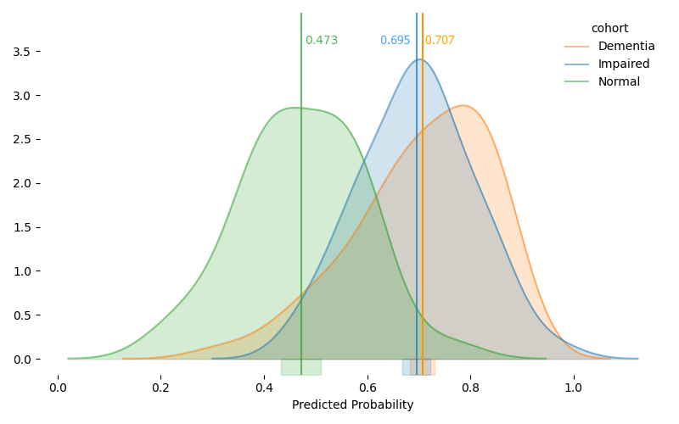

Supplementary Fig. 2. Predicted curve for recordings from cognitively normal controls, using the adjusted “Acoustic Watson” logistic regression model discriminating participants with mild cognitive impairment from those with dementia. The Y-axis represents the histogram count of subjects in the test set.
