Supplementary Material

Tau and total ADCS ADL-PI scores
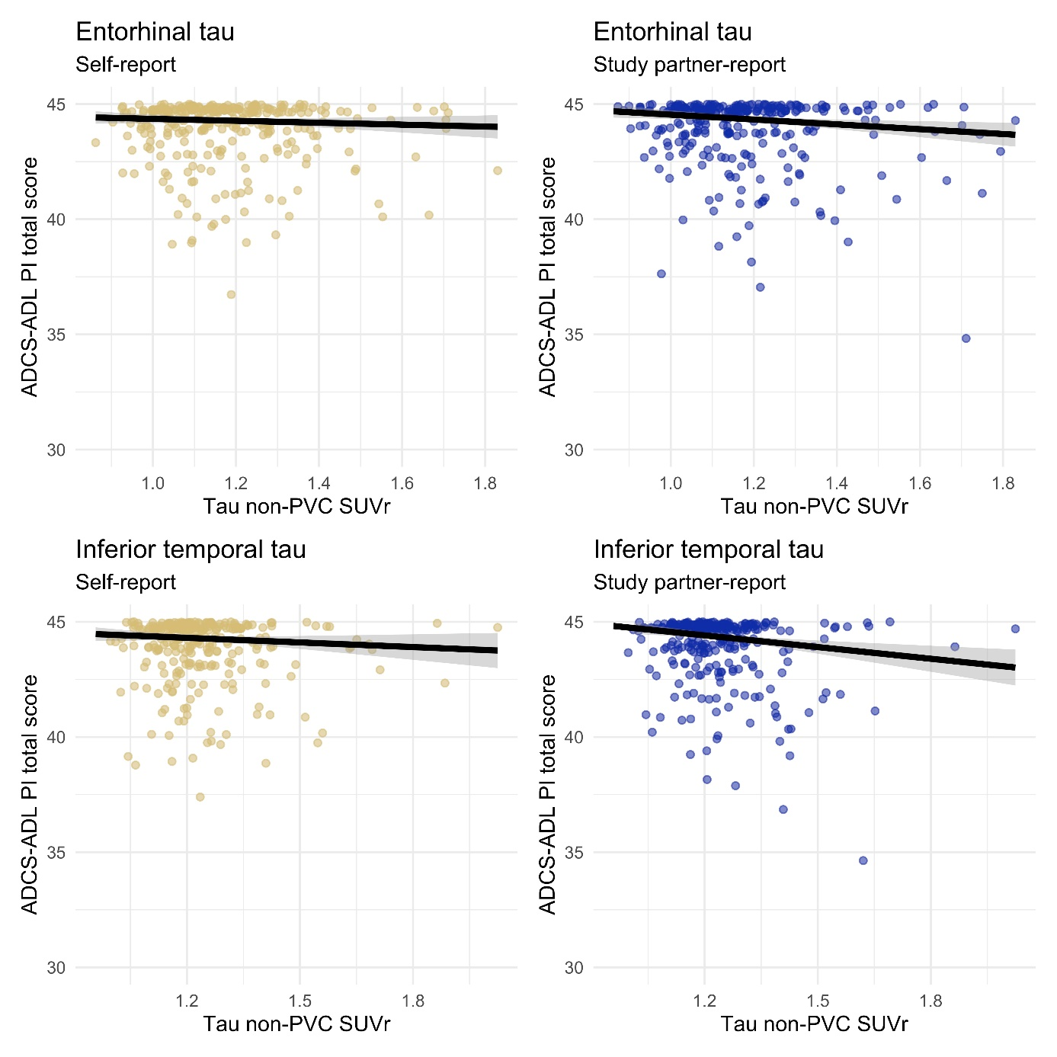
Supplementary Figure 1. Correlations between entorhinal tau (top row) and inferior temporal tau (bottom row) and ADCS ADL-PI total scores, as reported by the participant (left column) and their study partner (right column).
Abbreviations: ADCS ADL-PI, Alzheimer’s Disease Cooperative Study Activities of Daily Living Prevention Instrument; PVC, partial volume corrected; SUVr, standard uptake value ratio.

Dichotomized amyloid
Table 1. Coefficients and 95% confidence intervals from models with continuous ADCS ADL-PI scores and dichotomized amyloid
 | Self-report |  | Study partner-report
 | B [95%CI] | P | B [95%CI] | P
Entorhinal cortex
Tau | -0.04 [-0.30, 0.22] | 0.755 | -0.15 [-0.42, 0.11] | 0.257
Amyloid | -0.23 [-3.29, 2.83] | 0.882 | -0.78 [-3.88, 2.31] | 0.620
Tau–amyloid interaction | 0.01 [-0.26, 0.29] | 0.930 | 0.05 [-0.22, 0.33] | 0.698
Inferior temporal cortex
Tau | -0.18 [-0.50, 0.15] | 0.283 | -0.34 [-0.66, -0.01] | 0.043
Amyloid | -1.70 [-5.74, 2.35] | 0.411 | -2.48 [-6.56, 1.60] | 0.233
Tau–amyloid interaction | 0.13 [-0.20, 0.47] | 0.437 | 0.19 [-0.15, 0.53] | 0.269

Tau and dichotomized IADL
Table 2. Odds ratios and 95% confidence intervals from models with dichotomized ADCS ADL-PI scores
 | Self-report |  | Study partner-report
 | OR [95%CI] | P | OR [95%CI] | P
Entorhinal cortex
Model 1: Tau | 1.04 [0.92, 1.17] | 0.553 | 1.10 [0.97, 1.25] | 0.131
Model 2: Tau | 0.90 [0.39, 2.06] | 0.794 | 0.92 [0.39, 2.19] | 0.850
Model 2: Tau–amyloid interaction | 1.05 [0.58, 1.92] | 0.863 | 1.10 [0.59, 2.05] | 0.762
Model 3: Tau | 0.88 [0.57, 1.36] | 0.571 | 1.07 [0.71, 1.62] | 0.752
Model 3: Tau–amyloid interaction | 1.17 [0.74, 1.83] | 0.500 | 0.92 [0.59, 1.41] | 0.688
Inferior temporal cortex
Model 1: Tau | 1.12 [0.96, 1.30] | 0.147 | 1.15 [0.98, 1.35] | 0.079
Model 2: Tau | 0.68 [0.24, 2.00] | 0.487 | 1.87 [0.61, 5.75] | 0.273
Model 2: Tau–amyloid interaction | 1.36 [0.64, 2.90] | 0.427 | 0.68 [0.31, 1.50] | 0.336
Model 3: Tau | 1.13 [0.67, 1.89] | 0.644 | 0.82 [0.49, 1.35] | 0.432
Model 3: Tau–amyloid interaction | 0.95 [0.56, 1.63] | 0.858 | 1.24 [0.73, 2.11] | 0.422
Model 1 includes only tau, model 2 includes continuous tau, continuous amyloid, and a tau–amyloid interaction, model 3 includes continuous tau, dichotomized amyloid and a tau–amyloid interaction. All models are adjusted for age, sex and education.
Abbreviations: OR, odds ratio; 95%CI, 95% confidence interval

Participant and study partner discordance
Table 3. Odds ratios and 95% confidence intervals from models with participant and study partner discordance, divided into self-overreport (participant reports more IADL difficulty than study partner) and self-underreport (participant reports less IADL difficulty than study partner). Concordance is the reference group.
 | Self-overreport |  | Self-underreport
 | OR [95%CI] | P | OR [95%CI] | P
Entorhinal cortex
Model 1: Tau | 1.16 [1.01, 1.33] | 0.034 | 1.22 [1.05, 1.42] | 0.011
Model 2: Tau | 0.51 [0.20, 1.33] | 0.168 | 0.59 [0.21, 1.67] | 0.320
Model 2: Tau–amyloid interaction | 1.81 [0.90, 3.65] | 0.096 | 1.75 [0.81, 3.76] | 0.155
Model 3: Tau | 0.80 [0.64, 1.88] | 0.423 | 1.10 [0.64, 1.88] | 0.732
Model 3: Tau–amyloid interaction | 1.46 [0.84, 2.54] | 0.178 | 1.12 [0.64, 1.97] | 0.682
Inferior temporal cortex
Model 1: Tau | 1.25 [1.05, 1.50] | 0.013 | 1.34 [1.11, 1.62] | 0.003
Model 2: Tau | 0.48 [0.20, 1.19] | 0.114 | 1.99 [1.14, 3.47] | 0.016
Model 2: Tau–amyloid interaction | 1.97 [1.05, 3.71] | 0.036 | 0.77 [0.52, 1.14] | 0.191
Model 3: Tau | 1.30 [0.68, 2.50] | 0.434 | 2.04 [1.03, 4.04] | 0.041
Model 3: Tau–amyloid interaction | 0.95 [0.48, 1.88] | 0.888 | 0.63 [0.31, 1.29] | 0.205
Whole brain
Model 4: Amyloid | 1.98 [0.61, 6.46] | 0.256 | 1.39 [0.36, 5.37] | 0.631
Model 1 includes only tau, model 2 includes continuous tau, continuous amyloid, and a tau–amyloid interaction, model 3 includes continuous tau, dichotomized amyloid, and a tau–amyloid interaction, and model 4 includes only global cortical amyloid. All models are adjusted for age, sex, and education.
Abbreviations: OR, odds ratio; 95%CI, 95% confidence interval

