Economic evaluation of the fiscal costs and consequences of symptomatic Alzheimer´s disease in Germany: Microsimulation of patients and caregiver´s pathways

  - Supplemental Materials

Table of Contents
1. Structure of the health economic model 2
2. Health states in the economic model 2
3. Demographic characteristics used to generate the synthetic cohort 2
4. Age distributions in the economic model 3
5. Alzheimer’s disease progression 4
6. Applying hazard ratios to probabilities 4
7. Total informal care requirements 5
8. Probability of employment given informal care requirements 5
9. DelpHi-MV data analysis 6
10. Fiscal consequences 6
10.1 Gross revenue from employment 6
10.2 Indirect tax calculations 7
10.3 Financial benefits to households in the general population 7
10.4 Financial benefits to the cohort affected by AD 8
10.5 Healthcare costs 9
11. Model validation and additional results 9
References 13

Structure of the health economic model

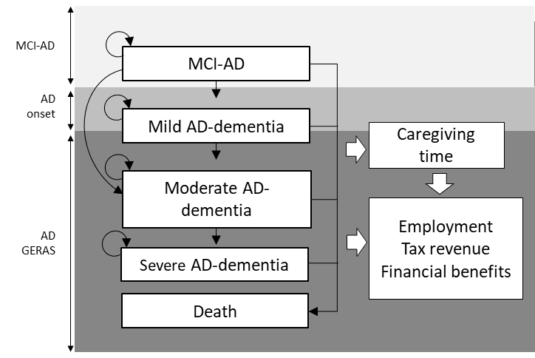
AD, Alzheimer’s disease; MCI-AD, mild cognitive impairment due to Alzheimer’s disease.

Health states in the economic model
Table 1 – Cognition scores ranges by clinical Alzheimer’s disease (AD) stages in the model
Clinical Disease Stage | MMSE ª
MCI-AD | 27-29
Mild AD | 21-26
Moderate AD | 10-20
Severe AD | <10
AD, Alzheimer’s disease; MMSE, Mini-Mental State Examination.
ª We assumed individuals with an MMSE score of 30 to be cognitively normal. MMSE categories used AD dementia classification reported by Green et. Al (1)

Demographic characteristics used to generate the synthetic cohort
Table 2 – Demographic characteristics used to generate the synthetic cohort
Attributes* | PwAD |  | Informal caregivers |  | Sampling distribution
 | Mean | SD (%) | Mean | SD (%)
n mild AD | 228 | - | 228 | - | -
Age | 74.7 | 6.9 | 66.6 | 11.2 | Lognormal
Females | 96 | 42% | 162 | 71% | Beta
Disease Duration | 1.3 | 1.6 | - | - | Gamma
MMSE score | 23.7 | 0.2 | - | - | Normal
Total ADL | 60 | 1.0 | - | - | Normal
Spouse (n=550) | - | - | 371/550 | 67.6% ₸ | Beta
AD, Alzheimer's disease; ADL, activities of daily living; MMSE, Mini-Mental State Evaluation; PwAD, person with Alzheimer’s disease; SD, standard deviation
* People with mild AD and caregivers in the German cohort of the GERAS I study (2, 3)
₸ Mean across AD severities from German GERAS (mild, moderate, and severe). Proportion of caregivers who were spouses was higher for people with mild AD 72.8%. Using the average was seen as more representative of the entire duration of the model as adult child caregivers would possibly take place of spouses in the event of their inability to be/remain the primary informal caregivers.

Age distributions in the economic model
Figure 1 - Age overlap between people with AD and informal caregivers

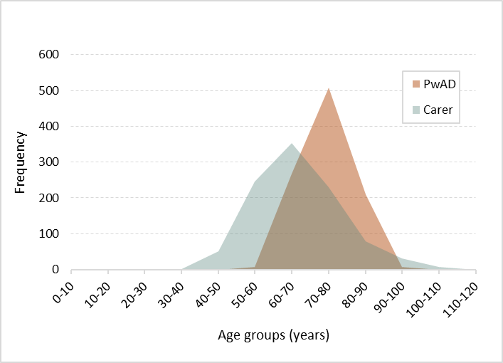
PwAD, person with Alzheimer’s disease

Table 3 - Age distribution in the model for a sample of 1,000 pairs
Age group | People with Alzheimer’s disease |  | Informal caregivers
 | n below age maximum | Cumulative % | n below age maximum | Cumulative %
105 | 1000 | - | 998 | 99.8%
100 | 1000 | - | 991 | 99.1%
95 | 1000 | 100.0% | 979 | 97.9%
90 | 993 | 99.3% | 961 | 96.1%
85 | 942 | 94.2% | 934 | 93.4%
80 | 784 | 78.4% | 882 | 88.2%
75 | 542 | 54.2% | 784 | 78.4%
70 | 275 | 27.5% | 652 | 65.2%
65 | 78 | 7.8% | 485 | 48.5%
60 | 8 | 0.8% | 298 | 29.8%
55 | 3 | 0.3% | 141 | 14.1%
50 | 0 | 0.0% | 53 | 5.3%
45 | 0 | 0.0% | 13 | 1.3%
40 | - | - | 2 | 0.2%
35 | - | - | 0 | 0.0%
30 | - | - | 0 | 0.0%

Alzheimer’s disease progression
Progression of AD dementia from the age at GERAS enrolment onwards was modelled using the equations published by Getsios and colleagues (4). The equations reproduced below were used to predict the change in Mini-Mental State Examination (MMSE) and Activities of Daily Living scores over time.
$${Change in MMSE}_{\left[Treated\right]}= {(T}_{eff}-5.4663-0.429{PM}_{1}-0.004{PM}_{2}+0.1415{PM}_{3}-0.079PrevMMSEChange+0.0747Age+δ_{i})×CycleLength$$ | Equation 1

Where T_{eff} is donepezil treatment effect, PrevMSSEChange is the value of MMSE change in the previous cycle, Age is current age in years, and CycleLength is the simulation cycle length.
T_{eff} took the values of 6.1583 for the first 20 weeks of treatment (assumed to be equivalent to 1 cycle in the model), 2.4671 from 20 weeks to 1 year and 0 thereafter. Between patient variability was introduced using δ_{i}, implemented as a random draw from a normal distribution with mean zero and standard deviation of 0.5.

$${PM}_{1}=min⁡(PrevMMSE,9)$$ | Equation 2
$${PM}_{2}=max⁡(0, min\left[PrevMMSE-9,9\right])$$ | Equation 3
$${PM}_{3}=max⁡(0, min⁡[PrevMMSE-18,12])$$ | Equation 4

$$Change in ADL={Base}_{ADL}+1.35-0.81donepezil+0.06weeks-0.79{ADL}_{baseline}+0.71{ADL}_{recent}+0.12{MMSE}_{baseline}+0.09age-0.49{MMSE}_{recent} + δ_{i}$$ | Equation 5

Where weeks is the simulation time in weeks, donepezil is donepezil treatment effect (coded 1 for those on treatment), ADL_{baseline/recent} and MMSE_{baseline/recent} are the ADL and MMSE scores at baseline or in the previous cycle, respectively.
Variability between patients was included using the δ_{i} parameter implemented by sampling from a normal distribution with mean 0 and standard deviation 2.48. The coefficients for race (-3.05) and psychiatric medication (0.81) used in the original publication were left out of the analysis as data was not available in the synthesized cohort. A full explanation of how these equations were obtained is detailed in the original publication (4).
The range for the total Alzheimer's Disease Cooperative Study (ADCS) ADL score used in GERAs ranged from 0 to 78, with high scores representing less dependency. Getsios and colleagues have standardized ADL scores to range from 0 to 100, with 100 representing higher levels of dependency. In the model the ADL scores sampled from average GERAS scores were rescaled using Equation 6.

$$S_{t}= \frac{{Max}_{Target}-{Min}_{Target}}{{Max}_{Source}-{Min}_{Source}}×\left(S_{i}-{Max}_{Source}\right)+{Max}_{Target}$$ | Equation 6

Where S_{t} is the desired value, S_{i} is the value score to be converted, Max and Min represent the maximum and minimum of the original (Source) and desired score (Target).

Applying hazard ratios to probabilities
Hazard ratios reflecting the negative effect of AD on employment status were applied to probabilities of employment in the general population using Equation 7 (5).
$$t_{p\left(t_{u}\right)}=1-exp\left\{H\left(t-u\right)-H(t)\right\}$$ | Equation 7
Where t_{p} is the transition probability, t_{u} is the current cycle (time in simulation), u is the cycle duration and H(t) is the cumulative hazard function for the parametric distribution.

Total informal care requirements
As PwAD reached the age of enrolment in the GERAS study individual MMSE, ADL and other unique attributes were used to model daily care requirement and its impact on carers likelihood of maintaining a job. Total hours of care were modelled using an equation derived from an analysis of the GERAS I study (6).
$$Total carer time=7.0706-0.3727Country-0.1411{MMSE}_{Severity}+0.0029Age-0.3600Spouse-0.403ADL+Scale$$ | Equation 8
Where Country took values specific to GERAS cohort location (-0.3727 for Germany, -0.1985 for France and 0 for the UK). MMSE_{Severity} took the values of -0.1411 for mild AD, 0.0168 for moderate AD and 0 for severe AD. Age was the individual age in the model; Spouse was the covariate identifying the spouses of PwAD taking the value of 0 if the carer was not the spouse and -0.36 if it was. ADL was the individual ADL score, and Scale took the value of 0.5438.
The outcome of Equation 8 were the daily hours of care delivered by informal carers. This output was converted into weekly hours of care and utilized to calculate the number of hours of work for carers remaining in employment.

Probability of employment given informal care requirements
The probability of employment in primary caregivers was calculated using Equation 9 in males and Equation 10 in females, both sourced from the publication by Lilly and colleagues.
$${P(LFP)}_{Males}= exp(-0.308-{0.089}_{CG}-0.275{Age}_{50-54}-0.843{Age}_{55-59}-1.531{Age}_{60-64}+0.339Spouse)$$ | Equation 9
$${P(LFP)}_{Females}= exp(-0.661-{0.004}_{CG}-0.249{Age}_{50-54}-0.781{Age}_{55-59}-1.470{Age}_{60-64}-0.113Spouse)$$ | Equation 10
Where CG took the value of 0 for primary caregivers and 1 for secondary caregivers, Age_{Min-Max} took the value of 0 or 1 if caregivers’ age fell above or below the maximum, respectively. The upper limit of Age₆₀₋₆₄ was assumed to equal SPA value. Spouse would take the value of 1 for spouses and 0 for child caregivers.
Other coefficients of the Probit equations above (region of birth, education, and number of children below the age of 15) were left out of the calculation as these attributes were not available from GERAS publications. We recognize this as limitation as it may increase the uncertainty in the values estimated by the equations.
In those predicted to work, the proportion of a full-time equivalent (FTE) in males and females was calculated using Equation 11 and Equation 12 sourced from the same publication by Lilly and colleagues.
$${Proportion_{FTE}}_{Males }= exp(-0.045Primary_{CG}-0.032Care_{10}- 0.089Care_{15}-0.156Care_{20})$$ | Equation 11
$${Proportion_{FTE}}_{Females }= exp(-0.037Primary_{CG}+0.023Care_{10}- 0.022Care_{15}-0.018Care_{20})$$ | Equation 12

Where Primary_{CG} took the value of 1 for primary caregivers and 0 otherwise, and Care₁₀, Care₁₅ and Care₂₀ took the value of 1 if informal care was provided for more than 10, 15 or 20 hours weekly, respectively, and took the value of 0 otherwise.

DelpHi-MV data analysis
The Dementia: life and person-centred help in Mecklenburg-Western Pomerania (DelpHi-MV) study, is a general practitioner-based, cluster randomized controlled intervention trial recruiting people over the age of 70 living at home (7, 8).
The design and study sample have been described comprehensively (7, 8). To sum up, eligible patients were 70 years or older, living at home and screened in GP-practices for dementia using the DemTect procedure (9). Patients, who met the inclusion criteria (DemTect < 9) were informed by their general practitioners (GPs) about the study, invited to participate and asked to provide written informed consent (as approved by the Ethical Committee of the Chamber of Physicians of Mecklenburg-Western Pomerania, registry number BB 20/11). Each patient’s caregiver was asked to participate as well. Overall, 6,838 people were screened by 125 GPs, of which 1,167 (17%) patients of 105 GPs were eligible for the study. In total 634 (54.4%) patients agreed to participate.
At baseline, a comprehensive standardized computer-assisted interview was conducted by specifically qualified nurses to assess the frequency of healthcare resource utilization and provision of financial support during the last 12 months. To ensure a systematic and comprehensive assessment, the interview addressed a list of common resources and services. To improve the validity of the data, both patients and caregivers were interviewed. The utilization reviews recorded utilization of medical treatments (practitioner, hospitalization, drugs, therapies, aids), formal care services (ambulatory care/ home care, day and night care, nursing home care), as well as financial support for professional and informal care.
The utilization of direct medical and non-medical healthcare costs, informal care as well as was caregivers’ productivity losses were published elsewhere (10, 11). However, the preservation of financial support for formal and informal care over the different care levels (1-5) were not published so far. We, therefore, conducted a post hoc analyses as demonstrated in #9.4. We used descriptive statistics to demonstrate the percentage of patients receiving care allowance only, financial support for professional care only, or a combination of both.

Fiscal consequences

Gross revenue from employment

Table 4 – Average monthly gross income by age (per capita)
Age bands | Gross income (monthly)
 | Males * | Females *
60+ | € 4,695 | € 3,424
55 to 59 | € 4,466 | € 3,242
50 to 54 | € 4,364 | € 3,251
45 to 49 | € 4,273 | € 3,254
40 to 44 | € 4,209 | € 3,280
35 to 39 | € 4,110 | € 3,403
20 to 34 | € 3,815 | € 3,413
25 to 29 | € 3,261 | € 3,071
20 to 24 | € 2,710 | € 2,466
<20 | € 2,348 | € 2,083
* Age specific mean gross income values were calculated as the weighted average of the gross income for self-employed and salaried employees from the Former German Federal Territory and New German Federal States. Inflated from 2005 values using consumer price index (CPI) (12). The CPI values for 2021 were calculated as the average of the monthly 2021 CPIs available at the time of access (13). Source: DESTATIS 2021 (14)

Indirect tax calculations
We calculated the average disposable income by dividing the total private consumption expenditure by total household income, both available from national statistics (57.5%) (15). The amount of value-added tax (VAT) paid on consumption products was calculated as a simple average of the different VAT rates paid on different type of products (16%) (16). Finally, indirect tax was calculated by multiplying together disposable income (57.5%), gross income and VAT (16%).

Table 5 - Private consumption expenditure as proportion of gross income
Income, receipts, and expenditure |  |  |  | Gross household income | Private consumption expenditure | Private consumption expenditure as proportion of gross income *
Averages per household and month in EUR | Household type | Households, total |  | € 4,474 | € 2,517 | 56.3%
 |  | Persons living alone |  | € 2,724 | € 1,629 | 59.8%
 |  | of whom | men living alone | € 3,068 | € 1,710 | 55.7%
 |  |  | woman living alone | € 2,547 | € 1,588 | 62.3%
 |  | single parents |  | € 2,945 | € 1,929 | 65.5%
 |  | couples |  | € 5,702 | € 3,181 | 55.8%
 |  | of whom | without children | € 5,267 | € 3,047 | 57.9%
 |  |  | with children | € 6,675 | € 3,483 | 52.2%
 |  | other households |  | € 6,669 | € 3,450 | 51.7%
 |  |  |  |  |  | 57.5%₸
* Calculated by dividing the private consumption expenditure by the gross household income.
₸ Calculated as the average of private consumption expenditure as proportion of gross income.
Source: DESTATIS 2020 (16)

Table 6 - Average value-added tax (VAT) in Germany
Expenditure | Germany
 | Euro | % | VAT
Private consumption expenditure | 2517 | 100 | 16% *
Food, beverages, and tobacco | 348 | 13.8 | 13%
Clothing and footwear | 110 | 4.4 | 19%
Housing, energy, maintenance of the dwelling | 897 | 35.6 | 19%
Furnishings, equipment, and household maintenance | 140 | 5.6 | 19%
Health | 98 | 3.9 | 13%
Transport | 348 | 13.8 | 13%
Postal and telecommunication services | 64 | 2.5 | 19%
Recreation, entertainment, and culture | 259 | 10.3 | 13%
Education | 18 | 0.7 | 13%
Restaurants and hotels | 146 | 5.8 | 19%
Miscellaneous goods and services | 90 | 3.6 | 19%
VAT, value-added tax.
* Calculated as the average of the VAT rates across expenditure categories. German VAT rates were obtained from an European Union report of VAT rates in member states (17)

Financial benefits to households in the general population
Table 7 - Persons in need of care in 2019 (Germany)
Age groups | Males | Females
> 90 years | 63.9% | 80.9%
85 to 90 years | 39.6% | 55.1%
75 to 84 years | 16.4% | 22.0%
< 75 years | 1.8% | 1.8%
Source: Gesundheitsberichterstattung des Bundes (18)

Table 8 - Distribution of beneficiaries of the social long-term care insurance by care level as of 30 June 2017
Level of care provided
Level 1 | 3.2%
Level 2 | 52.0%
Level 3 | 28.0%
Level 4 | 12.1%
Level 5 | 4.7%
Source: World Health Organization 2020 (19)
The value of financial support in the general population (€689/month) was calculated as an weighted average using care level distribution (Table 8), the average distribution of the type of financial support across AD severities (42.8% care allowance, 29.0% care in kind and 28.1% combination of both) and the amount of financial support by level of care (Table 10).

Financial benefits to the cohort affected by AD
Only individuals with a care level assessment were deemed to receive financial support in the model. The distributions of type of financial support by AD severity were informed by an ad hoc analysis of DelpHi-MV data (20), (Table 9).
Table 9 – Care level assessment status and type of financial support in the DelpHi-MV study
 | MCI-AD |  | Mild AD |  | Moderate AD |  |  | Severe AD
MMSE ranges | 27 to 29 |  | 21 to 26 |  | 10 to 20 |  |  | 1 to 10
 | n | % | n | % | n |  | % | n | %
Care level assessment status
Do not have a care level | 43 | 72.9 | 131 | 68.7 | 124 | 52.0 |  | 11 |  | 10.5
Have a care level | 16 | 27.1 | 59 | 31.3 | 115 | 48.0 |  | 90 |  | 89.5
Type of financial support
Care allowance only | 29 | 49.2 | 98 | 51.6 | 97 | 40.6 |  | 30 |  | 30.0
Professional care only | 14 | 23.7 | 37 | 19.5 | 74 | 31.0 |  | 42 |  | 42.0
Combination of both | 16 | 27.1 | 55 | 28.9 | 68 | 28.5 |  | 28 |  | 28.0
Total | 59 |  | 190 |  | 239 |  |  | 100
AD, Alzheimer’s disease; MCI-AD, mild cognitive impairment due to AD; MMSE, Mini-Mental State Evaluation
Source: Ad hoc analysis of data from the German DelpHi-MV study (20)
Long-term care had formerly been categorized into 3 levels of care but since 2017 the second Care Strengthening Act (book II) (21) has instituted five new grades of care. Care grades are established after evaluation of the care recipient by a health or social care professional and are not simply conditional to daily care needs. To meet modelling requirements, we have assigned a fixed number of daily hours of care by grade of care. This was based on the grading criteria set by the current German Social Code, interpreted alongside the hours of care assigned to the 3 levels of care ruled by the older legislation. This is depicted in the rightmost column of Table 10.
Table 10 – Amount of financial support by level of care
Care needs (hours) | Care allowance ("Pflegegeld") | Care benefits in kind ("Pflegesachleistung") | Illness relief contribution ("Entlastungsbeitrag")
Grade 5 (>5 h) | € 901 | € 1,995 | € 125
Grade 4 (3-5h) | € 728 | € 1,612
Grade 3 (1.5-3h) | € 545 | € 1,298
Grade 2 (<1.5) | € 316 | € 689
Source: German Social Code, Book XI (21)

Healthcare costs
Table 11 – Healthcare cost in people with AD and analogous individuals in the general population
AD severity | MCI-AD | Mild AD | Moderate AD | Severe AD
AD | € 5,013 | € 7,429 | € 8,963 | € 12,781
General population | € 4,151 | € 5,627
Reference | (21, 22) | (23)
AD, Alzheimer’s disease; MCI-AD, mild cognitive impairment due to AD

Model validation and additional results
Vermunt and colleagues assessed AD stage duration using 6 combined cohorts and predicted that for an individual experiencing MCI-AD at the age of 70, the duration of symptomatic AD was 11.8 years in average (24), slightly higher than predicted by our model. The discrepancy in the overall length of symptomatic AD was mostly related to the duration of mild AD as the duration of moderate to severe AD-dementia reported by the authors (4.6 years) closely matches that predicted by the fiscal model. It is hard to determine the factor underpinning the discrepancy in mild AD duration but both mortality and MMSE progression are likely contributing factors. The average monthly informal caregiving requirements predicted by the fiscal model were 68.6 hours in mild AD, 211.7 hours in moderate AD, 224.0 hours in severe AD, and 168.5.0 across all AD severities. These estimates are slightly different from those reported in the German GERAS (2), likely due to differences in cohort characteristics at baseline. Nonetheless, we believe that the fiscal model fairly predicts AD progression and informal care requirements.
Figure 2 - Proportion of time spent in mild, moderate and severe AD
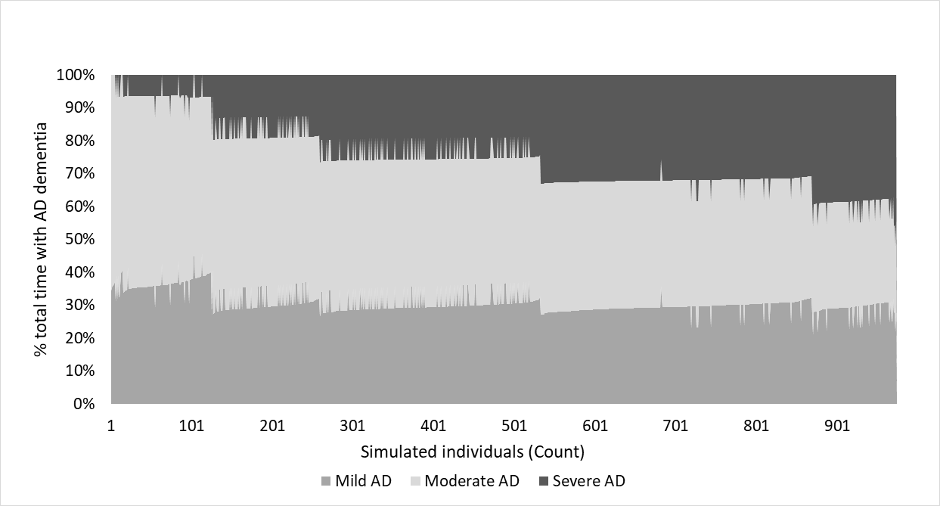
AD, Alzheimer’s disease
We have ranked values in descending order according to time spent in moderate AD.

Table 12 – Stage-specific duration of AD
 | Duration in years in the fiscal analysis, Mean (SD) | % Symptomatic AD, Mean (SD) | % AD-dementia, Mean (SD) | Duration in years (Vermunt 2019), Mean (95% CI) ₸
MCI-AD* | ₸ | 36.9% (15.8%) | - | 3.4 (2.7 to 4.2)
Mild AD | 2.18 (0.52) | 21.5% (3.7%) | 38.9% (22.0%) | 3.8 (3.5 to 4.2)
Moderate AD | 2.87 (1.16) | 26.3% (10.7%) | 38.8% (15.7%) | 4.6 (3.3.9 to 5.5)
Severe AD | 1.69 (2.21) | 15.3% (8.8%) | 22.3% (12.5%)
TOTAL | 10.15 (2.21) | 100.0% | 100.0% | 11.8 (NR)
AD, Alzheimer’s disease; MCI-AD, mild cognitive impairment due to AD, NR, not reported, SD, standard deviation
* MCI-AD was modelled using a fixed duration of 3.4 years (25)
₸ Used values reported by Vermunt and colleagues, people with AD age 70 in clinical setting (24)

Figure 3 depicts the annual rate of change in MMSE scores by MMSE severity reported by Getsios and colleagues (4) to validate the predictive equations utilized in the cost-effectiveness analysis of donepezil. The curve representing the observed MMSE values (continuous light grey) in the Consortium to Establish A Registry for Alzheimer’s Disease curves (CERAD) population compares very closely to the graphical representation of MMSE change over MMSE scores in the fiscal analysis (Figure 4).

Figure 3 – Predicted and actual MMSE rate of change in CERAD and donepezil clinical trials
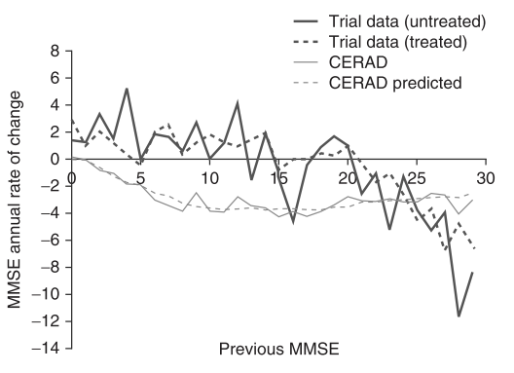
CERAD, Consortium to Establish A Registry for Alzheimer’s Disease; MMSE, Mini-Mental State Examination score.
Source: Getsios 2010 (4)

Figure 4 – Predicted and actual MMSE rate of change in the fiscal microsimulation
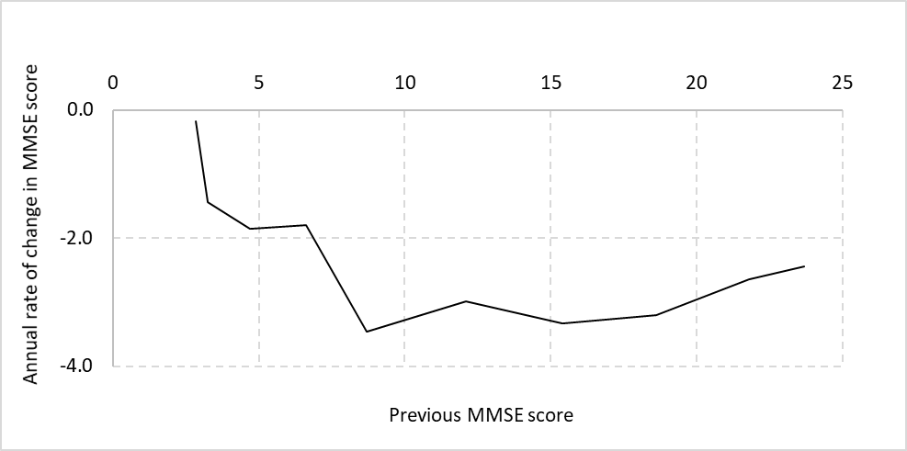
MMSE, Mini-Mental State Examination score.

Figure 5 - Gross income from employment in PwAD and Carer vs general population (per capita)
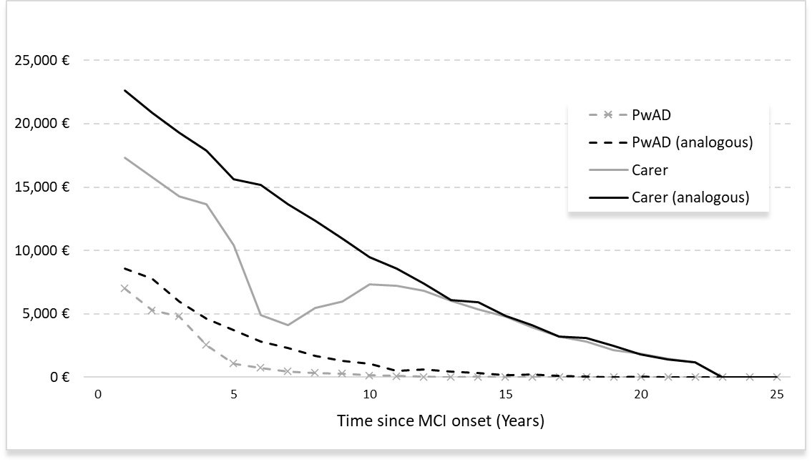
MCI-AD, mild cognitive impairment due to Alzheimer’s disease; PwAD, person with AD.

Figure 6 - Tax and transfers in the PwAD and Carer vs general population (per capita)
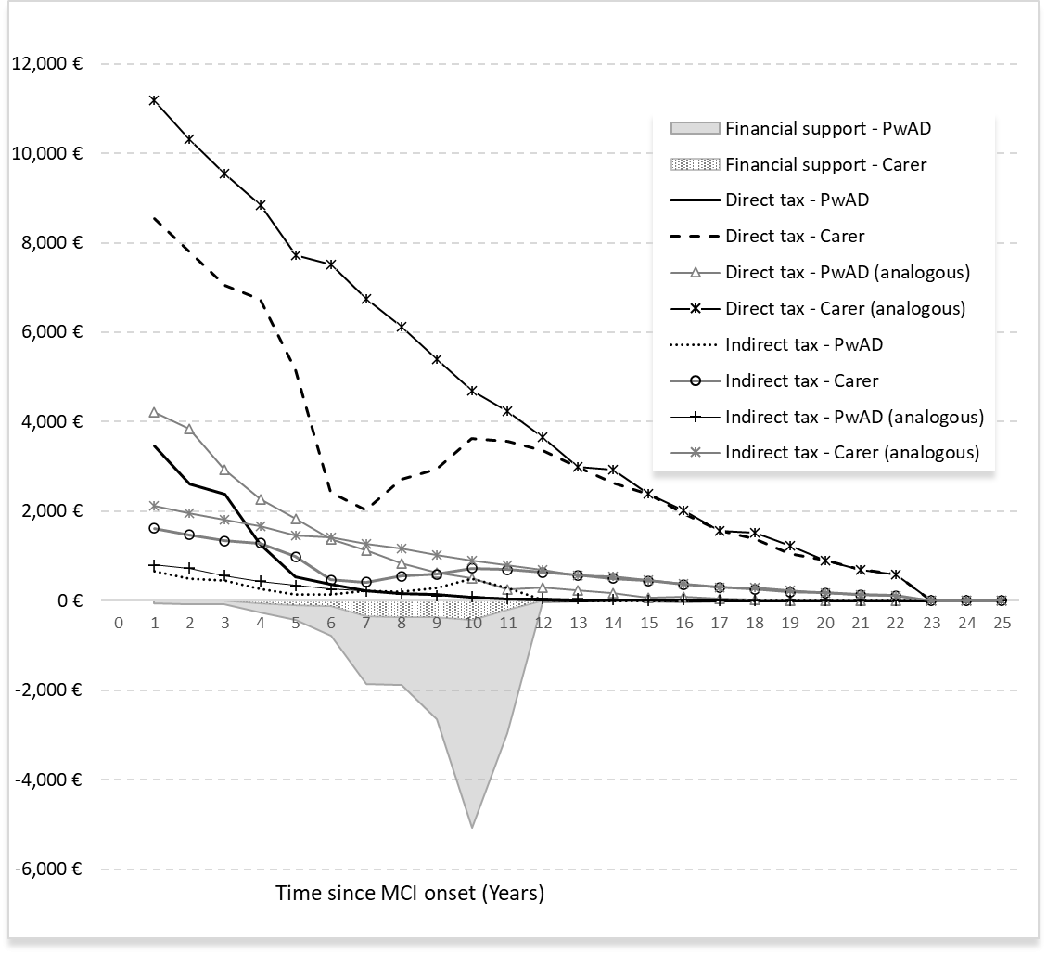
MCI-AD, mild cognitive impairment due to Alzheimer’s disease; PwAD, person with AD.

References
1. Green C, Zhang S. Predicting the progression of Alzheimer's disease dementia: A multidomain health policy model. Alzheimer's & Dementia. 2016; 12: 776-85.
2. Boess F, Lieb M, Schneider E, et al. Kosten der Alzheimer-Erkrankung in Deutschland – aktuelle Ergebnisse der GERAS-Beobachtungsstudie. Gesundheitsökonomie & Qualitätsmanagement. 2016; 21: 232-41.
3. Hager K, Henneges C, Schneider E, et al. [Alzheimer dementia: course and burden on caregivers : Data over 18 months from German participants of the GERAS study]. Nervenarzt. 2017; 89: 431-42.
4. Getsios D, Blume S, Ishak KJ, et al. Cost effectiveness of donepezil in the treatment of mild to moderate Alzheimer's disease: a UK evaluation using discrete-event simulation. Pharmacoeconomics. 2010; 28: 411-27.
5. Briggs AH, Claxton K, Sculpher MJ. Decision modelling for health economic evaluation. J Epidemiol Community Health. 2007; 61: 839.
6. Reed C, Belger M, Vellas B, et al. Identifying factors of activities of daily living important for cost and caregiver outcomes in Alzheimer's disease. Int Psychogeriatr. 2016; 28: 247-59.
7. Thyrian JR, Fiß T, Dreier A, et al. Life- and person-centred help in Mecklenburg-Western Pomerania, Germany (DelpHi): study protocol for a randomised controlled trial. Trials. 2012; 13: 56.
8. Thyrian JR, Eichler T, Michalowsky B, et al. Community-Dwelling People Screened Positive for Dementia in Primary Care: A Comprehensive, Multivariate Descriptive Analysis Using Data from the DelpHi-Study. Journal of Alzheimer's Disease. 2016; 52: 609-17.
9. Kalbe E, Kessler J, Calabrese P, et al. DemTect: a new, sensitive cognitive screening test to support the diagnosis of mild cognitive impairment and early dementia. International Journal of Geriatric Psychiatry. 2004; 19: 136-43.
10. Michalowsky B, Thyrian JR, Eichler T, et al. Economic Analysis of Formal Care, Informal Care, and Productivity Losses in Primary Care Patients who Screened Positive for Dementia in Germany. J Alzheimers Dis. 2016; 50: 47-59.
11. Michalowsky B, Flessa S, Eichler T, et al. Healthcare utilization and costs in primary care patients with dementia: baseline results of the DelpHi-trial. The European Journal of Health Economics. 2018; 19: 87-102.
12. DESTATIS. Consumer price index (including rates of change): Germany, years. 2021.
13. DESTATIS. Consumer price index (including rates of change): Germany, months. 2021.
14. DESTATIS. Workers, salaried employees, gross monthly earnings (prod. Trade and service sector): Former federal territory / new states, reference month (up to 10/2005), age groups, gender. 2021.
15. DESTATIS. Income, receipts and expenditure of households: type of household. 2020.
16. DESTATIS. Private consumption expenditure of households1 by territory 2017. 2020.
17. European Comission. VAT rates applied in the Member States of the European Union. 2020.
18. Federal Health Monitoring Autority. Persons in need of care (number and quota). Classification: years, region, age, sex. 2019.
19. WHO. Germany: Country case study on the integrated delivery of long-term care. 2020.
20. Michalowsky B, Thyrian R, Hoffmann W. Ad hoc analysis of data from the "Dementia: Life- and Person-centred Help in Mecklenburg-Western Pomerania" (DelpHi-MV) study. 2021.
21. German Social Code. Social code - Book XI- Sozialgesetzbuch. 2021.
22. Luppa M, Heinrich S, Matschinger H, et al. Direct costs associated with mild cognitive impairment in primary care. Int J Geriatr Psychiatry. 2008; 23: 963-71.
23. Leicht H, Heinrich S, Heider D, et al. Net costs of dementia by disease stage. Acta Psychiatr Scand. 2011; 124: 384-95.
24. Vermunt L, Sikkes SAM, van den Hout A, et al. Duration of preclinical, prodromal, and dementia stages of Alzheimer's disease in relation to age, sex, and APOE genotype. Alzheimers Dement. 2019; 15: 888-98.
25. Green C, Handels R, Gustavsson A, et al. Assessing cost-effectiveness of early intervention in Alzheimer's disease: An open-source modeling framework. Alzheimers Dement. 2019; 15: 1309-21.

