Table S1. Baseline characteristics of participants in each individual dataset
 | Early AD |  |  |  |  |  | Presymptomatic
 | Discovery |  |  | Validation |  |  | Discovery |  |  | Validation
 | ADNI | NACC |  | Phase 3 | PharmaCog |  | ADNI | NACC |  | OASIS-3
N | 858 | 293 |  | 115 | 76 |  | 237 | 391 |  | 128
Age, mean (std) | 73.3 (7.6) | 72.7 (8.6) |  | 74.3 (7.9) | 69.2 (7.5) |  | 74.3 (5.6) | 66.2 (9.3) |  | 69.4 (5.4)
Female % | 41.6 | 49.1 |  | 47.0 | 55.3 |  | 51.9 | 68.3 |  | 53.1
Education, mean (std) | 15.8 (2.8) | 15.0 (3.4) |  | - | 11.5 (4.5) |  | 16.3 (2.6) | 16.2 (2.9) |  | 16.0 (2.4)
APOE ε4 carriers % | 54.0 | 51.5 |  | 51.3 | 47.4 |  | 27.8 | 32.7 |  | 34.4
Baseline diagnosis
CU % | 0.0 | 0.0 |  | 0.0 | 0.0 |  | 100.0 | 100.0 |  | 100.0
MCI % | 80.7 | 57.3 |  | 0.0 | 100.0 |  | 0.0 | 0.0 |  | 0.0
AD % | 19.3 | 42.7 |  | 100.0 | 0.0 |  | 0.0 | 0.0 |  | 0.0
MMSE, mean (std) | 26.8 (2.5) | 24.6 (4.6) |  | 23.4 (1.7) | 26.7 (1.8) |  | 29.1 (1.1) | 29.2 (1.1) |  | 28.9 (1.5)
CDR-SB, mean (std) | 2.04 (1.5) | 3.11 (2.6) |  | 3.99 (1.6) | 1.10 (0.8) |  | 0.03 (0.1) | 0.10 (0.4) |  | 0.02 (0.1)
CU: cognitively unimpaired
Table S2. Performance (validation AUC) of early AD models
Model | AUC (%)
Age, sex, APOE ε4, MMSE, CDR-SB, MRI | 78.0 ± 1.6
Age, sex, APOE ε4, MRI | 76.3 ± 1.6
Age, sex, APOE ε4, MMSE, CDR-SB | 75.2 ± 1.2
Age, sex, APOE ε4 | 63.8 ± 1.2

Table S3. Performance (validation AUC) of presymptomatic models
Model | AUC (%)
Age, sex, APOE ε4, education, FAQ, MMSE, CDR-SB, MRI | 71.8 ± 1.2
Age, sex, APOE ε4, FAQ, MMSE, CDR-SB, MRI | 71.8 ± 1.2
Age, sex, APOE ε4, MMSE, CDR-SB, MRI | 71.6 ± 1.1
Age, sex, APOE ε4, MRI | 71.3 ± 1.2
Age, sex, APOE ε4, education, MRI | 71.3 ± 1.3
Age, sex, APOE ε4, FAQ, MMSE, CDR-SB | 71.0 ± 1.5
Age, sex, APOE ε4, education, FAQ, MMSE, CDR-SB | 70.5 ± 1.3
Age, sex, APOE ε4, MMSE, CDR-SB | 70.1 ± 1.5
Age, sex, APOE ε4 | 68.8 ± 1.7
Age, sex, APOE ε4, education | 68.3 ± 1.3

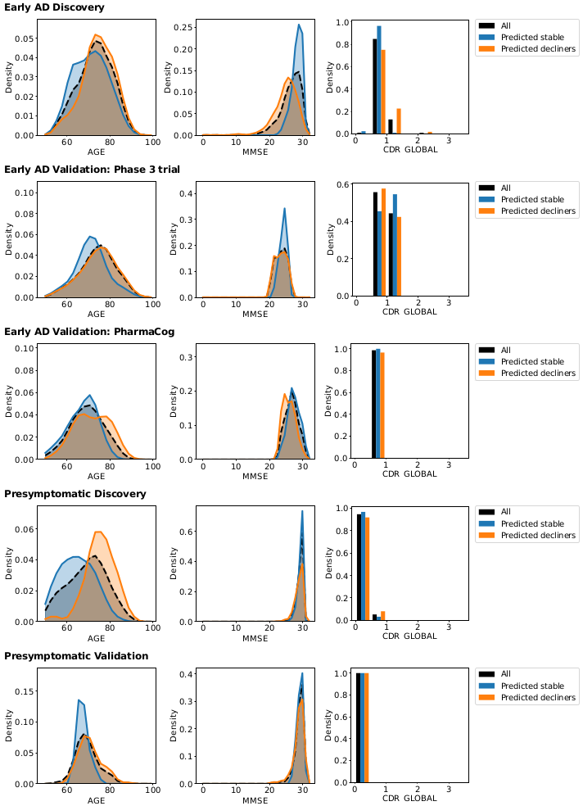
Figure S1. Distributions of age, MMSE, and global CDR measured at baseline for the whole sample (black), the predicted stable (blue) and the predicted decliners (orange).

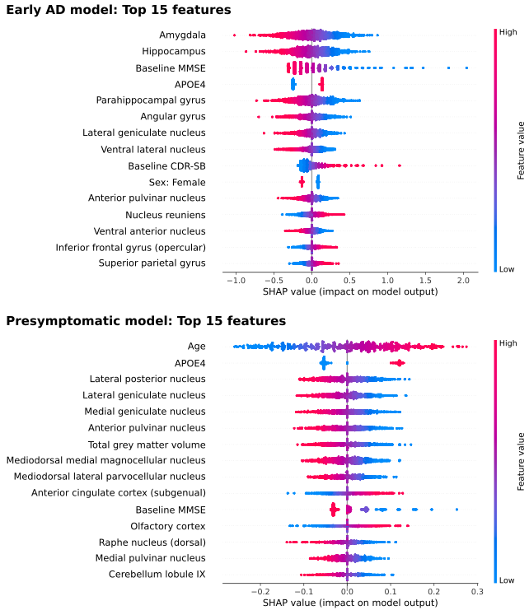
Figure S2. Analysis of the importance of each feature for both the early AD (top) and presymptomatic (bottom) models. The x-axis contains SHapley Additive exPlanations (SHAP) values (see Lundberg & Lee, 2017 (50)), while the y-axis contains the top 15 most important features, in descending order. Each point in the plot denotes the feature of a sample from the discovery set, and its colour indicates the value of that feature: higher feature values are in red and lower feature values are in blue. SHAP values measure the impact of a feature on the output of the model: the higher the SHAP value, the more that feature is driving the model to classify that participant as a decliner, while the lower the SHAP value, the more that feature is driving the model to predict that the participant will remain stable. Looking at the presymptomatic model for instance, one can see that older individuals (i.e. with a higher age, thus in red) have higher SHAP values, while younger individuals (in blue) have lower SHAP values. This indicates that the older the individual, the more the model will be driven to predict that individual as a decliner.

