Supplementary Figure 1
Distribution of daily dietary theobromine intake.
(A) original daily theobromine intake, while (B) log transformation distribution.

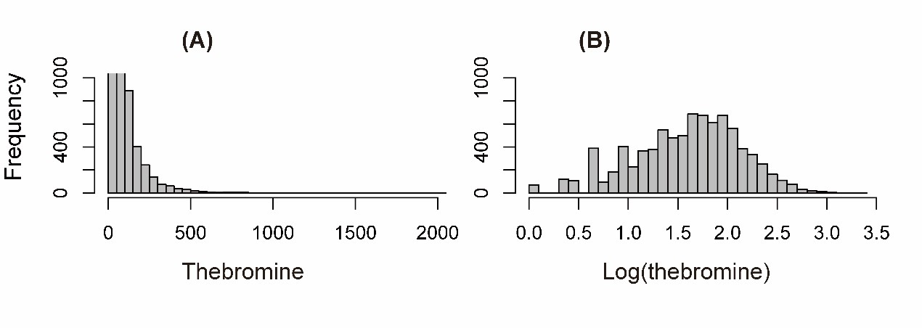
Supplementary Figure 2
Association of dietary theobromine intake and cognitive performance.
(A) CERAD-learning test score (B) CERAD-recall test score
(C) Animal fluency test score (D) DSST score

Supplementary Figure 3
Association of log-transformed theobromine intake and cognitive performance.
(A) CERAD-learning test score (B) CERAD-recall test score
(C) Animal fluency test score (D) DSST score

