Supplementary Information
Supplement to: Budd Haeberlein S, Aisen PS, Barkhof F et al. Two Randomized Phase 3 Studies to Evaluate Aducanumab in Early Alzheimer’s Disease.

Supplement
Supplement 1 Inclusion and exclusion criteria
Supplement 2 Discontinuation of study treatment
Supplement 3 Description of study populations and statistical models
Supplement 4 Sensitivity analyses of primary efficacy endpoint

Supplemental Data
Supplemental Data Table 1 Demographic and baseline disease characteristics in the amyloid PET, tau PET, CSF, and plasma p-tau¹⁸¹ populations
Supplemental Data Table 2 Change from baseline to week 78 on the CDR-SB, primary analysis and prespecified and post hoc sensitivity analyses in EMERGE
Supplemental Data Table 3 Summary of CDR-SB data in final data set compared with futility OTC
Supplemental Data Table 4 Proportion of patients in EMERGE and ENGAGE with amyloid PET composite SUVR ≤1.10 at week 78
Supplemental Data Table 5 Serious symptoms of ARIA
Supplemental Data Table 6 Severe ARIA symptoms during an ARIA episode
Supplemental Data Fig. 1 EMERGE and ENGAGE dose regimen, enrollment and timing of key protocol amendments
Supplemental Data Fig. 2 Mean change from baseline in the CDR-SB, MMSE, ADAS-Cog13, ADCS-ADL-MCI, and NPI scores
Supplemental Data Fig. 3 Subgroup analyses of primary and secondary endpoints
Supplemental Data Fig. 4 Correlation analysis of amyloid PET, plasma p-tau¹⁸¹ and clinical efficacy
Supplemental Data Fig. 5 Exploratory biomarker results from EMERGE and ENGAGE

Supplement 1
Inclusion and Exclusion Criteria

Inclusion Criteria (verbatim from Study Protocol)
To be eligible to participate in this study, candidates must meet the following eligibility criteria at Screening or at the timepoint specified in the individual eligibility criterion listed:
- Ability to understand the purpose and risks of the study and provide signed and dated informed consent and authorization to use confidential health information in accordance with national and local subject privacy regulations.
- Aged 50 to 85 years old, inclusive, at the time of informed consent.
- All women of childbearing potential and all men must practice highly effective contraception during the study and for 24 weeks after their last dose of study treatment.
- Must have at least 6 years of education or work experience to exclude mental deficits other than MCI or mild AD.
- Must have a positive amyloid PET scan. Previously obtained PET scan (within 12 months of Screening) is permissible for subjects not participating in the amyloid PET sub-study. Previous PET scan images must be submitted to the central imaging vendor to confirm study inclusion criteria are met.
- Must meet all of the following clinical criteria for MCI due to AD or mild AD according to NIA-AA criteria, and must have:
  - A CDR global score of 0.5.
  - An RBANS score of 85 or lower indicative of objective cognitive impairment (based upon the Delayed Memory Index score).
  - An MMSE score between 24 and 30 (inclusive).
- Apart from a clinical diagnosis of early AD, the subject must be in good health as determined by the investigator, based on medical history and screening assessments.
- Must consent to APOE genotyping.
- Has one informant/care partner who, in the investigator’s opinion, has frequent and sufficient contact with the subject as to be able to provide accurate information about the subject’s cognitive and functional abilities. The informant/care partner must minimally be available by phone to provide information to the investigator and study staff about the subject and agrees to attend in person clinic visits that require partner input for scale completion. An informant/care partner should be available for the duration of the study, and the use of the same informant/care partner for the duration of the study is encouraged.

Exclusion Criteria (verbatim from Study Protocol)
Candidates will be excluded from study entry if any of the following exclusion criteria exist at Screening, or at the timepoint specified in the individual criterion listed:
Medical History
- Any uncontrolled medical or neurological/neurodegenerative condition (other than AD) that, in the opinion of the investigator, might be a contributing cause of the subject’s cognitive impairment (e.g., substance abuse, vitamin B₁₂ deficiency, abnormal thyroid function, stroke or other cerebrovascular condition, Lewy body dementia, frontotemporal dementia, head trauma).
- Clinically significant unstable psychiatric illness (e.g., uncontrolled major depression, uncontrolled schizophrenia, uncontrolled bipolar affective disorder) within 6 months prior to Screening.
- Transient ischemic attack or stroke or any unexplained loss of consciousness within 1 year prior to Screening.
- Brain MRI performed at Screening (per centrally read MRI) that shows evidence of any of the following:
  - Acute or sub-acute hemorrhage.
  - Prior macrohemorrhage (defined as >1 cm in diameter on T2* sequence) or prior subarachnoid hemorrhage unless it can be documented that the finding is not due to an underlying structural or vascular abnormality (i.e., finding does not suggest subject is at risk of recurrent hemorrhage).
  - Greater than 4 microhemorrhages (defined as ≤ 1 cm in diameter on T2* sequence).
  - Cortical infarct (defined as >1.5 cm in diameter; irrespective of anatomic location).
  - >1 lacunar infarct (defined as ≤1.5 cm in diameter).
  - Superficial siderosis.
  - History of diffuse white matter disease as defined by a score of 3 on the age-related white matter changes scale.
  - Any finding that, in the opinion of the investigator, might be a contributing cause of subject’s dementia, might pose a risk to the subject, or might prevent a satisfactory
  - MRI assessment for safety monitoring.
- History of bleeding disorder or predisposing conditions, blood clotting or clinically significant abnormal results on coagulation profile at Screening, as determined by the investigator.
- Presence of diabetes mellitus that, in the judgment of the investigator, cannot be controlled or adequately managed.
- History of unstable angina, myocardial infarction, chronic heart failure (New York Heart Association Class III or IV), or clinically significant conduction abnormalities (e.g., unstable atrial fibrillation) within 1 year prior to Screening.
- Clinically significant 12-lead ECG abnormalities, as determined by the investigator.
- Uncontrolled hypertension defined as: average of 3 systolic blood pressure [SBP]/diastolic blood pressure [DBP] readings >165 mmHg and/or >100 mmHg at Screening (blood pressure measurements exceeding these limits may be repeated as warranted by the investigator, but values must be within the specified limits for the subject to be eligible for the study), or persistent SBP/DBP readings >180 mmHg and/or >100 mmHg 3 months prior to randomization (Day 1) that, in the opinion of the investigator, are indicative of chronic uncontrolled hypertension.
- History of malignancy or carcinoma. The following exceptions may be made after discussion with the Sponsor:
  - Subjects with cancers in remission more than 5 years prior to Screening.
  - Subjects with a history of excised or treated basal cell or squamous carcinoma of the skin.
  - Subjects with localized prostate cancer with treatment cycles that completed at least 6 months prior to Screening.
- History of seizure within 10 years prior to Screening.
- Indication of impaired liver function as shown by an abnormal liver function profile at Screening (e.g., repeated values of aspartate aminotransferase [AST] and alanine aminotransferase [ALT] ≥ 2 × the upper limit of normal).
- History or evidence of an autoimmune disorder considered clinically significant by the investigator or requiring chronic use of systemic corticosteroids or other immunosuppressants.
- Recent history (within 1 year of Screening) of alcohol or substance abuse as determined by the investigator, a positive urine drug (due to nonprescription drug) or alcohol test at Screening, or use of cannabinoids (prescription or recreational).
- Clinically significant systemic illness or serious infection (e.g., pneumonia, septicemia) within 30 days prior to or during Screening.
- History of or known seropositivity for human immunodeficiency virus (HIV).
- History of or positive test result at Screening for hepatitis C virus antibody or hepatitis B virus (defined as positive for both hepatitis B surface antigen AND hepatitis B core antibody).
- History of severe allergic or anaphylactic reactions, or history of hypersensitivity to any of the inactive ingredients in the drug product (refer to the IB for information on the clinical formulation).
- Any other medical conditions (e.g., renal disease) that are not stable or controlled, or, which in the opinion of the investigator, could affect the subject’s safety or interfere with the study assessments.
Medications
- Any medications that, in the opinion of the investigator, may contribute to cognitive impairment, put the subject at higher risk for AEs, or impair the subject’s ability to perform cognitive testing or complete study procedures.
- Use of allowed chronic medications at doses that have not been stable for at least 4 weeks prior to Screening Visit 1 and during Screening up to Study Day 1, or use of AD medications (including but not limited to donepezil, rivastigmine, galantamine, tacrine, and memantine) at doses that have not been stable for at least 8 weeks prior to Screening Visit 1 and during Screening up to Study Day 1.
- Use of medications with platelet anti-aggregate or anti-coagulant properties (the use of aspirin at a prophylactic dose [≤ 325 mg daily] is allowed).
- Use of illicit narcotic medication.
- Vaccinations within 10 days prior to randomization (Day 1).
- Participation in any active immunotherapy study targeting Aβ unless documentation of receipt of placebo is available.
- Participation in any passive immunotherapy study targeting Aβ within 12 months of Screening unless documentation of receipt of placebo is available.
- Participation in any study with purported disease-modifying effect in AD within 12 months prior to Screening unless documentation of receipt of placebo is available. Subjects who developed `-E during a previous disease-modifying trial should be excluded.
- Participation in a previous study with aducanumab (subject is eligible if he/she did not receive active aducanumab).
Study Procedures
- Contraindications to having a brain MRI (e.g., pacemaker; MRI-incompatible aneurysm clips, artificial heart valves, or other metal foreign body; claustrophobia that cannot be medically managed).
- Contraindication to having a PET scan (e.g., inability to lie flat or still for the duration of the scan) or intolerance to previous PET scans (i.e., previous hypersensitivity reactions to any PET ligand or imaging agent, failure to participate in and comply with previous PET scans).
- A negative PET scan result with any amyloid-targeting ligand within 6 months prior to Screening.
- Have had or plan exposure to experimental radiation within 12 months prior to Screening such that radiodosimetry limits would be exceeded by participating in this study.
- For subjects who consent to LP, any contraindications to having a LP (e.g., platelet count <100,000/μL, lumbar spine deformity). Any symptoms caused by or related to the optional LP during Screening must be resolved prior to randomization (Day 1). Subjects may still participate in the overall study even if participation in the optional LP portion is contraindicated.
Others
- Female subjects who are pregnant or currently breastfeeding.
- Previous participation in this study. Subjects who fail Screening will be permitted to be rescreened once at the Sponsor’s discretion, except those who fail due to PET, MMSE, CDR global score >0.5, hepatitis B or C, or abnormal MRI findings. (Subjects who fail Screening due to a CDR global score of 0 may be rescreened; such subjects will be allowed to repeat the screening CDR assessment after 6 months.
- Subject currently living in an organized care facility with extensive intervention and/or support of daily living activities.
- Blood donation (≥ 1 unit) within 1 month prior to Screening.
- Inability to comply with study requirements.
- Other unspecified reasons that, in the opinion of the investigator or Biogen, make the subject unsuitable for enrollment.

Supplement 2
Discontinuation of study treatment
A participant must permanently discontinue study treatment for any of the following reasons:
- The participant develops any of the following:
  - ARIA-E accompanied by serious clinical symptoms except for “other medically important event”*
  - Symptomatic ARIA-H (microhemorrhages) with serious clinical symptoms except for “other medically important event”*
  - Symptomatic ARIA-H (superficial siderosis) with serious clinical symptoms except for “other medically important event”*
  - ARIA-H with ≥10 microhemorrhages and/or >2 focal areas of superficial siderosis
  - Any new incident macrohemorrhage (defined as >1 cm in diameter on T2*sequence)
  - The participant becomes pregnant. Study treatment must be discontinued immediately, and pregnancy must be reported
  - The participant withdraws consent to continue study treatment
  - The participant experiences a medical emergency that necessitates permanent discontinuation of study treatment or unblinding of the participant’s treatment assignment
  - The participant experiences an adverse event that does not resolve or requires continued treatment that meets exclusionary criteria
  - The participant experiences a severe infusion reaction
  - At the discretion of the investigator for medical reasons
  - At the discretion of the investigator or Sponsor for noncompliance
A participant who discontinues treatment is to remain in the study, attend a follow-up visit 18 weeks after the final dose, and immediately continue protocol-required tests and assessments at a subset of the clinic visits until the end of the study per the schedule of events or until the participant withdraws consent.
*Including those that are life-threatening (in the opinion of the investigator), require inpatient hospitalization or prolongation of existing hospitalization, and/or result in persistent or significant disability/incapacity or a congenital anomaly/birth defect.

Supplement 3
Description of Study Populations and Statistical Models

Analysis Population (verbatim from Statistical Analysis Plan)
- Intent-to-treat (ITT) population:
The ITT population is defined as all randomized subjects who received at least one dose of study treatment (aducanumab or placebo).
- Per-protocol (PP) population:
The PP population is defined as all subjects in the ITT population and also
  - had no violations of the following inclusion criteria:
    - Must have at least 6 years of education or work experience to exclude mental deficits other than MCI or mild AD;
    - Must have a positive amyloid PET scan;
    - Must have:
      - A CDR-Global Score of 0.5;
      - A Repeatable Battery for Assessment of Neuropsychological Status (RBANS) score of 85 or lower indicative of objective cognitive impairment (based upon the Delayed Memory Index score);
      - An MMSE score between 24 and 30 (inclusive).
  - had at least 14 infusions.*
  - did not make any change to concomitant AD symptomatic medications during the study.
- ¹⁸F-florbetapir amyloid PET analysis population:
The ¹⁸F-florbetapir amyloid PET analysis population is defined as all randomized subjects who received at least one dose of study treatment (aducanumab or placebo), used ¹⁸F-florbetapir ligand for amyloid PET scan, and had an evaluable baseline amyloid PET SUVR value for the composite region-of-interest using cerebellum as the reference region.
- Tau PET analysis population:
The tau PET modified analysis population is defined as all randomized subjects who received at least one dose of study treatment (aducanumab or placebo), had an evaluable baseline tau PET SUVR value and a post-baseline tau PET SUVR value.
- CSF analysis population:
The CSF modified analysis population for a specific biomarker is defined as all randomized subjects who received at least one dose of study treatment (aducanumab or placebo), had an evaluable baseline value as well as a post-baseline value at week 78 for that specific biomarker.
- Safety population:
The safety population is defined as all randomized subjects who received at least one dose of study treatment (aducanumab or placebo). It is the same population as the ITT population.
- Safety MRI population:
The safety MRI population is defined as all randomized subjects who received at least one dose of study treatment (aducanumab or placebo) and had at least one post-baseline MRI assessment.

Efficacy analysis
For efficacy endpoints, the following treatment groups of aducanumab (per randomization) will be evaluated and compared with placebo:
- Aducanumab high dose (10 mg/kg in ApoE ε4 carriers [including 6 mg/kg for subjects enrolled under protocol versions 1-3 who do not have the opportunity to uptitrate to 10 mg/kg prior to completing week 78 of the study] and 10 mg/kg in ApoE ε4 noncarriers).
- Aducanumab low dose (3 mg/kg in ApoE ε4 carriers and 6 mg/kg in ApoE ε4 noncarriers).
All efficacy analyses will be performed on the ITT population. In addition, the primary and secondary endpoints will also be performed on the per-protocol population. The efficacy analysis will be presented by treatment group (per randomization), i.e., aducanumab high dose, aducanumab low dose and placebo.

The primary, sensitivity and supplementary analyses for the primary and secondary endpoints are listed below:
Endpoint | Analysis | Analysis population | Included in this manuscript
CDR-SB | Primary: Analysis of change from baseline at week 78 (MMRM) | ITT | Yes
 | Sensitivity: Pattern mixture model (ANCOVA) | ITT | Supplemental Data Table 2
 | Sensitivity: Copy increment from reference method (ANCOVA) | ITT | Supplemental Data Table 2
 | Sensitivity: Imputation by natural disease progression (ANCOVA) | ITT | No
 | Sensitivity: Tipping point analysis (ANCOVA) | ITT | No
 | Supplementary: Censoring after intercurrent events (MMRM)* | ITT | Supplemental Data Table 2
 | Supplementary: Per-protocol analysis (MMRM) | Per-protocol | No
 | Supplementary: Responder analysis (Logistic regression) | ITT | No
 | Supplementary: Slope analysis (MMRM) | ITT | No
 | Supplementary: Divergence effect analysis (MMRM) | ITT | No
MMSE, ADAS-Cog13, ADCS-ADL-MCI | Primary: Analysis of change from baseline at week 78 (MMRM) | ITT | Yes
 | Sensitivity: Pattern mixture model (ANCOVA) | ITT | No
 | Supplementary: Censoring after intercurrent events (MMRM)* | ITT | No
 | Supplementary: Per-protocol analysis (MMRM) | Per-protocol | No
 | Supplementary: Slope analysis (MMRM) | ITT | No
 | Supplementary: Divergence effect analysis (MMRM) | ITT | No
* Analysis excludes data collected after the following intercurrent events: (1) premature discontinuation of the study treatment and (2) any change to concomitant AD symptomatic medications during the study.

Handling of missing items for scales (verbatim from Statistical Analysis Plan)
If any of the individual items for the primary and secondary endpoints is missing, the total score of the corresponding endpoint will be imputed by prorating the observed scores. For ADAS-Cog13, if 3 or fewer of 13 items (<25%) are missing, the total score will be imputed by the following algorithm: Total score = total score from the completed items * [maximum total score (=85) / maximum total score for the completed items]. The imputed number will be rounded up to the nearest integer. If more than 3 items are missing, the total score of ADAS-Cog13 at that visit will be considered missing. For ADCS-ADL-MCI, if 4 or fewer of 18 items (<25%) are missing, the total score will be imputed by a similar algorithm as that for ADAS-Cog13. The imputed number will be rounded up to the nearest integer. If more than 4 items are missing, the total score for ADCS-ADL-MCI at that visit will be considered missing. The same imputation algorithm will be applied to CDR-SB and MMSE, if only 1 box (of 6) of CDR is missing or if only 2 or fewer items (out of 11) are missing for MMSE. If the score from more than 1 box of CDR or more than 2 items of MMSE is not available, the CDR-SB or MMSE at that visit will be considered missing.

Considerations for multiple comparison adjustments (verbatim from Statistical Analysis Plan)
A sequential (closed) testing procedure will be used to control the overall Type I error rate due to multiple comparisons for the primary endpoint. The order of treatment comparisons is as follows: aducanumab high dose vs placebo and aducanumab low-dose vs placebo. All comparisons after the initial comparison with P>.05 will not be considered statistically significant.
Secondary endpoints have been rank prioritized, in the order of MMSE, ADAS-Cog13, and ADCS-ADL-MCI. In order to control for a Type I error for the secondary endpoints, a sequential closed testing procedure will be used and will include both the order of the secondary endpoints and treatment comparisons. Specifically, for each of the secondary endpoints, a sequential (closed) testing procedure, as for the primary endpoint, will be used to control the overall Type I error rate due to multiple treatment comparisons. If statistical significance is not achieved for 1 or 2 treatment comparisons, all endpoint(s) of a lower rank will not be considered statistically significant for that 1or 2 treatment comparisons, respectively.
There will be no multiple comparison adjustments for the sensitivity and supplementary analyses for the primary and secondary efficacy endpoints, the tertiary efficacy endpoints, the subgroup analyses or the additional analyses.

Primary analysis of CDR-SB (primary endpoint)
The estimand of the primary analysis is the mean difference of the change from baseline CDR-SB scores at week 78 between treatment groups in the ITT population. All observed data will be included in the primary analysis, including data collected after intercurrent events, i.e., treatment discontinuation or a change in concomitant use of AD symptomatic medication.
The change from baseline CDR-SB scores will be summarized by treatment group at each post-baseline visit. A mixed model repeated measures (MMRM) model will be used as the primary analysis to analyze change from baseline CDR-SB using fixed effects of treatment group, time (categorical), treatment group-by-time interaction, baseline CDR-SB, baseline CDR-SB by time interaction, baseline MMSE, AD symptomatic medication use at baseline (yes/no), region, and laboratory ApoE ε4 status (carrier/noncarrier). An unstructured covariance matrix will be used to model the within-patient variance-covariance errors. If the unstructured covariance structure matrix results in a lack of convergence, the heterogeneous Toeplitz covariance structure followed by the heterogeneous first-order autoregressive covariance structure will be used. The Kenward-Roger approximation will be used to estimate the denominator degrees of freedom. In the primary analysis, missing data are assumed to be missing at random.

Primary analysis of MMSE (secondary endpoint)
The change from baseline MMSE scores will be summarized by treatment group at each post-baseline visit. An MMRM model will be used as the primary analysis to analyze change from baseline MMSE using fixed effects of treatment group, time (categorical), treatment group-by-time interaction, baseline MMSE value, baseline MMSE by time interaction, AD symptomatic medication use at baseline (yes/no), region, and laboratory ApoE ε4 status (carrier/noncarrier). The same methods as in the primary analysis will be considered for the covariance structure and the degrees of freedom.

Primary analysis of ADAS-Cog13 (secondary endpoint)
The change from baseline ADAS-Cog13 scores will be summarized by treatment group at each post-baseline visit. An MMRM model will be used as the primary analysis to analyze change from baseline ADAS-Cog13 using fixed effects of treatment group, time (categorical), treatment group-by-time interaction, baseline ADAS-Cog13, baseline ADAS-Cog13 by time interaction, baseline MMSE, AD symptomatic medication use at baseline (yes/no), region, and laboratory ApoE ε4 status (carrier/noncarrier). The same methods as in the primary analysis will be considered for the covariance structure and the degrees of freedom.

Primary analysis of ADCS-ADL-MCI (secondary endpoint)
The change from baseline ADCS-ADL-MCI scores will be summarized by treatment group at each post-baseline visit. An MMRM model will be used as the primary analysis to analyze change from baseline ADCS-ADL-MCI using fixed effects of treatment group, time (categorical), treatment group-by-time interaction, baseline ADCS-ADL-MCI, baseline ADCS-ADL-MCI by time interaction, baseline MMSE, AD symptomatic medication use at baseline (yes/no), region, and laboratory ApoE ε4 status (carrier/noncarrier). The same methods as in the primary analysis will be considered for the covariance structure and the degrees of freedom.

The baseline and change from baseline amyloid SUVR values will be summarized by treatment groups (placebo, low dose and high dose) and by visit for the amyloid PET analysis population. An MMRM model will be used to analyze change from baseline SUVR with cerebellum as the reference region. Fixed effects of the model will include treatment groups (placebo, low dose and high dose), visit (week 26 and week 78), treatment group-by-visit interaction, baseline SUVR (continuous), baseline SUVR by visit interaction, baseline MMSE (continuous), laboratory ApoE ε4 status (carrier and noncarrier), and baseline age (continuous). Visit and treatment group will be treated as categorical variables in the model along with their interactions. An unstructured covariance matrix will be used to model the within-patient variance-covariance errors. If the unstructured covariance structure matrix results in a lack of convergence in any of the parameters, the heterogeneous Toeplitz covariance structure followed by the heterogeneous first-order autoregressive covariance structure will be used for all the parameters. The Kenward-Roger approximation will be used to estimate the denominator degrees of freedom. Adjusted means for each treatment group, pairwise adjusted differences with placebo, 95% confidence intervals for the differences and associated p-values will be presented at week 26 and week 78. The composite SUVR was also transformed to the centiloid (CL) scale using the following conversion equation: CL = 100*(SUVR – 1.0124) / 0.4339. This equation was derived following methods described previously.¹

Tau PET sub-study analysis
All the available post-baseline tau PET assessments will be used as one single post-baseline timepoint for analysis purpose. Six composite regions of interests (frontal, temporal, medial temporal, parietal, cingulate and occipital) normalized to cerebellar cortex served as summary measures of regional tau levels. The baseline and change from baseline values will be summarized by treatment groups (placebo, low dose and high dose) for each of the 6 composite regions at baseline and at post-baseline timepoint. An ANCOVA model will be used to analyze change from baseline value for each composite region at post-baseline timepoint. The model will include treatment groups (placebo, low dose and high dose), baseline SUVR value (continuous) and laboratory ApoE ε4 status (carrier and noncarrier) as covariates. Adjusted means for each treatment group, pairwise adjusted differences with placebo, 95% confidence intervals for the differences and associated p-values will be presented at post-baseline timepoint.

CSF sub-study analysis
The baseline and change from baseline values will be summarized by treatment groups (placebo, low-dose and high dose) for each CSF biomarker at baseline and week 78. An ANCOVA model will be used to analyze change from baseline value for each CSF biomarker at week 78. The model will include treatment groups (placebo, low dose and high dose), baseline biomarker value (continuous), laboratory ApoE ε4 status (carrier and noncarrier) and baseline age as covariates. Adjusted means for each treatment group, pairwise adjusted differences with placebo, 95% confidence intervals for the differences and associated p-values will be presented at week 78.

Supplement 4
Sensitivity analyses of primary efficacy endpoint

Sensitivity analyses assessed the robustness of the treatment effect to early treatment discontinuation, the use of or changes in Alzheimer’s disease symptomatic medications, and different assumptions for missing data. Several sensitivity analyses were prespecified, as listed below. The jump to reference analysis was not prespecified but was conducted given that this method is a most conservative assessment of missing data. In these sensitivity analyses, results for the high dose are consistent with the primary analysis:

- Censoring after intercurrent events: excluding data after intercurrent events (i.e., after early withdrawal or change in concomitant medications) estimates the result expected if all participants adhered to their randomized treatment.

- Pattern mixture model: this approach was used to model the predictive distribution of missing data conditional on the observed data. Participants who withdrew due to reasons related to efficacy were penalized and their missing data were imputed using the copy increment from reference method. Data from participants who withdrew due to reasons not related to efficacy or who stopped the study due to the termination of the studies were assumed to be missing at random.

- Copy increment from reference: this approach was prespecified to estimate what would have happened if participants who prematurely withdrew from the study and a similar proportion of those ongoing participants who could have withdrawn prematurely if the study had not been terminated (i.e., a total of 12% of the intent-to treat [ITT] population) retained the benefit gained from their prior treatment but progressed as if they were on placebo after withdrawal.

- Jump to reference: this approach was not prespecified but is the most conservative method among this family of sensitivity analysis approaches. It assumes that participants who withdrew early and a similar proportion of those ongoing participants who could have withdrawn prematurely if the study had not been terminated (i.e., a total of 12% of the ITT population) immediately lost benefit from previous study treatment and progressed as placebo afterward.

Therefore, across several different sensitivity analyses, statistical significance of the high-dose arm was consistently maintained (Supplemental Data Table 2)

In the tipping-point analysis, this prespecified delta adjustment approach showed that in order to overturn statistical significance achieved in the primary efficacy endpoint analysis, participants in the high-dose group who withdrew prematurely by March 20, 2019, and a similar proportion of those ongoing participants who could have withdrawn prematurely if the study had not been terminated (i.e., a total of 12% of the ITT population) would have had to progress faster than the participants in the placebo group. This is implausible, given that the large amount of posttreatment data collected after study termination showed no sign of high-dose participants performing worse than the placebo participants after discontinuing aducanumab. The implausibility of the worsening needed to overturn the statistical significance reinforces the robustness of the primary analysis.

Two additional post hoc sensitivity analyses were used to assess the consequences of nonnormality in the data. The nonnormality (i.e., right-skewness in the data) increased heterogeneity and could possibly bias estimates of treatment effects. The consequences of the nonnormality were assessed by repeating the primary analysis on data that were “normalized” using a log-transformation and a nonparametric procedure that used the ranked order of outcomes rather than the actual values. In the nonparametric and log-transformed analyses, the magnitude of the treatment effect was increased compared to the primary analysis (−0.44 and −0.49, respectively). The data transformations also decreased heterogeneity.

In summary, the treatment effect observed in the EMERGE high-dose arm was robust to a range of missing data assumptions and departures from normality assumptions.
Supplement references
1 Klunk, W. E. et al. The Centiloid Project: standardizing quantitative amyloid plaque estimation by PET. Alzheimers Dement. 11 (2015).

Supplemental Data
Supplemental Data Table 1 Demographic and baseline disease characteristics in the amyloid PET, tau PET, CSF, and plasma p-tau¹⁸¹ populations
Demographics and baseline characteristics are shown for the amyloid PET substudy population, the tau PET substudy population, the CSF substudy population, and the plasma p-tau¹⁸¹ analysis population.
ADAS-Cog13, Alzheimer’s Disease Assessment Scale–cognitive subscale (13 items); ADCS-ADL-MCI, Alzheimer’s Disease Cooperative Study–Activities of Daily Living Inventory (mild cognitive impairment version); ApoE, apolipoprotein E; CDR-SB, Clinical Dementia Rating–sum of boxes; MCI, mild cognitive impairment; MMSE, Mini-Mental State Examination; PET, positron emission tomography; RBANS, Repeatable Battery for Assessment of Neuropsychological Status; SUVR, standardized uptake value ratio.

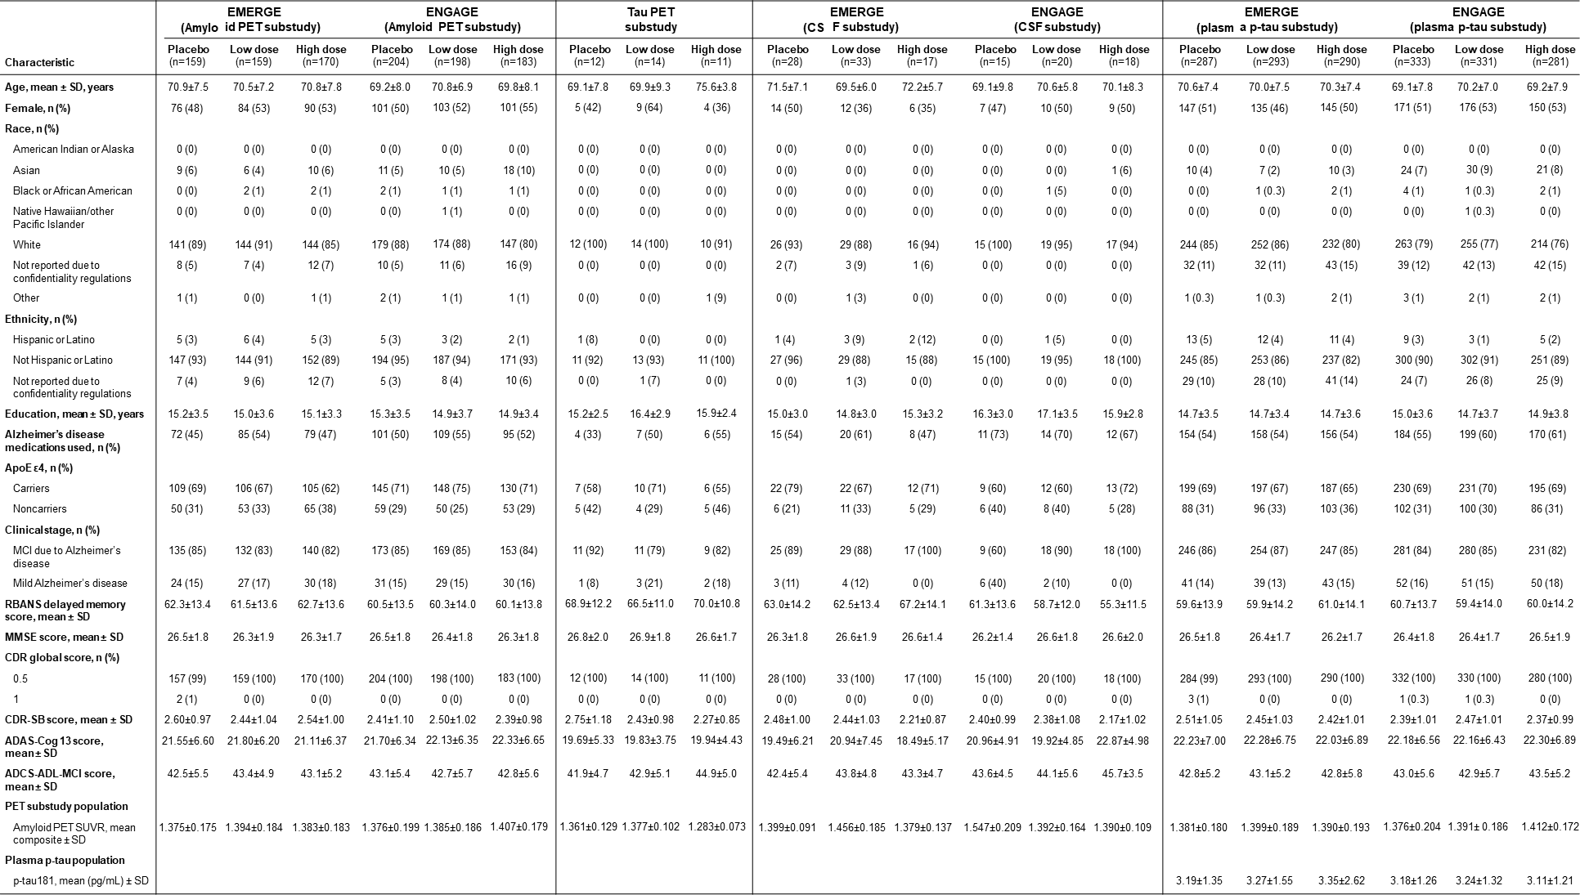

Supplemental Data Table 2 Change from baseline to week 78 on the CDR-SB, primary analysis and
prespecified and post hoc sensitivity analyses in EMERGE
The primary analysis was conducted on the randomized and dosed population excluding data collected after March 20, 2019. An MMRM was used as the primary analysis to analyze change from baseline in the CDR-SB with fixed effects of treatment group, time, treatment group-by-time interaction, baseline CDR-SB, baseline CDR-SB by time interaction, baseline MMSE, AD symptomatic medication use at baseline, region, and laboratory ApoE ε4 status (carrier and noncarrier). Except for the primary analysis, all other P values are nominal.
ª Difference vs. placebo at week 78. Negative percentage means less progression in the treated arm.
^{b} Data collected after premature discontinuation of treatment and any change to concomitant AD symptomatic medication were excluded.
^{c} Missing data for participants who withdrew from study due to reasons related to efficacy (e.g., consent withdrawn, withdrawal by parent/guardian, investigator decision, loss of capacity, change of treatment, disease progression and other) were imputed using the copy increment from reference method. Within administratively terminated participants, 5.5% were assumed to be potential dropouts due to reasons related to efficacy if the study had not been terminated and their missing data were imputed using the copy increment from reference method. All other missing data were imputed using the missing at random method.
^{d} Missing data for participants in active drug groups were imputed using the copy increment from the reference method. The missing data for participants still active in the placebo-controlled period on March 20, 2019, were imputed using the missing at random method, except for a portion that were assumed to be potential dropout if the study had not been terminated and were imputed using the copy increment from the reference method.
^{e} Missing data for participants in active drug groups was imputed using the jump to reference method. The missing data for participants still active in the placebo-controlled period on March 20, 2019, were imputed using the missing at random method, except for a portion that were assumed to be potential dropout if the study had not been terminated and were imputed using the jump to reference method.
^{f} An MMRM was fitted based on the log-transformed data, and the results were then transformed back to the original scale. The P values are for the difference at the log scale.
^{g} Nonparametric test P values were from a rank analysis of covariance model of the change from baseline CDR-SB at week 78 based on a data set imputed with multiple imputations. Hodges-Lehmann estimator of median difference at week 78 was calculated based on a data set imputed with multiple imputations.
AD, Alzheimer’s disease; ApoE, apolipoprotein E; CDR-SB, Clinical Dementia Rating Scale–sum of boxes; MMRM, mixed model for repeated measure; MMSE, Mini Mental State Examination.

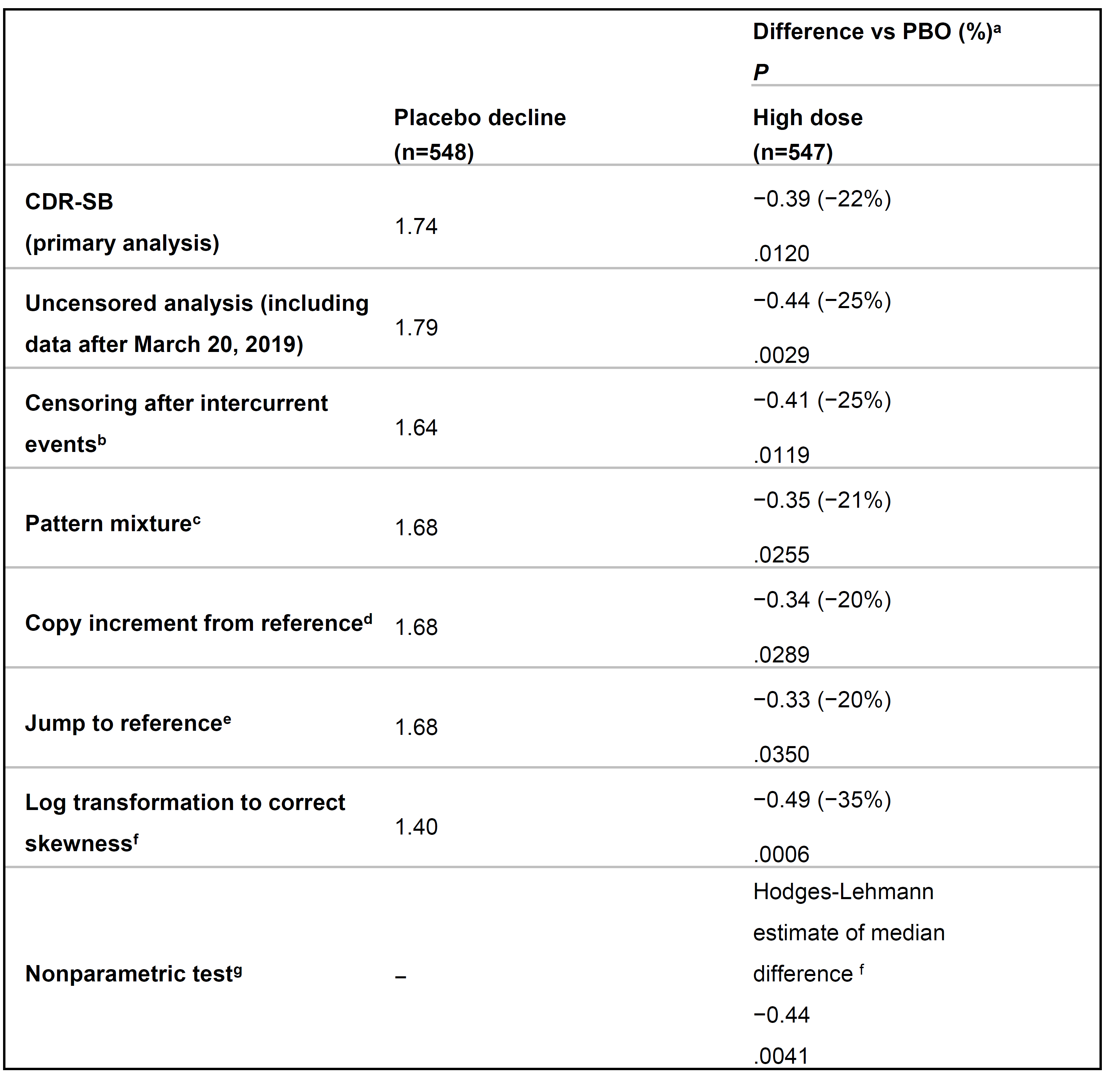

Supplemental Data Table 3 Summary of CDR-SB data in final data set compared with futility OTC
CDR-SB, Clinical Dementia Rating Scale–sum of boxes; futility OTC, opportunity to complete Week 78 by futility analysis cut-off.

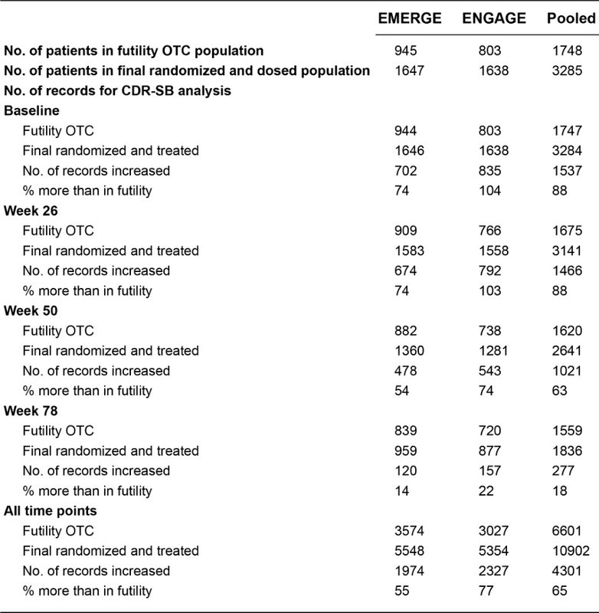

Supplemental Data Table 4 Proportion of patients in EMERGE and ENGAGE with amyloid PET composite SUVR ≤1.10 at week 78

PET, positron emission tomography; SUVR, standardized uptake value ratio. 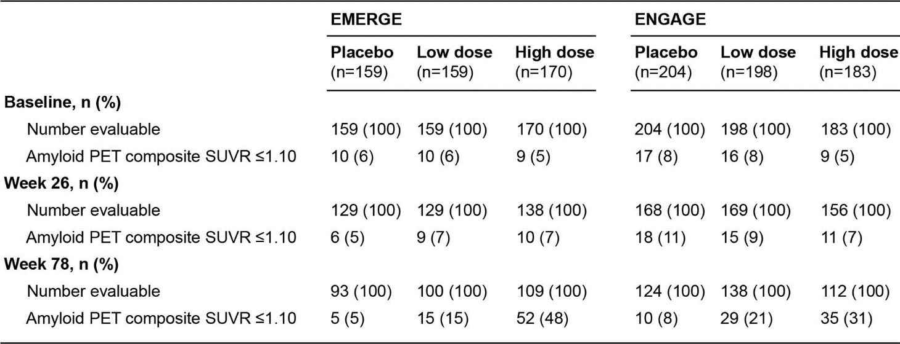

Supplemental Data Table 5 Serious symptoms of ARIA
The EMERGE and ENGAGE safety MRI population includes all randomized participants who received at least one dose of study treatment and had at least one postbaseline MRI assessment.
ª Includes all SAEs considered related to ARIA by the investigator, whether or not the event temporally overlapped with an ARIA episode (the case of delirium was not concurrent with ARIA).
adu, aducanumab; ARIA, amyloid-related imaging abnormalities.

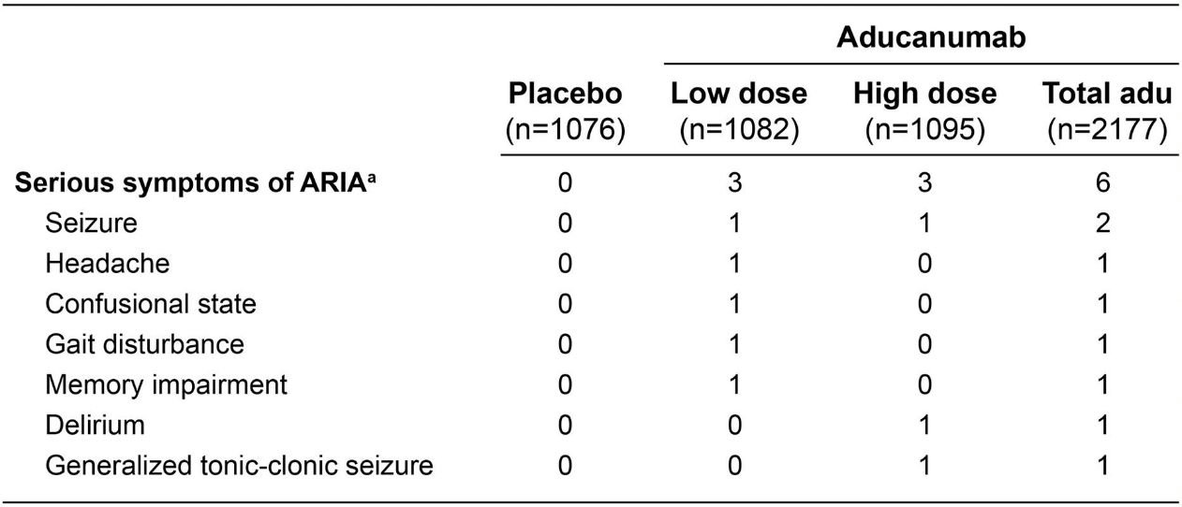
Supplemental Data Table 6 Severe ARIA symptoms during an ARIA episode
The EMERGE and ENGAGE safety MRI population includes all randomized participants who received at least one dose of study treatment and had at least one postbaseline MRI assessment.
ª One additional subject in the high dose group experienced a severe AE of delirium that was marked as an ARIA symptom but did not temporally overlap with an ARIA episode.
adu, aducanumab; ARIA, amyloid-related imaging abnormalities.

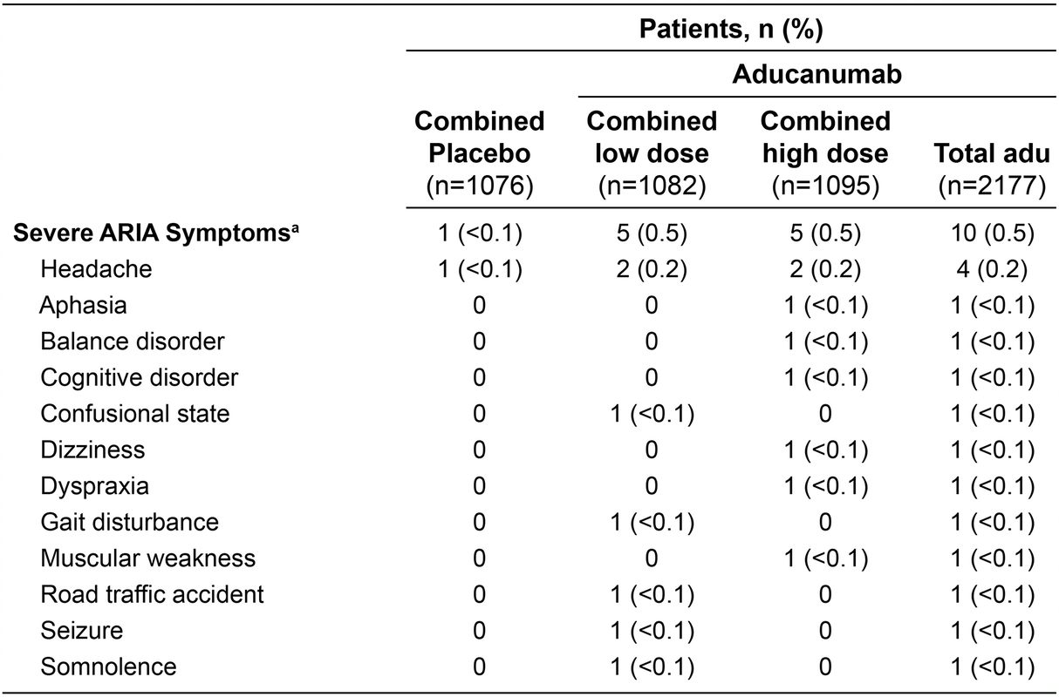

Supplemental Data Fig. 1 EMERGE and ENGAGE dose regimen, enrollment and timing of key protocol amendments
Panel a shows enrollment of patients and the timing of key protocol amendments relative to enrollment are shown. ENGAGE (blue line) began 1 month earlier than EMERGE (green line) and remained ahead in enrollment throughout the study. Recruitment was complete in both studies in July 2018. Two key protocol amendments affected dose. Protocol amendment 3 allowed some patients who had their dose suspended due to ARIA to have their dose re-titrated up to the originally assigned dose. Protocol amendment 4 allowed ApoE ε4 carriers to have their dose titrated to 10 mg/kg. The numbers of patients affected by the protocol amendments are approximate as the implementation of protocol changes occurred over time at different study sites. Panel b shows the dose regimens from EMERGE and ENGAGE. The studies both used two dose regimens, stratified by ApoE ε4 carrier status. In the low-dose group, the dose for ApoE ε4 carriers (top panel) was titrated to aducanumab 3 mg/kg, and the dose for ApoE ε4 noncarriers (middle panel) was titrated to aducanumab 6 mg/kg. These dosing regimens were maintained throughout the study. At study start, the high-dose group (lower panel) was different for ApoE ε4 noncarriers, whose dose was titrated to aducanumab 10 mg/kg (purple line), and carriers, whose dose was titrated to aducanumab 6 mg/kg (green line). Following protocol amendment, the dose for ApoE ε4 carriers in the high-dose group was titrated to aducanumab 10 mg/kg (purple line).
ApoE, apolipoprotein E; ApoE ε4−, noncarrier; ApoE ε4+, carrier; ARIA, amyloid-related imaging abnormalities.

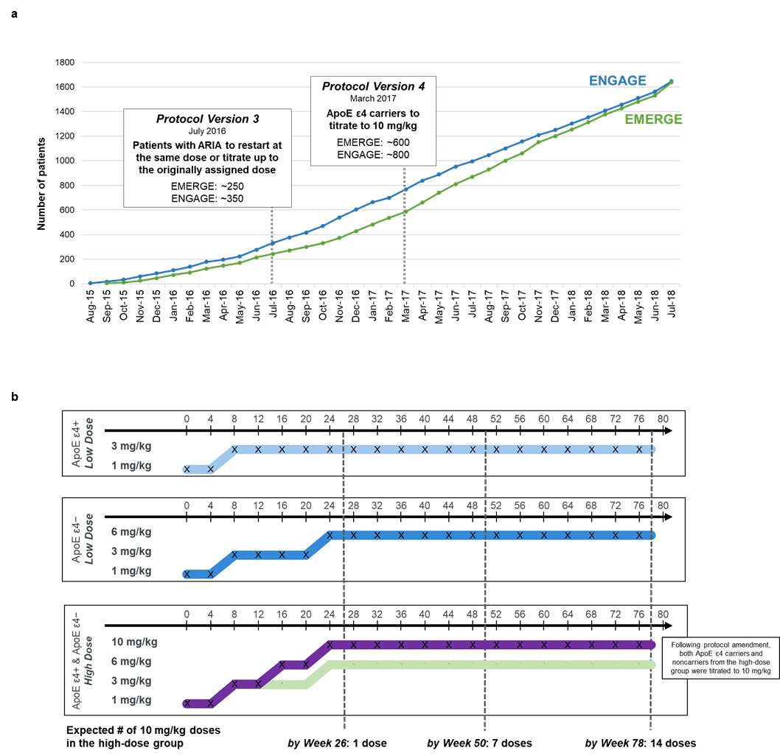

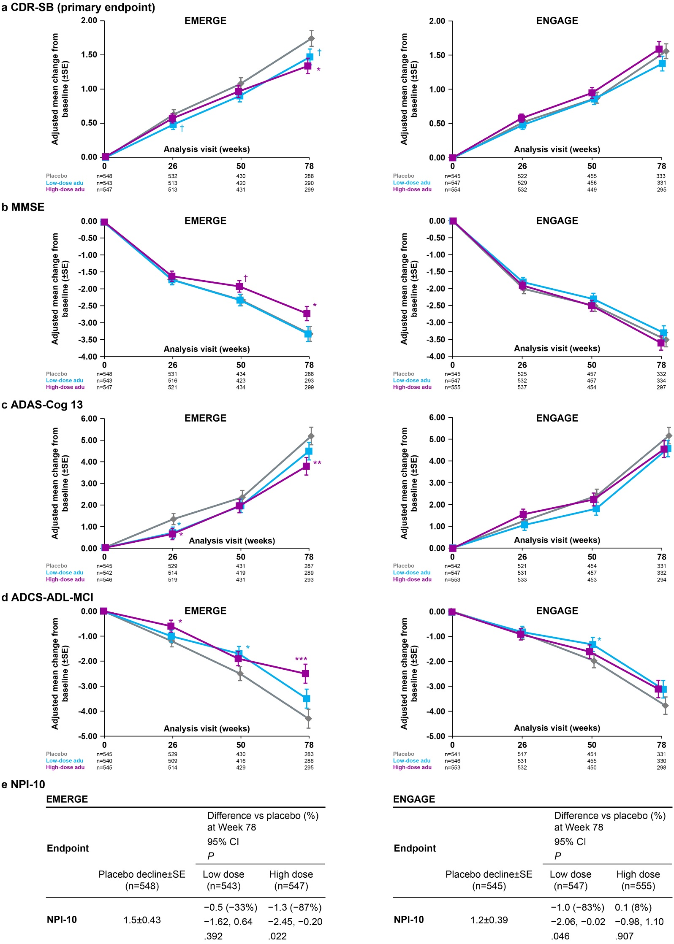

Supplemental Data Fig. 2 Mean change from baseline in the CDR-SB, MMSE, ADAS-Cog13, ADCS-ADL-MCI, and NPI scores
Longitudinal change from baseline in clinical measures is presented here. Panel a shows the adjusted mean change from baseline in the CDR-SB score; scores range from 0 to 18, rating three domains of cognition (memory, orientation, and judgment/problem solving) and three domains of function (community affairs, home/hobbies, and personal care), with higher scores indicating greater impairment. Panel b shows the adjusted mean change from baseline in the MMSE score; scores range from 0 to 30, with lower scores indicating greater impairment. Panel c shows the adjusted mean change from baseline in the ADAS-Cog13 score; scores range from 0 to 85, with higher scores indicating greater impairment. Panel d shows the adjusted mean change from baseline in the ADCS-ADL-MCI score; scores range from 0 to 53, with lower scores indicating greater impairment. Results were based on a mixed model for repeated measures for each endpoint, with change from baseline in CDR-SB, MMSE, ADAS-Cog13, or ADCS-ADL-MCI score as the dependent variable and with fixed effects of treatment group, categorical visit, treatment-by-visit interaction, baseline measure, baseline measure-by-visit interaction, baseline MMSE score (same as baseline score in the MMSE model), AD symptomatic medication use at baseline, region, and laboratory ApoE ε4 status. Data collected after March 20, 2019. were excluded. †P<.1 and ≥.05, *P<.05, **P<.01, ***P<.001. Error bars denote SE. Panel e shows results from the randomized and dosed population based on a mixed model for repeated measures, with change from baseline in NPI-10 as the dependent variable and with fixed effects of treatment group, categorical visit, treatment group-by-visit interaction, baseline NPI-10, baseline NPI-10 by visit interaction, baseline MMSE, AD symptomatic medication use at baseline, region, and laboratory ApoE status (carrier and noncarrier). Data collected after March 20, 2019, were excluded.
Negative percentage means less progression in the treated arm. P values are nominal. NPI-10 scores range from 0 to 120, with lower scores indicating greater impairment.
ADAS-Cog13, Alzheimer’s Disease Assessment Scale–cognitive subscale (13 items); ADCS-ADL-MCI, Alzheimer’s Disease Cooperative Study–Activities of Daily Living Inventory, mild cognitive impairment version; adu, aducanumab; ApoE, apolipoprotein E; CDR-SB, Clinical Dementia Rating Scale–sum of boxes; MMSE, Mini-Mental State Examination; NPI-10, Neuropsychiatric Inventory-10.

Supplemental Data Fig. 3 Subgroup analyses of primary and secondary endpoints
Forest plots of adjusted mean change from baseline vs placebo at week 78 on the primary and secondary clinical endpoints in EMERGE (a-d) and ENGAGE (e-h) high-dose groups and EMERGE (i-l) and ENGAGE (m-p) low dose groups. Prespecified subgroups by demographic characteristics and disease characteristics were analyzed for CDR-SB (a,e,i,m), MMSE (b,f,j,n), ADAS-Cog13 (c,g,k,o), and ADCS-ADL-MCI (d,h,l,p). Results were based on mixed models for repeated measures for each subgroup, with change from baseline in the clinical endpoint as dependent variable and with the following fixed effects (excluding covariates defining the subgroup): treatment group, categorical visit, treatment-by-visit interaction, baseline score, baseline score by visit interaction, baseline MMSE, AD symptomatic medication use at baseline, region, and laboratory ApoE status. Data collected after March 20, 2019, were excluded. The prespecified subgroups were laboratory ApoE status, baseline clinical stage, baseline MMSE, baseline AD medication use, region, age, and sex. These subgroups were not powered to detect a statistically significant difference in outcomes between the study arms.
AD, Alzheimer’s disease; ADAS-Cog13, Alzheimer’s Disease Assessment Scale–cognitive subscale (13 items); ADCS-ADL-MCI, Alzheimer’s Disease Cooperative Study–Activities of Daily Living Inventory, mild cognitive impairment version; ApoE, apolipoprotein E; CDR-SB, Clinical Dementia Rating Scale–sum of boxes; MMSE, Mini Mental State Examination.

Supplemental Data Fig. 4 Correlation analysis of amyloid PET, plasma p-tau¹⁸¹ and clinical efficacy
Panel a shows scatterplot of change from baseline in plasma p-tau¹⁸¹ levels vs. change from baseline in amyloid PET composite SUVR at Week 78 in EMERGE (left) and ENGAGE (right). R: Partial spearman correlation adjusted for baseline p-tau, baseline amyloid PET, and age. Correlations calculated based on all arms.
Panel b shows association between treatment effect on brain Aβ plaque levels and CDR-SB across aducanumab studies (group-level analysis). The analysis was conducted in active treatment groups, as pre-specified. CDR-SB results for EMERGE and ENGAGE were from the PET substudies using the same mixed model for repeated measures as the primary analysis for CDR-SB. The regression line was derived based on the data points from all three studies except the ENGAGE high-dose group. Sample sizes for each study are as follows: EMERGE (n=159 for low dose; n= 170 for high dose); ENGAGE (n=198 for low dose; n=183 for high dose); PRIME (n=29 for 1 mg/kg; n=32 for 3 mg/kg; n=30 for 6 mg/kg; n=31 for 10 mg/kg; n=19 for titration).
Panel c shows correlations between amyloid reduction or reduction in levels of plasma p-tau¹⁸¹ and efficacy endpoints change from baseline at week 78 (participant-level analysis). The population is limited to those participants in the amyloid PET or plasma p-tau¹⁸¹ subgroup who completed amyloid PET assessment or collection of plasma p-tau¹⁸¹ and efficacy assessments at week 78. P values (nominal): *P<.05 ** P<.01, *** P<.001. Correlations are partial Spearman correlations assessed in pooled low- and high-dose groups after adjustment for baseline biomarker and efficacy values (and age for correlation between plasma p-tau¹⁸¹ and efficacy correlation).
Aβ, amyloid β; ADAS-Cog13, Alzheimer’s Disease Assessment Scale–cognitive subscale (13 items); ADCS-ADL-MCI, Alzheimer’s Disease Cooperative Study–Activities of Daily Living Inventory, avg, average; mild cognitive impairment version; CDR-SB, Clinical Dementia Rating Scale–sum of boxes; MMSE, Mini Mental State Examination; PET, positron emission tomography; p-tau, phosphorylated tau; SUVR, standardized uptake value ratio.

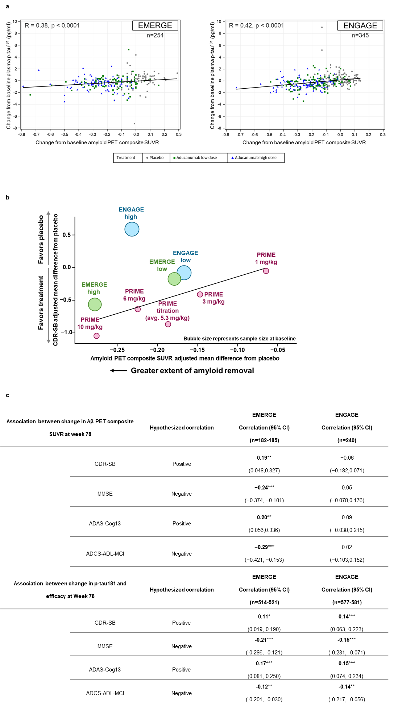
Supplemental Data Fig. 5 Exploratory biomarker results from EMERGE and ENGAGE
Panel a shows adjusted mean change from baseline in CSF Aβ₁₋₄₂ values in the CSF substudy for EMERGE (left) and ENGAGE (right). Results were based on an analysis of covariance model at week 78, fitted with change from baseline as the dependent variable, and with treatment, baseline CSF Aβ₁₋₄₂ value, baseline age, and laboratory ApoE ε4 status (carrier and noncarrier) as the independent variables. Panel b shows adjusted mean change from baseline in CSF levels of p-tau and t-tau in the CSF substudy for EMERGE (left two panels) and ENGAGE (right two panels). Results were based on an analysis of covariance model at week 78, fitted with change from baseline as the dependent variable, and with treatment, baseline biomarker value, baseline age, and laboratory ApoE ε4 status (carrier and noncarrier) as the independent variables. Panel c shows aducanumab treatment effect on tau PET SUVR (pooled results from EMERGE and ENGAGE) in the medial temporal (top left), temporal (top middle), afrontal (top right), cingulate (bottom left), occipital (bottom middle), and parietal (bottom right) regions. Adjusted mean change from baseline in tau PET average standardized uptake value ratio was assessed by ¹⁸F-MK-6240 in the tau PET substudy. Results were based on an analysis of covariance model at week 78, fitted with change from baseline as the dependent variable, and with categorical treatment, baseline tau PET value, and laboratory ApoE ε4 status (carrier and noncarrier) as independent variables. Panel d (EMERGE) and panel e (ENGAGE) show structural MRI results at weeks 30 and 78. Results (in cm³) were based on a mixed model for repeated measures, with change from baseline as dependent variable and with fixed effects of treatment group, categorical visit, treatment-by-visit interaction, baseline MRI value, baseline MRI value by visit interaction, baseline MMSE, baseline age, and laboratory ApoE ε4 status.
For all panels: P values (nominal): *P<.05, **P<.01, and ***P<.001.
ApoE, apolipoprotein E; CSF, cerebrospinal fluid; MMSE, Mini-Mental State Examination; MRI, magnetic resonance imaging; PET, positron emission tomography; p-tau, phosphorylated tau 181; t-tau, total tau.
