Supplementary materials

Supplementary Figure 1. Box plots of plasma Aβ42/Aβ40 ratio across the six platforms.
Supplementary Table 1. Correlations between plasma Aβ42/Aβ40 ratios across the six platforms in CU participants.
Supplementary Table 2. Parameters of discriminative ability of six plasma Aβ42/Aβ40 measures for Aβ-PET status in MCI.
Supplementary Table 3. Parameters of discriminative ability of six plasma Aβ42/Aβ40 measures for AD vs CU+MCI.
Supplementary Figure 2. Scatter plot of plasma Aβ42/Aβ40 ratio from WashU with PET centiloid.

Supplementary Figure 1. Box plots of plasma Aβ42/Aβ40 ratio across the six platforms.
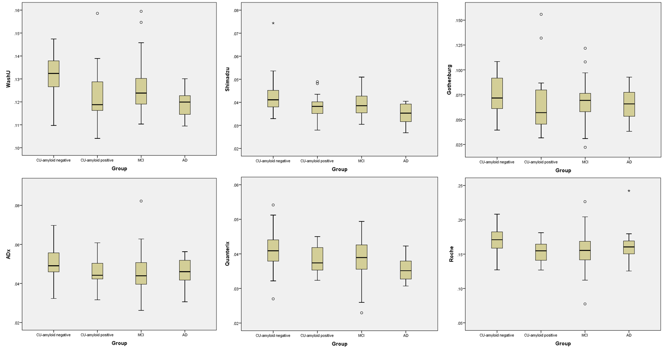
Supplementary Table 1. Correlations between plasma Aβ42/Aβ40 ratios across the six platforms in CU participants.
Pearson correlation |  | WashU | Shimadzu | Gothenburg | ADx | Quanterix | Roche
WashU |  | 1 | .429** | .398** | .559** | .307* | .529**
Shimadzu |  |  | 1 | .293* | .026 | .292* | .065
Gothenburg |  |  |  | 1 | .033 | .330* | .245
ADx |  |  |  |  | 1 | -.027 | .596**
Quanterix |  |  |  |  |  | 1 | .402**
Roche |  |  |  |  |  |  | 1
Note: **. Correlation is significant at the 0.01 level (2-tailed); *. Correlation is significant at the 0.05 level (2-tailed).

Supplementary Table 2. Parameters of discriminative ability of six plasma Aβ42/Aβ40 measures for Aβ-PET status in MCI.
Assays | AUC (95% CI) | P
WashU | 0.860 (0.761-0.959) | <0.001
Shimadzu | 0.713 (0.575-0.851) | 0.008
Gothenburg | 0.613 (0.460-0.765) | 0.159
ADx | 0.731 (0.590-0.873) | 0.004
Quanterix | 0.550 (0.391-0.709) | 0.533
Roche | 0.754 (0.616-0.892) | 0.002

Supplementary Table 3. Parameters of discriminative ability of six plasma Aβ42/Aβ40 measures for AD vs CU+MCI.
Assays | AUC (95% CI) | P
WashU | 0.734 (0.613-0.854) | 0.008
Shimadzu | 0.723 (0.581-0.865) | 0.012
Gothenburg | 0.533 (0.371-0.696) | 0.708
ADx | 0.515 (0.351-0.679) | 0.869
Quanterix | 0.726 (0.594-0.857) | 0.011
Roche | 0.502 (0.336-0.668) | 0.978

Supplementary Figure 2. Scatter plot of plasma Aβ42/Aβ40 ratio from WashU with PET centiloid.
