SUPPLEMENT

Supplement Figure 1. Longitudinal Change and Effect Size vs Aβ- CN Controls for IDN, DET, OCL, and OBK

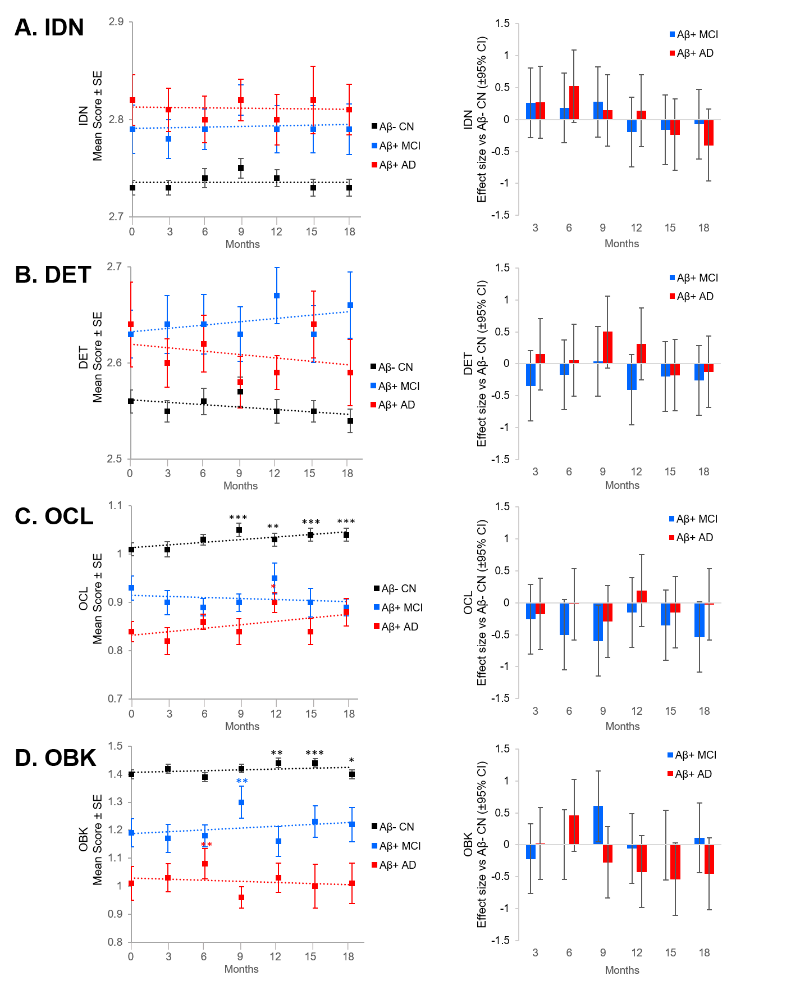
* p<.05, † p<.001 LMM slope significantly different from baseline.
Aβ, amyloid-β; AD, Alzheimer’s disease; CI, confidence interval; CN, cognitively normal; DET, Detection Task; IDN, Identification Task; MCI, mild cognitive impairment; OBK, One-Back Task; OCL, One Card Learning Task; SE, standard error.

Supplement Figure 1: Left column: IDN (A), DET (B), OCL (C), and OBK (D) mean scores for Aβ- CN (black line), Aβ+ MCI (blue line), and Aβ+ AD (red line) at 3-month intervals over 18 months. Right column: effect sizes for Aβ+ MCI (blue) and Aβ+ AD (red) versus Aβ- CN on IDN (A), DET (B), OCL (C) and OBK (D) at 3-month intervals over 18 months.

