Supplementary materials

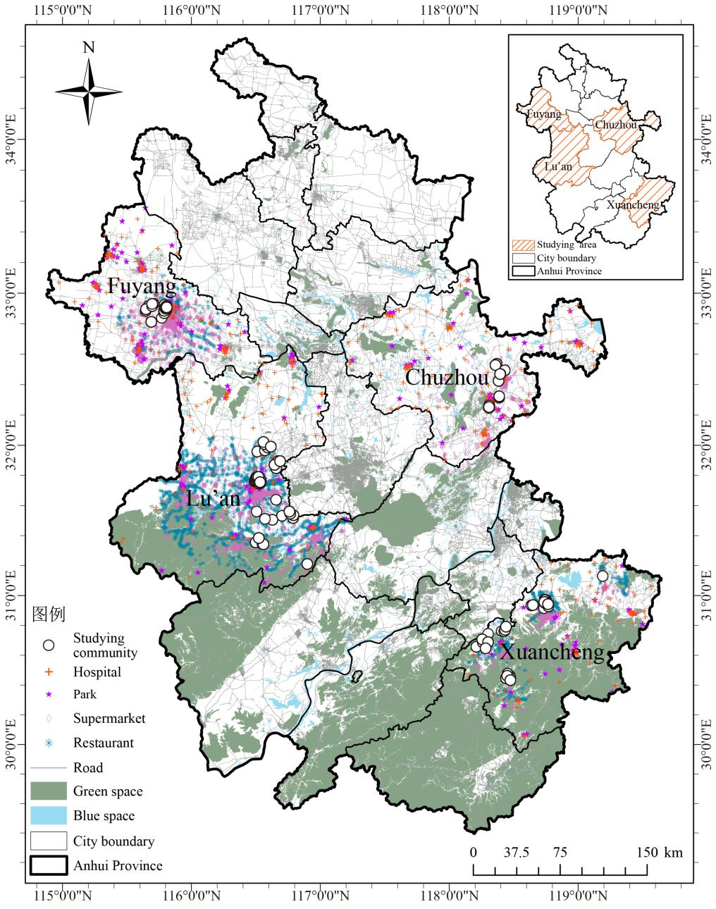

Fig.1 The distribution of built environment factors of the studying areas in AHLS

(A) Median distance to the nearest supermarket, restaurant, hospital and park, by cities (m)

(B) Proportions of the people with or without green/blue space within 800m buffers, by cities (%)
100
50
0
50
100
Fig. 2 Distributions of the built environmental factors across the four studying cities
Table 1. Basic characteristics of the environmental factors by MCI categories
 | Normal cognitive function（n=3682） | MCI  （n=1986） | χ2 | p
Noise
Yes | 486 | 222 | 2.430 | 0.119
No | 3376 | 1764
Dust
Yes | 358 | 214 | 3.369 | 0.006
No | 3504 | 1772
Space
Yes | 2464 | 1019 | 84.972 | <0.001
No | 1398 | 967
Supermarket
Q1 | 1170 | 508 | 51.582 | <0.001
Q2 | 944 | 478
Q3 | 970 | 441
Q4 | 778 | 559
Restaurant
Q1 | 979 | 507 | 7.057 | 0.070
Q2 | 1143 | 554
Q3 | 747 | 439
Q4 | 993 | 486
Hospital
Q1 | 1007 | 475 | 15.192 | 0.002
Q2 | 971 | 445
Q3 | 921 | 553
Q4 | 963 | 513
Park
Q1 | 1028 | 480 | 43.016 | <0.001
Q2 | 1105 | 479
Q3 | 736 | 518
Q4 | 993 | 509
Green Space
Any | 1489 | 694 | 7.308 | 0.007
None | 2373 | 1292
Blue Space |  |  | 20.820 | <0.001
Any | 1162 | 485
None | 2700 | 1501

Table 2. The associations between living environment, built environment factors and cognitive function by sexes: Coefficients and 95% CIs for MMSE and Odds Ratios for MCI (by multi-level regression models).
 | Both sexes |  |  |  | Male |  |  |  | Female
 | MMSE ª | P _{adjusted} | MCI ª | P _{adjusted} | MMSE ^{b} | P _{adjusted} | MCI ^{b} | P _{adjusted} | MMSE ^{b} | P _{adjusted} | MCI ^{b} | P _{adjusted}
Living environment
Noise (No)  (Ref: yes) | -0.011  (- 0.390, 0.368) | 1 | 0.957  (0.798 ,1.148) | 1 | -0.083  (-0.617, 0.451) | 1 | 0.879  (0.671, 1.152) | 1 | 0.170  (-0.360, 0.702) | 1 | 0.982  (0.769, 1.254) | 1
Dust (No)  (Ref: yes) | 0.351  (-0.064, 0.765) | 0.882 | 0.813  (0.671, 0.985) | 0.315 | 0.812  (0.223, 1.401) | 0.063 | 0.649  (0.487, 0.865) | 0.027 | 0.012  (-0.567, 0.591) | 1 | 0.942  (0.728, 1.219) | 1
Recreational space (No)  (Ref: yes) | -0.589  (-0.892, -0.285) | <0.001 | 1.144  ( 0.993,1.317) | 0.558 | -1.111  (-1.532,-0.689) | <0.001 | 1.407  (1.137, 1.742) | 0.018 | -0.288  (-0.708, 0.131) | 1 | 0.994  (0.827, 1.196) | 1
Built environment
Supermarket Ref: Q1 | - |  |  |  | - |  |  |  | -
Q2 | -0.159  (-0.561, 0.242) | 1 | 1.191  (1.010, 1.404) | 0.333 | -0.199  (-0.731, 0.332) | 1 | 1.204  (0.938, 1.545) | 1 | -0.428  (-0.942, 0.087) | 0.936 | 1.179  (0.946, 1.469) | 1
Q3 | -0.147  (-0.584, 0.291) | 1 | 1.111  (0.932, 1.324) | 1 | 0.103  (-0.451, 0.658) | 1 | 0.902  (0.690, 1.178) | 1 | -0.597  (-1.164, -0.029) | 0.351 | 1.282  (1.012, 1.624) | 0.351
Q4 | -0.648  (-1.159, -0.137) | 0.117 | 1.204  (1.001, 1.448) | 0.441 | -0.434  (-1.053, 0.187) | 1 | 1.034  (0.784, 1.362) | 1 | -0.972  (-1.613, -0.332) | 0.027 | 1.338  (1.040, 1.720) | 0.207
Restaurant  Ref: Q1 | - |  |  |  | - |  |  |  | -
Q2 | 0.283  (-0.078, 0.645) | 1 | 0.868  (0.722, 1.043) | 1 | 0.103  (-0.412, 0.618) | 1 | 0.950  (0.734, 1.231) | 1 | 0.468  (-0.021, 0.957) | 0.549 | 0.803  (0.644, 1.003) | 0.729
Q3 | -0.280  (-0.720, 0.159) | 1 | 1.095  (0.902, 1.329) | 1 | -0.510  (-1.112, 0.093) | 0.882 | 1.307  (0.974, 1.753) | 0.675 | -0.187  (-0.778, 0.403) | 1 | 0.944  (0.731, 1.218) | 1
Q4 | -0.040  (-0.529, 0.448) | 1 | 1.007  (0.837, 1.210) | 1 | -0.072  (-.666, 0.523) | 1 | 0.981  (0.740, 1.299) | 1 | -0.046  (-0.671, 0.578) | 1 | 1.011  (0.793, 1.290) | 1
Park  Ref: Q1 | - |  |  |  | - |  |  |  | -
Q2 | 0.043  (-0.480, 0.566) | 1 | 0.939  (0.749, 1.178) | 1 | -0.202  (-0.846, 0.442) | 1 | 1.066  (0.785, 1.447) | 1 | 0.344  (-0.332, 1.020) | 1 | 0.824  (0.626, 1.085) | 1
Q3 | -0.063  (-0.694, 0.568) | 1 | 0.961  (0.761, 1.214) | 1 | -0.314  (-1.042, 0.415) | 1 | 0.993  (0.725, 1.359) | 1 | 0.198  (-0.583, 0.979) | 1 | 0.913  (0.700, 1.189) | 1
Q4 | -0.561  (-1.210, 0.088) | 0.810 | 1.169  (0.923, 1.479) | 1 | -0.457  (-1.155, 0.241) | 1 | 1.137  (0.841, 1.537) | 1 | -0.423  (-1.209, 0.364) | 1 | 1.134  (0.863, 1.492) | 1
Hospital  Ref: Q1 | - |  |  |  | - |  |  |  | -
Q2 | -0.120  (-0.520, 0.279) | 1 | 0.977  (0.804, 1.187) | 1 | -0.229  (-0.783, 0.324) | 1 | 0.982  (0.739, 1.304) | 1 | -0.132  (-0.672, 0.408) | 1 | 1.036  (0.803, 1.336) | 1
Q3 | -0.080  (-0.524, 0.363) | 1 | 1.045  (0.850, 1.284) | 1 | -0.185  (-0.789, 0.418) | 1 | 0.976  (0.721, 1.319) | 1 | 0.058  (-0.531, 0.646) | 1 | 1.035  (0.804, 1.331) | 1
Q4 | 0.340  (-0.127, 0.808) | 1 | 0.845  (0.673, 1.062) | 1 | 0.322  (-0.302, 0.945) | 1 | 0.853  (0.603, 1.207) | 1 | 0.062  (-0.553, 0.676) | 1 | 0.962  (0.735, 1.259) | 1
Green space within 800m buffers (Any) (Ref: none) | 0.144  (-0.198, 0.485) | 1 | 0.960  (0.825, 1.117) | 1 | 0.136  (-0.295, 0.567) | 1 | 0.922  (0.750, 1.134) | 1 | 0.187  (-0.272, 0.647) | 1 | 1.001  (0.837, 1.198) | 1
Blue space within 800m buffers (Any) (Ref: none) | 0.347  (-0.146, 0.840) | 1 | 0.882  (0.718, 1.084) | 1 | 0.311  (-0.222, 0.843) | 1 | 0.934  (0.721, 1.210) | 1 | 0.619  (-0.062, 1.300) | 0.676 | 0.840  (0.660, 1.707) | 1
a: The model adjusted sex (male and female), age (continuous), location (urban and rural), city (Chuzhou, Lu’an, Xuancheng and Fuyang), education (0, 0–6 years and more than 6 years), marital status (married and not married), income (lower than 6500 RMB and 6500 RMB or higher), diabetes (yes and no), hypertension (yes and no), drinking status (never, former and current), smoking (current smoker, noncurrent smoker), depression (yes and no), overweight (yes and no), sleep quality (very good, good, bad and very bad), and sedentary hours (continuous).

b: The model adjusted age (continuous), location (urban and rural), city (Chuzhou, Lu’an, Xuancheng and Fuyang), education (0, 0–6 years and more than 6 years), marital status (married and not married), income (lower than 6500 RMB and 6500 RMB or higher), diabetes (yes and no), hypertension (yes and no), drinking status (never, former and current), smoking (current smoker, noncurrent smoker), depression (yes and no), overweight (yes and no), sleep quality (very good, good, bad and very bad), and sedentary hours (continuous).
Table 3. The associations between multiple environments factors and cognitive function among males: Coefficients and 95% CIs for MMSE and Odds Ratios for MCI (by multi-level regression models).
 | MMSE | p | MCI | p
Living environment
Dust (No)  (Ref: yes) | 0.828  (0.243, 1.413) | 0.006 | 0.651  (0.488, 0.868) | 0.003
Recreational space (No)  (Ref: yes) | -1.107  (-1.529, -0.686) | <0.001 | 1.403  (1.134, 1.737) | 0.002

The model adjusted age (continuous), location(urban and rural), city (Chuzhou, Lu’an, Xuancheng and Fuyang), education (0, 0–6 years and more than 6 years), marital status (married and not married), income (lower than 6500 RMB and 6500 RMB or higher), diabetes (yes and no), hypertension (yes and no), drinking status (never, former and current), smoking (current smoker, noncurrent smoker), depression (yes and no), overweight (yes and no), sleep quality (very good, good, bad and very bad), and sedentary hours (continuous).

