**Appendix 4- Figure A4: Acceptability curves of intervention strategies vs. placebo using different effectiveness criteria**

**Appendix 4.b: Acceptability curves of intervention strategies vs. placebo using percentage of participants with no aggravation between 3 years and baseline**

**Appendix 4.a: Acceptability curves of intervention strategies vs. placebo using changes in Z score between 3 years and baseline**

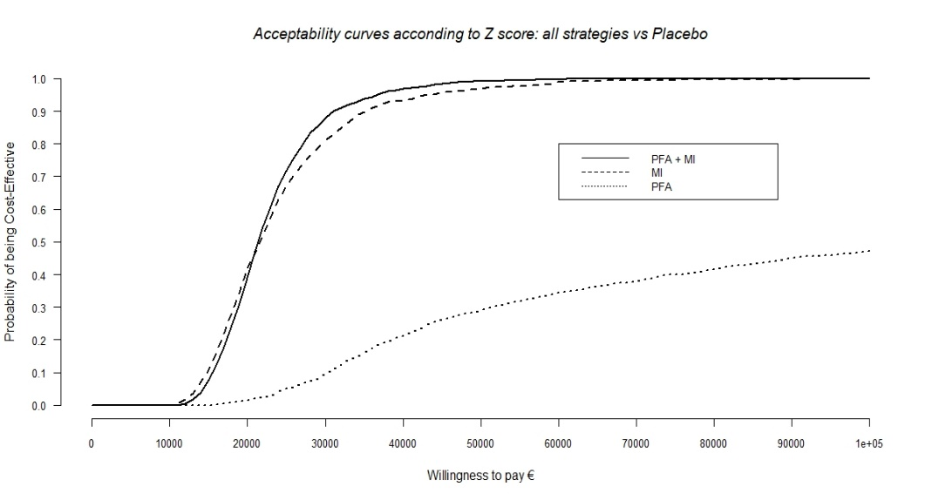 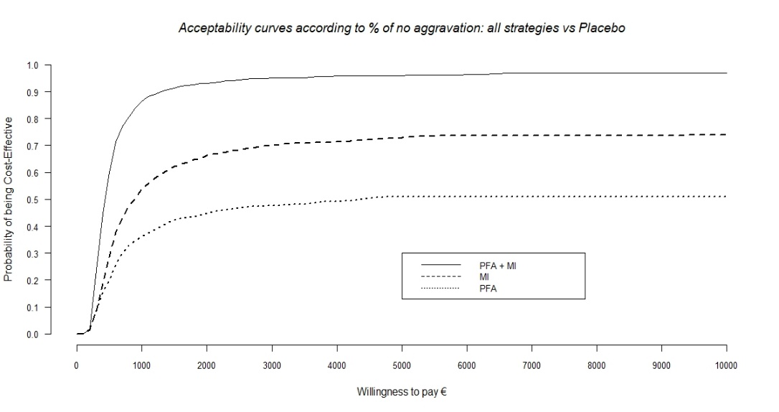

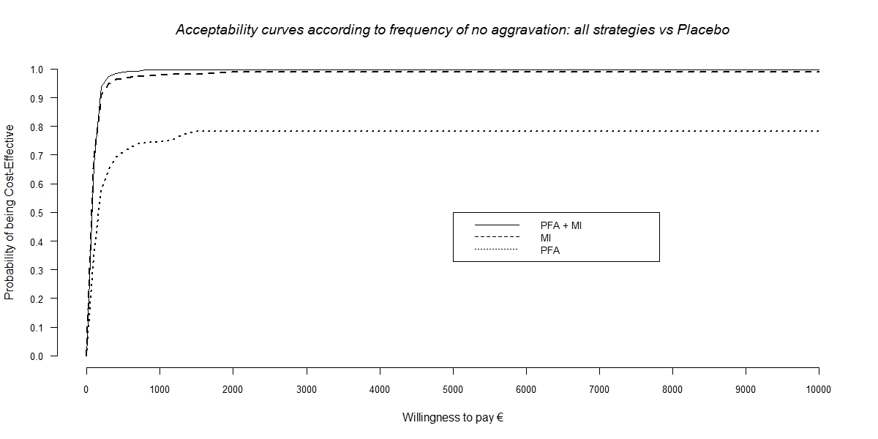

**Appendix 4.c: Acceptability curves of intervention strategies vs. placebo using number of participant with no aggravation between 3 years and baseline**