**SUPPLEMENTAL MATERIALS**

**Supplemental Figure 1: Mailing Letter and Prepaid Envelope**

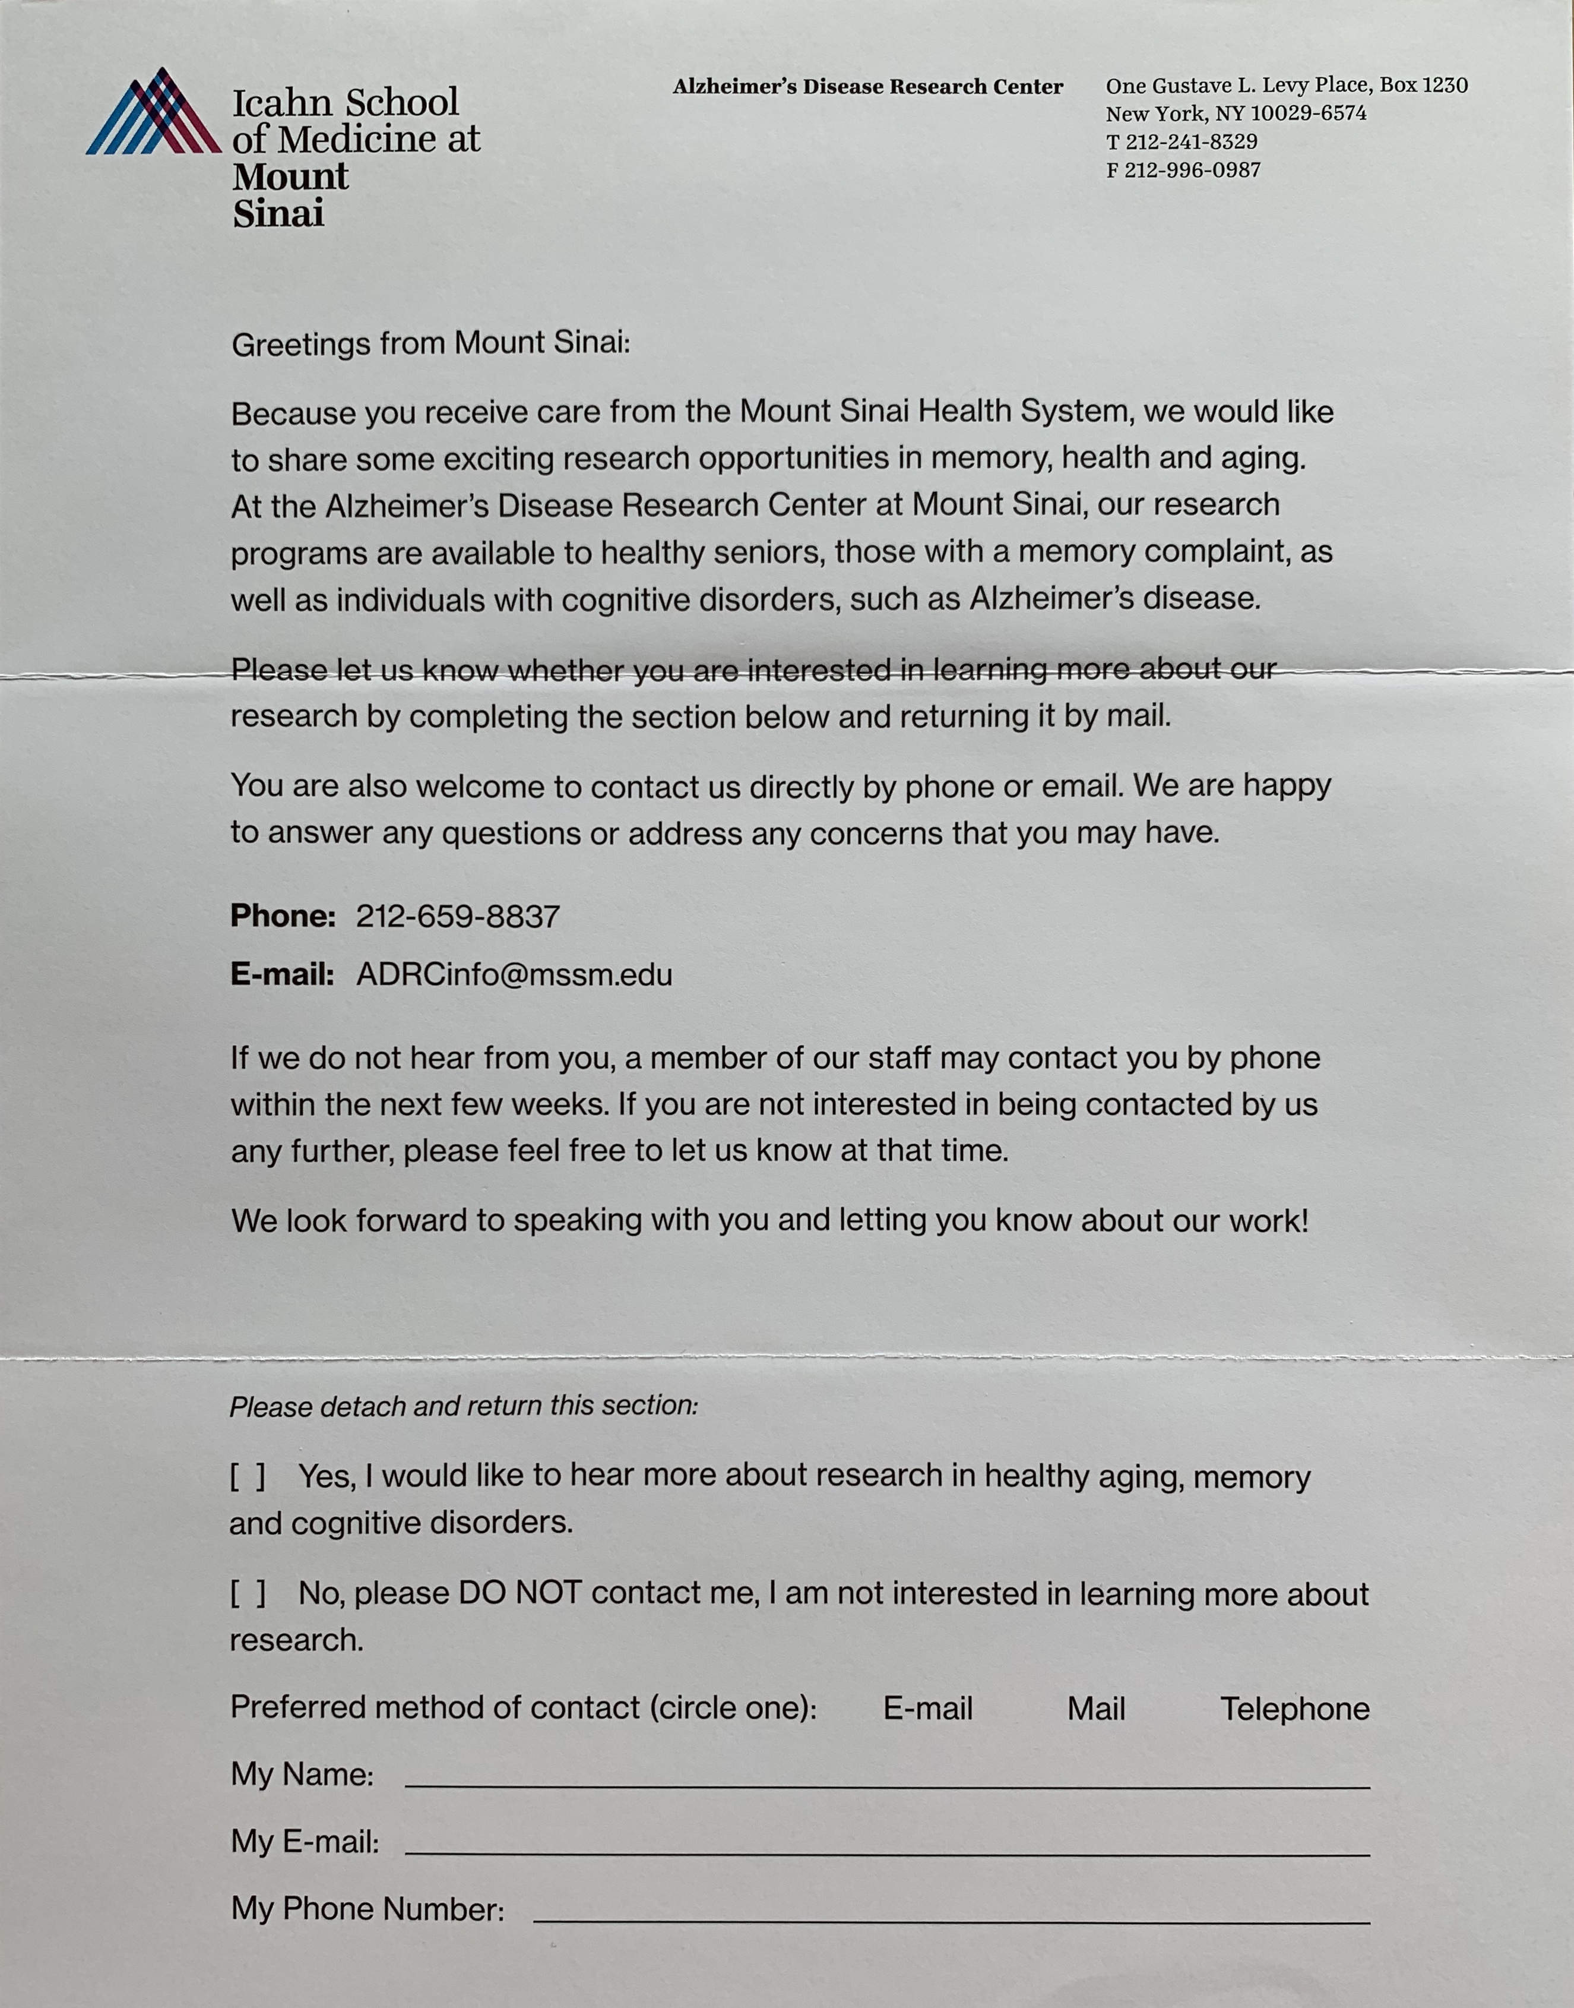



|  |  |  |  |  |  |
| --- | --- | --- | --- | --- | --- |
| **Supplemental Materials Table 1: Observational Studies and Interventional Trials Reviewed with Interested Individuals by Telephone** | | | | | |
| **Study Title** | **Primary Objective** | **Age** | **Diagnosis** | **Duration** | **Participation Criteria** |
| **OBSERVATIONAL STUDIES** | | | | | |
| **UDS** | Nation-wide study to collect basic data to better understand diseases affecting memory and thinking, including Alzheimer’s Disease and other related disorders. Participants are also invited to participate in other biomarker studies and our Brain Tissue Donation Program. | 65+  (unless symptomatic) | Normal Control, MCI, and AD | Annual evaluation | • neuropsychological testing, physical and neurological exam, and blood draw |
| **OBSERVATIONAL STUDIES WITH IMAGING** | | | | | |
| **ADNI-3** | Collect longitudinal data from a vast and cognitively diverse cohort to determine the relationships between clinical, genetic, and biochemical biomarker characteristics of the spectrum of Alzheimer’s disease. This data ultimately aids the discovery and validation of clinical trial measures used in AD research, and informs the design of future therapeutic trials. | 55-90 | Normal Control, MCI, and AD | 2-6 years (dependent on diagnostic cohort) | • in-clinic visits every 12 months and telephone follow-ups every 6 months  • neuropsychological testing, physical and neurological exam, and blood work  • MRI, FDG-PET, AV-1451 PET, Amyloid PET, and LP |
| **Project 1** | Examine the biology of cognitive impairment and risks of Alzheimer’s Disease in non-white or Latino patients with Type 2 Diabetes. | 50+ | Normal Control and MCI | 2 years | • 4 in-clinic visits  • neuropsychological testing, physical and neurological exam, and blood work  • MRI and LP |
| **TANSNIP** | Investigate how cardiovascular risk factors such as hypertension, diabetes, obesity, and smoking affect cognitive functioning in daily life. | 60-85 | Normal Control and MCI | Total of 7 hours (2-3 visits) | • neuropsychological testing, physical and neurological exam, and blood work  • ultrasound of major arteries and CT Scan of carotids  • MRI and Amyloid PET |
| **INTERVENTIONAL TRIALS** | | | | | |
| **EXERT** | Examine the effects of aerobic exercise on cognition, functional status, brain atrophy, and CSF biomarkers of AD in adults with amnestic MCI  ***Aerobic exercise:*** *may improve cognition and other measures of brain health in older adults with amnestic MCI* | 65-89 | MCI | 18 months | • in-clinic visits every 6 months  • neuropsychological testing, physical and neurological exam, and blood work  • complete exercises at designated Y facility with certified trainer 4x per week for 12 months and exercise independently for last 6 months  • MRI  • cannot be on memantine (Namenda) |
| **MIND** | Test whether daily transdermal nicotine will produce sustained cognitive, clinical, and functional benefits for patients with MCI and to assess whether nicotine will influence the underlying biology related to MCI/AD.  ***Nicotine:*** *Stimulation of nicotinic cholinergic receptors with nicotine may be a promising strategy to ameliorate symptoms of MCI and/or slow progression to dementia.* | 55-90 | MCI | 24 months | • in-clinic visits every 3 months  • neuropsychological testing, physical and neurological exam, and blood work  • optional MRI  • can be on stable dose of memantine (Namenda) for 12 weeks  • cannot be on AChE inhibitor |