Cognitive test questions

1a.What year is it? – Free text (1 point)
1b.What month is it? - Multiple choice (1 point)
1c. What day of the month is it? – Free text (1 point)
1d. What day of the week is it? – Multiple choice (1 point)
1e. What month will it be in 3 months? – Multiple choice (1 point)
2. Connecting dots (thee attempts) – Draw by hand (3 points)
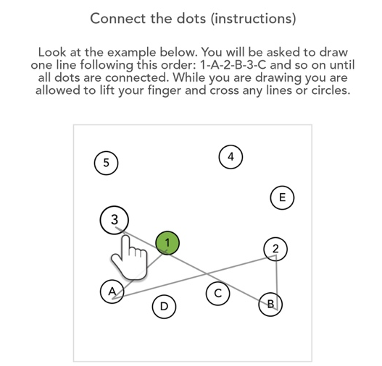
3. Draw a cube (three attempts) - Draw by hand (1 point)
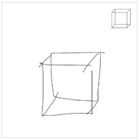

4. Draw the specified time (five attempts) - Draw by hand (5 points)
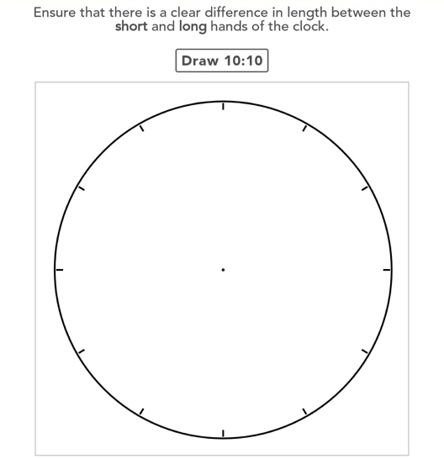
5. What animal is this (three attempts) – Free text (1 point)
6. Remember words: Bus, Painting, Hat, Rose and Face (two attempts) – Speak (1 point)
7. Number sequence (eight attempts), from 4 to 6 digits - Free text (keypad) (4 points)
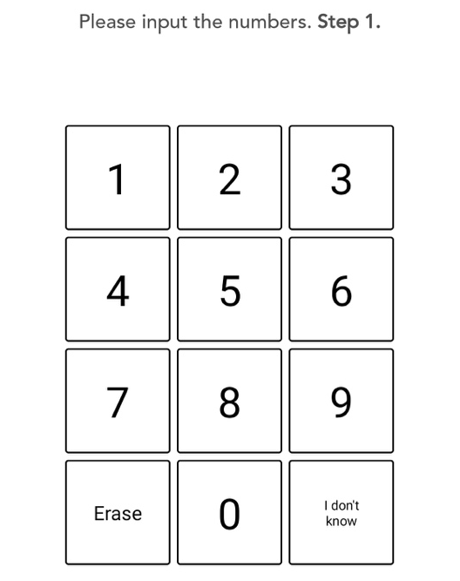
8. Reverse number sequence (eight attempts), from 3 to 6 digits - Free text (keypad) (4 points)
9. Series of subtraction, subtract 7 from 100 (five attempts) - Free text (keypad) (5 points)
10. How are they alike, categorization of objects (two attempts), apples & pears / motorcycles & trucks - Multiple choice (2 points)
11. Remember words after delay: Bus, Painting, Hat, Rose and Face (one attempts) – Speak (5 points)
12. Remember pattern (five attempts) - Multiple choice (5 points)
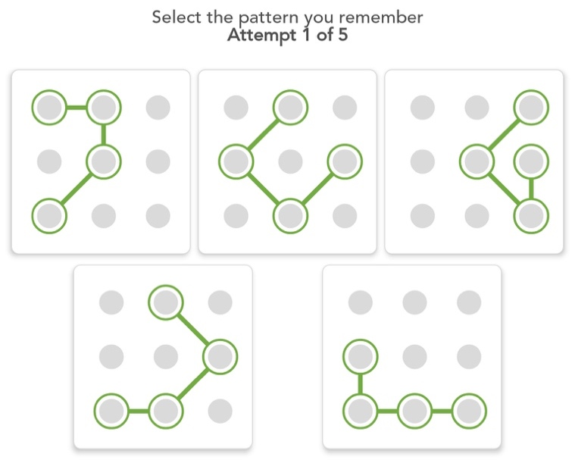

13a. Recording as many words as possible beginning with “A” in 1 min – Speak (1 point)
13b. Recording as many words as possible beginning with “F” in 1 min – Speak (1 point)
14. Coding test with digit symbols, perform as many as possible in 1.5 min – Multiple choice (6 points)
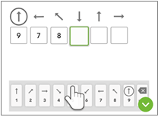
15. What time is this? Determines the time on the clock (five attempts) - Free text (digits) (5 points)
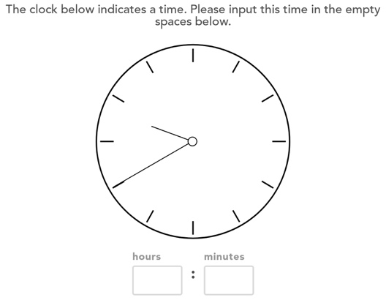

16. Remember patterns after delay (five attempts) - Multiple choice (5 points)
