Supplementary Figure 1. Change per year in performance on the six cognitive measures (A: AIBL-PACC; B: Verbal Episodic Memory; C: Executive Function; D: CDR Sum of Boxes; E: MMSE; F: CVLT-II LDFR) for the four contracted AT(N) groups in NC
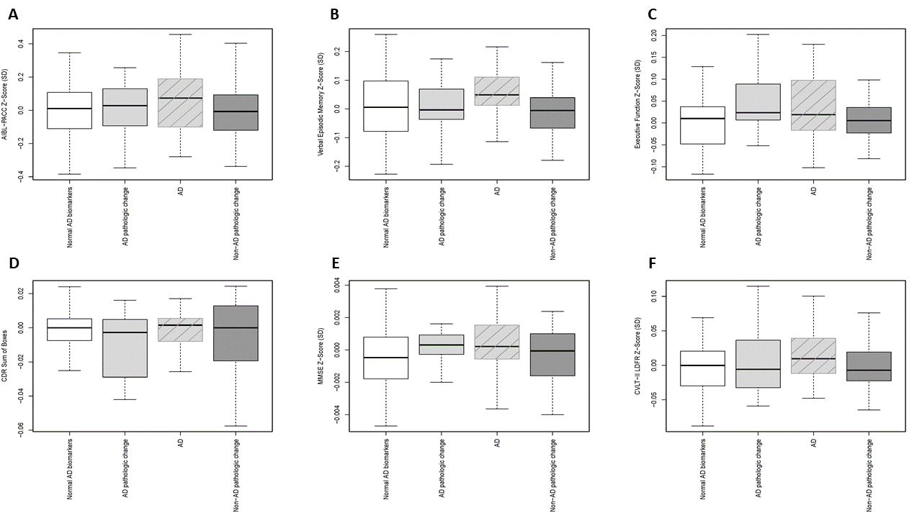
AD, Alzheimer’s disease; AIBL-PACC, Australian Imaging, Biomarker & Lifestyle Flagship Study of Ageing – Preclinical Alzheimer Cognitive Composite; CDR, Clinical Dementia Rating; CVLT-II LDFR, California Verbal Learning Test – Second Edition; Long-Delay Free Recall; MMSE, Mini-Mental State Examination; NC, normal control; SD, standard deviation.
Supplementary Figure 2. Change per year in performance on the six cognitive measures (A: AIBL-PACC; B: Verbal Episodic Memory; C: Executive Function; D: CDR Sum of Boxes; E: MMSE; F: CVLT-II LDFR) for the four contracted AT(N) groups in MCI
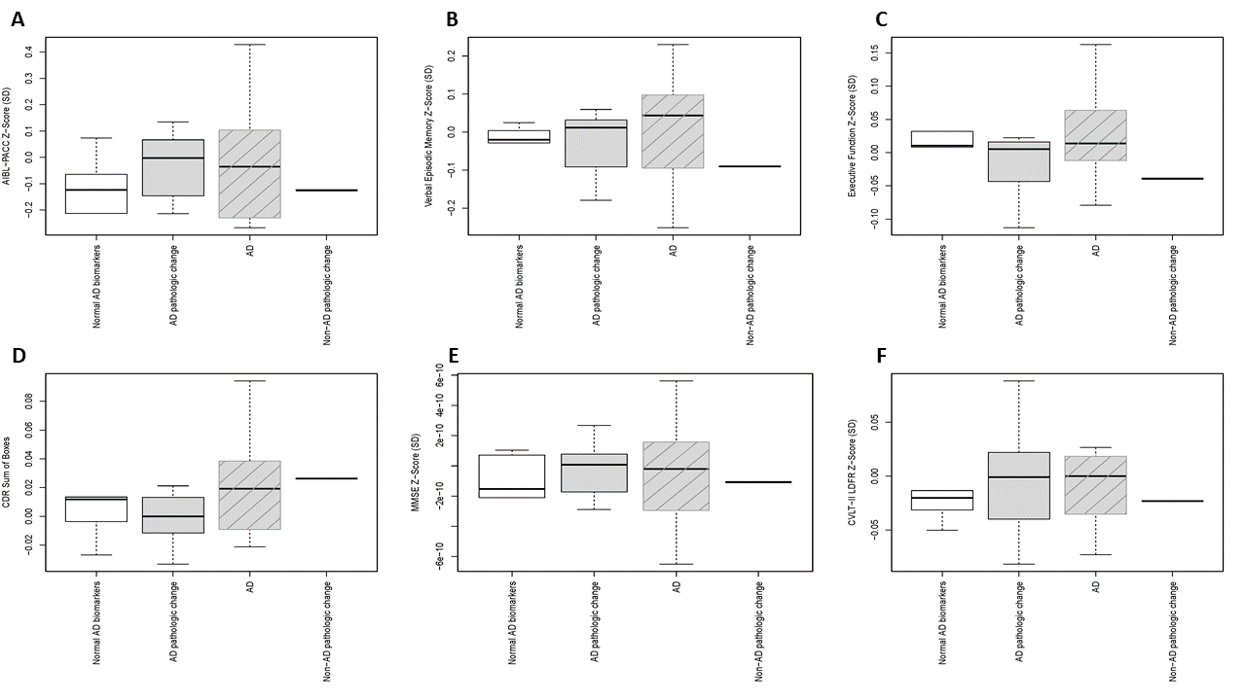
AD, Alzheimer’s disease; AIBL-PACC, Australian Imaging, Biomarker & Lifestyle Flagship Study of Ageing – Preclinical Alzheimer Cognitive Composite; CDR, Clinical Dementia Rating; CVLT-II LDFR, California Verbal Learning Test – Second Edition; Long-Delay Free Recall; MMSE, Mini-Mental State Examination; NC, normal control; SD, standard deviation.

